

SECURE DATA TRANSMISSION IN CLOUD COMPUTING USING ENCRYPTION AND MACHINE LEARNING
CipherGuard Shield: AES-256-GCM with ECDH key exchange, and an XGBoost + 1D-CNN intrusion detector
A project report submitted in partial fulfilment of the requirements for the award of the degree of
BACHELOR OF TECHNOLOGY
in
COMPUTER SCIENCE AND ENGINEERING
Submitted by
AVUTI SANDHYA | 23K91A0520
BANOTHU INDU | 23K91A0530
DASARI SRITEJA | 23K91A0559
BEJUGAM VAISHNAVI | 23K91A0533
Batch A5 (CSE-A)
Under the esteemed guidance of
CH. PRABHAKAR
[DESIGNATION]
DEPARTMENT OF COMPUTER SCIENCE AND ENGINEERING
TKR COLLEGE OF ENGINEERING & TECHNOLOGY (AN AUTONOMOUS INSTITUTION)
Medbowli, Meerpet, Balapur, Hyderabad, Telangana - 500 097
Academic year [ACADEMIC YEAR]

CERTIFICATE
This is to certify that the project report entitled "Secure Data Transmission in Cloud Computing using Encryption and Machine Learning" is a bonafide record of the work carried out by AVUTI SANDHYA (23K91A0520), BANOTHU INDU (23K91A0530), DASARI SRITEJA (23K91A0559), BEJUGAM VAISHNAVI (23K91A0533), in partial fulfilment of the requirements for the award of the degree of Bachelor of Technology in Computer Science and Engineering, during the academic year [ACADEMIC YEAR], under my supervision.

Project Guide | Head of the Department | Principal
CH. Prabhakar | [HOD NAME] | [PRINCIPAL NAME]
[DESIGNATION] | Department of Computer Science and Engineering | TKR College of Engineering & Technology

External Examiner: [NAME AND SIGNATURE]
Place: [PLACE]
Date: [DATE]

DECLARATION
We hereby declare that the project report entitled "Secure Data Transmission in Cloud Computing using Encryption and Machine Learning", submitted to the Department of Computer Science and Engineering, TKR College of Engineering & Technology, in partial fulfilment of the requirements for the award of the degree of Bachelor of Technology in Computer Science and Engineering, is a record of original work carried out by us under the guidance of CH. Prabhakar, [DESIGNATION]. The results embodied in this report have not been submitted to any other university or institution for the award of any degree or diploma.

AVUTI SANDHYA 23K91A0520
BANOTHU INDU 23K91A0530
DASARI SRITEJA 23K91A0559
BEJUGAM VAISHNAVI 23K91A0533

Place: [PLACE]
Date: [DATE]

ACKNOWLEDGEMENT
We express our sincere gratitude to our project guide, CH. Prabhakar, [DESIGNATION], for valuable guidance, encouragement and constructive suggestions throughout this project.
We thank [HOD NAME], Head of the Department of Computer Science and Engineering, for providing the facilities and support needed to complete this work, and [PRINCIPAL NAME], Principal, TKR College of Engineering & Technology, for the encouragement given to us.
We thank the project coordinators and all faculty and staff members of the department for their help, and our families and friends for their constant support.
We also acknowledge the authors of the base paper, the UNSW Canberra Cyber Range Lab for creating and sharing the UNSW-NB15 dataset, and the maintainers of the open-source software used in this project (FastAPI, React, Vite, the cryptography package, XGBoost, scikit-learn, PyTorch, pandas and Playwright).

AVUTI SANDHYA
BANOTHU INDU
DASARI SRITEJA
BEJUGAM VAISHNAVI
Data that travels to a cloud service crosses networks its owner does not control. Encryption protects the content but cannot notice an attacker who is already sending traffic, and intrusion detection watches the traffic but never sees inside the payload; most work treats the two separately. This project builds CipherGuard Shield, a platform that places both protections around one cloud data path. Its SecureChannel module encrypts every payload with a fresh ECDH P-256 key pair, HKDF-SHA256 and AES-256-GCM, so any change to the ciphertext is rejected at the cloud. Its ThreatSense Engine classifies network flows with XGBoost and a one-dimensional convolutional network fused by logistic-regression stacking; a FastAPI service and React console show verdicts and alerts.
The shipped demonstration model was trained on generated synthetic data and scores 97.3% on it, but this figure does not transfer: on the 82,332 real UNSW-NB15 test flows the same model reaches 66.0%. Trained on the official UNSW-NB15 training set, the stacked ensemble reaches 0.890 ± 0.002 accuracy on the official test set (XGBoost alone 0.910 ± 0.001) and 0.938 under the base paper's 9,000-flow protocol, about one point below the paper's reported 0.949. All 5,000 of 5,000 tampered messages were rejected, and one protected 100 KB transfer costs 5.67 ms, 81% of it detection. The cloud is a mock, nothing is captured live, and no adversarial testing was done.
Keywords: cloud security, secure data transmission, AES-256-GCM, elliptic-curve Diffie-Hellman, intrusion detection, machine learning, XGBoost, 1D CNN, UNSW-NB15.

TABLE OF CONTENTS
CERTIFICATE i
DECLARATION ii
ACKNOWLEDGEMENT iii
TABLE OF CONTENTS v
LIST OF FIGURES vii
LIST OF TABLES viii
LIST OF ABBREVIATIONS ix
CHAPTER 1: INTRODUCTION 1
1.1 Domain 1
1.2 Background and Motivation 1
1.3 Problem Statement 1
1.4 Need for the Work 2
1.5 Objectives 2
1.6 Scope 3
1.7 Contributions 3
1.8 Limitations and Assumptions 4
1.9 Organisation of the Report 4
CHAPTER 2: LITERATURE SURVEY 5
2.1 Overview 5
2.2 Base Paper Analysis 5
2.3 Related Work 7
2.4 Datasets and Algorithms Used in This Project 9
2.5 Strengths and Limitations of the Surveyed Work 9
2.6 Research Gap 9
CHAPTER 3: FEASIBILITY STUDY 11
3.1 Technical Feasibility 11
3.2 Economic Feasibility 12
3.3 Operational Feasibility 12
3.4 Schedule Feasibility 13
3.5 Advantages and Constraints 13
CHAPTER 4: SYSTEM REQUIREMENTS AND ANALYSIS 15
4.1 Existing System and Its Limitations 15
4.2 Proposed System and Its Advantages 15
4.3 Functional Requirements 16
4.4 Non-Functional Requirements 17
4.5 Hardware Requirements 17
4.6 Software Requirements 17
4.7 User Roles and Constraints 18
4.9 Data Requirements 18
CHAPTER 5: SYSTEM DESIGN 19
5.1 Design Goals and Architecture 19
5.2 High-Level Workflow 20
5.3 Data Flow Diagrams 21
5.4 UML Design 24
5.5 Data Design 25
5.6 Algorithm Design 27
5.7 Module Design 29
5.8 API Design 29
5.9 User Interface Design 30
5.10 Key Design Decisions 31
5.11 Security and Error-Handling Design 31
CHAPTER 6: METHODOLOGY AND SOFTWARE IMPLEMENTATION 33
6.1 Overall methodology 33
6.2 Datasets 34
6.3 Data preparation and feature encoding 35
6.4 Algorithm choice and justification 36
6.5 Mathematical formulation 38
6.6 Model architecture and training 40
6.7 Application architecture 41
6.8 API design 42
6.9 Security and error handling 43
6.10 Installation and execution 44
CHAPTER 7: SYSTEM TESTING 45
7.1 Testing strategy 45
7.2 Unit testing 45
7.3 Integration testing 46
7.4 Functional testing 47
7.5 Security testing 47
7.6 Validation and edge cases 48
7.7 Performance testing 49
7.8 User acceptance testing 51
7.9 Defects and observations from testing 51
7.10 Limits of the testing done 51
CHAPTER 8: RESULTS AND OUTPUT SCREENS 53
8.1 Experimental set-up 53
8.2 Output screens 53
8.3 Detection performance on real UNSW-NB15 traffic 55
8.4 Detection performance under the base paper's protocol 58
8.5 The shipped model on synthetic data: why 97.33% is not evidence 59
8.6 Cryptographic performance and integrity 60
8.7 The combined overhead of encryption and detection 61
8.8 Comparison with the base paper 62
8.9 Sample inputs and outputs 63
8.10 Success and failure analysis 64
8.11 Limitations of the evaluation 65
8.12 Objectives versus outcomes 65
CHAPTER 9: CONCLUSION 67
9.1 Summary of the work 67
9.2 Objectives achieved 67
9.3 Key findings 67
9.4 Practical applications 68
9.5 Known limitations 68
9.6 Lessons learned 68
CHAPTER 10: FUTURE SCOPE 69
10.1 Improvements to the existing system 69
10.2 Additional features 69
10.3 Scalability and deployment 69
10.4 Further research 70
REFERENCES 71
APPENDIX A: IMPORTANT CODE 74
A.1 Key derivation and authenticated encryption (`secure_channel.py`) 74
A.2 The 1D CNN, XGBoost and the stacking meta-model (`train.py`) 74
A.3 Scoring and severity (`inference.py`) 75
A.4 The encrypt and decrypt routes (`main.py`) 75
APPENDIX B: INSTALLATION AND USER GUIDE 77
B.1 Requirements and start 77
B.2 Real-trained bundle, tests and experiments 77
APPENDIX C: ADDITIONAL SCREENS 78

LIST OF FIGURES
Figure 1: Four-tier architecture of CipherGuard Shield (console, FastAPI application, core packages and in-memory state, file stores). 19
Figure 2: The two protection lanes around one transfer. 20
Figure 3: Data flow diagram, level 0 (context). 21
Figure 4: Use-case diagram. 21
Figure 5: Data flow diagram, level 1. 22
Figure 6: Data flow diagram, level 2, of the scoring process. 23
Figure 7: UML class diagram. 24
Figure 8: Sequence diagram of scoring, encryption and verified decryption. 25
Figure 9: Logical entity-relationship diagram (no database). 26
Figure 10: Flowchart of SecureChannel encryption and verified decryption. 27
Figure 11: Flowchart of the scoring algorithm. 28
Figure 12: Architecture of the stacked detector. 28
Figure 13: Architecture of the ThreatSense Engine: preprocessing, XGBoost, the 1D CNN and the stacking meta-model. 40
Figure 14: Median encryption and decryption time against payload size for SecureChannel, AES-GCM alone and two RSA hybrids (log scale). 50
Figure 15: Output screen: live scoring. The attack preset was scored: verdict ATTACK, severity HIGH, stacked probability 0.84 (XGBoost 0.45, CNN 1.00). Counters show 53 flows scored in this session. 54
Figure 16: Output screen: secure transfer. A text payload was encrypted (ciphertext, 12-byte nonce, 16-byte tag, 65-byte ephemeral public key shown) and then decrypted and verified at the mock cloud. 54
Figure 17: Output screen: model performance of the shipped bundle - 97.33% accuracy on 1,800 synthetic test rows. The banner at the top states the data mode. 55
Figure 18: Output screen: model performance of the real-trained bundle served with CIPHERGUARD_MODELS_DIR - 88.79% accuracy on the 82,332-flow official test set, 192 input dimensions. 55
Figure 19: Output screen: 120 real UNSW-NB15 flows scored by the shipped (synthetic-trained) bundle - 66 flagged as attack and 78 of 120 verdicts (65.0%) agree with the labels in the file. 55
Figure 20: Output screen: the same 120 real flows scored by the real-trained bundle - 73 flagged as attack and 101 of 120 verdicts (84.2%) agree with the labels. 55
Figure 21: Accuracy, F1 and false-positive rate of the seven models on the official test set; error bars are one standard deviation over five seeds. 56
Figure 22: Confusion matrices: the stacked model and XGBoost on the official test set (seed 42), and the shipped model on its own synthetic test split. 57
Figure 23: ROC curves of the two base models and the stacked model on the official test set (seed 42). 57
Figure 24: Precision, recall, F1 and false-positive rate of the stacked model against the decision threshold (official test set, seed 42). 57
Figure 25: Share of each category handled correctly by the stacked model (attack classes: detected; Normal: correctly passed). 58
Figure 26: Accuracy of the stacked ensemble for each combination of training data and test data. 60
Figure 27: Median encryption and decryption time against payload size for SecureChannel, raw AES-256-GCM and two RSA-OAEP hybrids (log-log axes). 61
Figure 28: Batch CSV scoring of the bundled 120-row synthetic sample. 78
Figure 29: Session charts: attack versus normal and the confidence distribution. 78
Figure 30: Secure transfer: a flipped ciphertext byte is rejected. 78
Figure 31: Alerts screen populated by the batch. 78

LIST OF TABLES
Table 1: Abbreviations used in this report ix
Table 2: Project objectives and how each was addressed 2
Table 3: The base paper at a glance 5
Table 4: Datasets and algorithms of this project 9
Table 5: Related work compared 9
Table 6: Technical feasibility checks and what was measured 11
Table 7: Components, licences and cost to the project 12
Table 8: Limitations of the existing approach 15
Table 9: Advantages of the proposed system over the existing practice 16
Table 10: Functional requirements 16
Table 11: Non-functional requirements and the evidence 17
Table 12: Hardware 17
Table 13: Software: pinned versions and what actually ran 17
Table 14: User roles 18
Table 15: Data structures and where they live 26
Table 16: Modules, responsibilities and size 29
Table 17: HTTP interface 29
Table 18: Decisions and their reasons 31
Table 19: Datasets and splits used in this project. 35
Table 20: Algorithm choices and the alternatives that were not used. 36
Table 21: Training configuration shared by the shipped bundle and the experiments. 40
Table 22: API routes of CipherGuard Shield. 42
Table 23: Test levels, tools and results. 45
Table 24: Unit tests of the cryptography. 45
Table 25: Unit tests of the detection engine (shipped bundle). 46
Table 26: Functional checks by screen. 47
Table 27: Tamper tests on the SecureChannel (1,000 trials each). 47
Table 28: Edge cases and how they were checked. 48
Table 29: Median encryption and decryption time in milliseconds by payload size. 49
Table 30: API latency over HTTP on 127.0.0.1 (milliseconds). 50
Table 31: Data used in the evaluation 53
Table 32: Detection metrics on the official testing set, mean ± standard deviation over five seeds (threshold 0.5) 55
Table 33: Stacked model on the official test set (seed 42) at different thresholds 57
Table 34: Stacked model by category on the official test set (seed 42, threshold 0.5) 58
Table 35: Detection metrics under the base-paper-style protocol, mean ± standard deviation over ten repetitions 59
Table 36: The same models on different data 59
Table 37: Median time in milliseconds (encrypt / decrypt) by payload size 60
Table 38: Integrity and uniqueness tests (scripts/benchmark_crypto.py) 61
Table 39: In-process timings (milliseconds) 61
Table 40: HTTP API latency on 127.0.0.1 (milliseconds) 62
Table 41: Reported and measured detection results 62
Table 42: The six batch objectives and what the measurements show 65

LIST OF ABBREVIATIONS
Table 1: Abbreviations used in this report
Abbreviation | Expansion
AES | Advanced Encryption Standard
API | Application Programming Interface
AUC | Area Under the Curve
BCE | Binary Cross-Entropy
CNN | Convolutional Neural Network
CORS | Cross-Origin Resource Sharing
CPU | Central Processing Unit
CSV | Comma-Separated Values
DFD | Data Flow Diagram
DoS | Denial of Service
ECC | Elliptic Curve Cryptography
ECDH | Elliptic Curve Diffie-Hellman
EECC | Enhanced Elliptic Curve Cryptography
ER | Entity-Relationship
FNR | False-Negative Rate
FPR | False-Positive Rate
GCM | Galois/Counter Mode
HKDF | HMAC-based Key Derivation Function
HTTP | Hypertext Transfer Protocol
IDS | Intrusion Detection System
JSON | JavaScript Object Notation
LR | Logistic Regression
MCC | Matthews Correlation Coefficient
ML | Machine Learning
NIDS | Network Intrusion Detection System
NIST | National Institute of Standards and Technology
OAEP | Optimal Asymmetric Encryption Padding
QNN | Quantum Neural Network
RF | Random Forest
ROC | Receiver Operating Characteristic
RSA | Rivest-Shamir-Adleman
TLS | Transport Layer Security
UI | User Interface
UML | Unified Modeling Language
UNSW-NB15 | University of New South Wales Network-Based 2015 dataset
XGBoost | Extreme Gradient Boosting

CHAPTER 1: INTRODUCTION
This chapter introduces the domain of the project, the motivation for building CipherGuard Shield, the problem it addresses, the objectives set for it, the scope that was actually delivered, its contributions, and the limitations and assumptions that govern every result reported later. It closes with a map of the rest of the report.

1.1 Domain
Cloud computing lets an organisation keep its files, databases and services on infrastructure owned by someone else and reach them over the Internet. The attraction is economic and operational: capacity is rented as needed, backups and availability are handled by the provider, and users reach their data from anywhere. The price is that the data no longer stays inside a network the organisation controls. Every upload and every download crosses links, routers and gateways that belong to third parties, and the data finally rests on machines run by a provider that can, unless the data is protected, read it.

1.2 Background and Motivation
The base paper of this project [1] states the dilemma clearly: once an attacker has access to a network they can quickly collect information, so an intrusion detection system is needed, and because the data crossing the network is itself valuable, it must also be encrypted. The paper therefore combines a deep-learning detector with an enhanced elliptic-curve scheme in one framework. Other recent work follows the same two tracks separately: detectors built from deep networks, ensembles and feature-selection pipelines for cloud traffic [21], [22], [25], and encryption schemes proposed or tuned for cloud storage and transfer [2]-[5].
Symmetric ciphers such as AES are fast but need a secure way to share the key; asymmetric ciphers such as RSA or elliptic-curve Diffie-Hellman solve the key exchange but are too slow for bulk data. Hybrid cryptography uses the asymmetric step to agree a key and the symmetric step to protect the payload. Modern authenticated modes such as AES-GCM [12] add an integrity tag to the ciphertext, so a single changed bit is detected at decryption. Encryption alone, however, says nothing about an attacker who already holds valid credentials or who is flooding the service with legitimate-looking requests, and that is the case where a machine-learning detector adds value.

1.3 Problem Statement
The batch problem statement lists four weaknesses of current practice:
• data placed in a public cloud is readable by the provider unless it is encrypted before upload;
• symmetric encryption alone leaves the key exchange itself vulnerable to interception;
• encryption cannot detect an attacker who has already obtained valid credentials;
• most academic systems address either cryptography or intrusion detection, rarely both together.
The problem addressed here is to build and evaluate a transmission framework that encrypts data with a hybrid asymmetric-symmetric scheme and, on the same data path, monitors network flows with a machine-learning intrusion detector, so that confidentiality and integrity are protected and suspicious traffic is flagged and logged.

1.4 Need for the Work
The work is needed because the surveyed studies treat the two protections separately and rarely measure their combined cost; because authenticated encryption should be shown by repeated tamper trials and not by argument; and because a detector trained on generated data can look excellent and fail on real traffic, so the real-data evidence and the claims of the default demonstration model must be kept apart.

1.5 Objectives
The six objectives set for the project, and what each became, are summarised in Table 1.1. Chapter 8 returns to this table with the measured outcome for each.
Table 2: Project objectives and how each was addressed
No. | Objective | How it was addressed
1 | Design a hybrid encryption scheme using AES for the payload and RSA for key exchange | AES-256-GCM for the payload; ECDH P-256 + HKDF-SHA256 for key agreement (RSA-OAEP hybrid benchmarked as a baseline only)
2 | Implement secure key generation, distribution and storage between sender and receiver | Fresh ephemeral P-256 key pair per message; public key travels in the envelope; the cloud key pair lives in process memory only
3 | Build a transmission module that encrypts before upload and decrypts after download | Encrypt / decrypt-and-verify API and console screen for text and files up to 5 MB, against a mock cloud endpoint
4 | Train a classifier on a benchmark intrusion dataset to detect anomalous access | XGBoost + 1D CNN + logistic-regression stacking, trained and evaluated on real UNSW-NB15; the shipped default is trained on synthetic data
5 | Integrate the detection layer so suspicious sessions are flagged and logged during transfer | Flow records and CSV batches are scored; attacks are logged with severity in a 500-entry alert list
6 | Evaluate encryption and decryption time, throughput overhead and detection accuracy | Crypto latency by size and algorithm, combined per-transfer overhead, detection metrics over seeds, thresholds and categories

Two objectives differ from the original wording. Objective 1 asks for RSA in the key exchange; the implementation uses elliptic-curve Diffie-Hellman, because a fresh ephemeral key per message gives every message its own key and a 65-byte public value in place of a 256-byte wrapped key, and an RSA-OAEP hybrid [16] was benchmarked as the baseline. Objective 2 covers key storage, which is not met: the cloud key pair is kept in memory.

1.6 Scope
CipherGuard Shield consists of two modules and two interfaces:
• SecureChannel: ECDH P-256 key agreement, HKDF-SHA256 key derivation, AES-256-GCM authenticated encryption, with an ephemeral key pair per message, 12-byte random nonces and a 93-byte fixed envelope overhead.
• ThreatSense Engine: preprocessing of the 42-feature UNSW-NB15 flow schema, an XGBoost classifier, a one-dimensional CNN in PyTorch, and a logistic-regression meta-model that stacks their probabilities; severity bands and an in-memory alert log.
• Interfaces: a FastAPI service (port 8305) with nine API routes, a React 19 console (port 5305) with live scoring, secure transfer, alerts and model-performance screens, and the original HTML dashboard served by the API.
• Evidence: an experiment suite on the real UNSW-NB15 official partition and on the base paper's 9,000-flow protocol, a crypto benchmark, a latency measurement of the combined path, 26 automated tests and 15 smoke checks.
Out of scope are live packet capture, automatic blocking of flagged sessions, a real cloud provider, user accounts and authentication, persistent storage of alerts, and the quantum-inspired network and the enhanced elliptic-curve scheme of the base paper.

1.7 Contributions
1. A working platform that places authenticated encryption and ML intrusion detection around one cloud data path, with a console, an API and 26 automated tests.
2. A measured cost of protection: a protected 100 KB transfer takes 5.67 ms in process, of which detection is 81%; the cost is reported by payload size and compared with RSA-OAEP hybrids.
3. Tamper-resistance evidence: six tamper and key cases, 1,000 trials each, all behaving as expected, and no repeated nonce in 20,000 encryptions.
4. A real-data evaluation of the stacked detector: 0.890 ± 0.002 accuracy on the official UNSW-NB15 test set over five seeds, with XGBoost alone at 0.910 ± 0.001, and 0.938 under the base paper's protocol.
5. An explicit demonstration of the synthetic-data trap: the shipped synthetic-trained model scores 97.3% on its own data and 66.0% on real flows.

1.8 Limitations and Assumptions
The conclusions of this report hold under the following limitations and assumptions.
• The shipped default model is trained on a generated synthetic dataset; the real-trained bundle is an experiment kept under experiments/, not the default.
• The official UNSW-NB15 test set comes from a different capture period than its training set, which makes it harder than a random split; the detector produces many false alarms on normal traffic at the default threshold (false-positive rate 0.222).
• Traffic is supplied as flow records or CSV rows; the system does not sniff packets, and it does not block or quarantine anything on its own.
• The cloud is a mock endpoint in the same process, with a key pair that lives only as long as the server process; there is no authentication, TLS or rate limiting.
• Alerts are kept in an in-memory list of at most 500 entries and are lost on restart; there is no database.
• Timings were measured on one shared Intel Core i5-12500 machine with 15.7 GB of memory and are indicative; no multi-user load, adversarial-evasion or browser-compatibility testing was done.

1.9 Organisation of the Report
The report continues with the literature survey (Chapter 2), the feasibility study and requirements (Chapters 3 and 4), the design (Chapter 5), the methodology and implementation (Chapter 6), testing (Chapter 7), results with the comparison against the base paper (Chapter 8), the conclusion and future scope (Chapters 9 and 10), the references and three appendices.

CHAPTER 2: LITERATURE SURVEY

2.1 Overview
The survey covers four strands of work that meet in this project: machine-learning detectors for network and cloud intrusion, encryption schemes used for data in the cloud, designs that combine the two, and the datasets and evaluation protocols on which the detectors are judged. The batch literature survey lists five works, led by the base paper [1]; the other four [2]-[5] are an encryption-and-anomaly-detection study of cloud storage and transmission, a multi-cloud intrusion-detection method with automated data deletion, a federated attack-detection scheme with an improved Blowfish cipher, and a hybrid-encryption privacy framework. Their abstracts were read where they could be retrieved; results quoted below are the authors' own claims and were not reproduced. The base paper's own reference list supplies much of the detector literature, and each claim taken from it is marked as described in the base paper.

2.2 Base Paper Analysis

2.2.1 Problem and approach
Kalyanasundaram, Raja and Kanthimathi [1] observe that once an attacker has access to a network the attacker can collect information quickly, so a detector is needed, and that the data must also be protected. They propose a deep-learning intrusion detector followed by an enhanced elliptic-curve encryption of the data judged non-intrusive. The detector has three stages. Inputs are first normalised with min-max scaling. Two classifiers then score each sample: a quantum-inspired network (FLPF with EVD-QNN) that adds an eigenvalue-decomposition block to its flatten-layer feature map, and a LeNet CNN [10]. Their scores are fused by a double-sigmoid, median min-max normalisation (DSMMN-SLF) followed by a weighted sum. The paper stresses that the QNN is quantum-inspired and runs on classical hardware, with the quantum circuit simulated by differentiable classical transformations.
The cryptographic part, EECC, modifies the key relations and the encryption and decryption equations of elliptic-curve cryptography so that, the authors claim, equivalent security is obtained with a smaller key and lower computation. Security is discussed against brute-force, chosen-ciphertext, known-plaintext and man-in-the-middle attacks by empirical comparison with AES, ElGamal, Blowfish, ECC and RSA.

2.2.2 Evaluation protocol and reported numbers
Table 3: The base paper at a glance
Item | As reported in the paper
Data | UNSW-NB15 [7], 9,000 samples, balanced (4,500 attack, 4,500 non-attack), 2 classes
Split and repetitions | Stratified 70/15/15 train / validation / test; every experiment run 10 times and averaged
Preprocessing | Min-max normalisation of every feature to [0, 1]
Detector | FLPF with EVD-QNN (a quantum-inspired network run on classical hardware) fused with a LeNet CNN by double-sigmoid median min-max score-level fusion (DSMMN-SLF)
Cryptography | Enhanced Elliptic Curve Cryptography (EECC), applied to the data that the detector declares non-intrusive
Hardware | 64-bit OS, x64 processor, 16 GB RAM (15.7 GB usable)
Headline accuracy | Mean accuracy 0.9487 over repetitions (Table 2 of the paper); 0.95638 in the ablation at 80 % training data
Precision and FPR | Precision 0.97 at 90 % training data; false-positive rate 0.03
Baselines (mean accuracy) | QNN+ECC 0.9049; QAE 0.9044; PolyNet 0.9050; LinkNet 0.9127; Bi-LSTM 0.8993; SqueezeNet 0.9354; LeNet 0.9069
Encryption cost | Encryption 0.39 s, decryption 0.26 s, latency 0.645 (units and payload size as printed in the paper)

2.2.3 Strengths
• It addresses detection and encryption in one framework, which is the gap this project also targets.
• It uses a public benchmark (UNSW-NB15), repeats each experiment ten times, fixes seeds and keeps hyper-parameters constant across models.
• It includes an ablation (removing the QNN, the fusion, or the normalisation lowers accuracy) and a parameter-sensitivity analysis of the fusion.
• It is candid that the network is quantum-inspired and that a formal proof of EECC security is future work.

2.2.4 Limitations
• The evaluation uses a 9,000-sample balanced subset of a dataset whose official training and testing sets hold 175,341 and 82,332 flows; the paper itself notes that unbalanced classes are left to future work, and the selection of the subset is not published.
• The ablation and the headline accuracy are reported at different training fractions (80 % and 90 %), so figures from different tables cannot be mixed.
• EECC lacks a proof under standard hardness assumptions such as the elliptic-curve discrete-logarithm problem; its timing figures are quoted without a stated payload size in bytes or key length, so they cannot be compared directly with a production cipher.
• The detector and the cipher are connected in sequence (only data judged non-intrusive is encrypted); detection metrics and encryption timings are reported separately, and the cost of running both on one path is not reported.
This project follows the paper's idea of one framework with both protections and its 70/15/15 protocol, but replaces the quantum-inspired network by XGBoost and a one-dimensional CNN, replaces EECC by a standard ECDH + HKDF + AES-GCM construction [12], [13], [14] and fuses the two detector outputs with a logistic-regression stack.

2.3 Related Work

2.3.1 Machine-learning and deep-learning intrusion detection
Detectors for network and cloud intrusion form the largest body of work. As described in the base paper, Lin et al. [26] compared ResNet-50, VGG19, XceptionNet and EfficientNet for a network security-grade evaluation and report a 99.9 % detection rate for EfficientNet; Alrayes et al. [25] built a deep-neural-network IDS; Nadeem et al. [21] combined SMOTE oversampling with cuckoo-search, information-gain and particle-swarm feature selection and a random forest for a cloud IDS; and Bakro et al. [22] proposed a hybrid feature-selection design for cloud intrusion detection. Rahman et al. [24] trained detectors on GAN-generated data and report perfect scores on BoT-IoT, a result that should be read with caution because synthetic training and evaluation data can make a task easier than real traffic. Alani et al. [27] study a hybrid ensemble IDS for the Internet of Things, and Qazi et al. [28] a deep-learning network IDS called zero-touch network security. Mbaya et al. [23] combine blockchain with a BiLSTM-RNN in a federated IDS (SecFedIDM-V1).
Alhusseini et al. [6], archived with this batch, address cloud intrusion detection from the feature side: the Energy Valley Optimizer reduces the CIC-DDoS2019 features from 88 to 38 and the CSE-CIC-IDS2018 features from 80 to 43, and four classifiers (SVM, random forest, decision tree, KNN) are evaluated after down-sampling; the best model, a decision tree with the optimiser, reaches 99.13 % accuracy (F1 98.94 %) on the first dataset and 99.78 % accuracy (F1 99.70 %) on the second. These numbers are on different datasets and cannot be compared with UNSW-NB15 results.
Across this strand, tree ensembles and small neural networks perform similarly on tabular flow features, and the reported accuracies depend heavily on dataset, subset and split. The ensemble idea used here, a stacking of a tree model and a network, follows Wolpert's stacked generalisation [11] with gradient-boosted trees [9].

2.3.2 Encryption for data in the cloud
The batch survey items add four recent studies of protecting data in the cloud. Boye [2] combines homomorphic and quantum-resistant encryption with CNN and LSTM anomaly detection on access and activity logs, with encryption applied during transmission, and evaluates the idea by simulation. Singh and Bhathal [3] propose an automated data-deletion system with an integrated intrusion detector that removes stored data as soon as an intrusion is detected; the abstract presents it as a brief idea and gives no evaluation. Shinde and Ghadekar [4] pair federated-learning attack detection with an improved Blowfish cipher for secure transmission; only the title, venue and year could be verified, so no result from it is quoted. Pamarthi and Rao [5] describe a three-layer hybrid in which the data is obfuscated, encrypted with AES, the AES key is masked with XOR, and the key is exchanged with RSA or a modified elliptic-curve scheme; for inputs of 2 to 12 KB they report encryption in 2.09 s and decryption in 2.45 s (author-reported, different hardware, so not comparable with the timings of this report).
The building blocks of this project are standards rather than novel schemes: AES [15] in Galois/Counter Mode [12], elliptic-curve Diffie-Hellman key establishment on the NIST P-256 curve [13], HKDF [14] for key derivation, and, as the comparison baseline, RSA with OAEP padding [16]. Authenticated encryption is preferred to a bare cipher because it detects modification, which matters for data in transit.

2.3.3 Joint intrusion detection and cryptography
Few designs put the two protections in one framework. Kadry et al. [20] combine an optimised quantum neural network with elliptic-curve cryptography and report 98.5 % accuracy, as described in the base paper; the base paper [1] extends the idea with a fused detector and EECC; Boye [2] pairs encryption with anomaly detection on logs but, as far as the abstract shows, gives no figures; and Shinde and Ghadekar [4] pair federated attack detection with an improved Blowfish cipher by their title. Of the five works in the batch survey only the base paper and Boye combine detection and encryption at all. In these works the two parts are evaluated separately: detection accuracy on one side, encryption strength or timing on the other. The cost of running both on one data path, and the way the cost splits between them, is not reported.

2.3.4 Datasets and evaluation protocol
UNSW-NB15 was created at the UNSW Canberra Cyber Range Lab with the IXIA PerfectStorm tool, which mixes real modern normal activity with synthetic contemporary attack behaviour; the authors captured 100 GB of raw traffic with tcpdump and derived 49 features with the Argus and Bro-IDS tools [7], [8]. It has nine attack categories (Fuzzers, Analysis, Backdoors, DoS, Exploits, Generic, Reconnaissance, Shellcode, Worms). The official partition has 175,341 training and 82,332 testing flows. Because the two sets come from different capture periods, a model trained on one is tested under a mild distribution shift, whereas random splits of the pooled data are easier. This project therefore reports both the official partition and the base paper's balanced 9,000-sample protocol. Zoghi and Serpen [35] describe class imbalance and class overlap in UNSW-NB15, and Ring et al. [34] survey network-based IDS datasets in general; both are reasons for stating the split and the class balance next to every accuracy figure.

2.4 Datasets and Algorithms Used in This Project
Table 4: Datasets and algorithms of this project
Element | Choice | Why
Real data | UNSW-NB15 official partition: 175,341 train, 82,332 test flows, 42 features used | Same benchmark as the base paper; official split gives a realistic, harder test
Demo data | Generated synthetic set: 12,000 rows, same 42-feature schema | Lets the product run with no download; carries no claim about real traffic
Preprocessing | Min-max scaling of 39 numeric features, one-hot encoding of proto, service and state | Min-max as in the base paper; one-hot for the three categorical features
Tree model | XGBoost [9], 200 trees, depth 6 | Strong on tabular flow data, trains in seconds
Neural model | 1D CNN in PyTorch [18], two conv layers, Adam [19] | Counterpart of the base paper's convolutional LeNet branch
Fusion | Logistic-regression stacking [11] on the two probabilities | Simple, trainable analogue of score-level fusion
Key agreement | ECDH on P-256 [13], fresh ephemeral key per message | Small public values, per-message keys
Key derivation | HKDF-SHA256 [14] | Standard extract-and-expand KDF
Payload cipher | AES-256-GCM [12], 12-byte nonce, 16-byte tag | Authenticated encryption; tampering is detected
Baseline | RSA-2048 / 3072 OAEP [16] + AES-GCM | The objective's RSA design, benchmarked
Tooling | scikit-learn [17], PyTorch, FastAPI, React | Reproducible, open-source stack

2.5 Strengths and Limitations of the Surveyed Work
Table 5: Related work compared
Work | Approach | Reported result | Limitation for this project
Lin et al. [26] | ResNet-50, VGG19, XceptionNet, EfficientNet for security-grade evaluation | EfficientNet 99.9 % detection rate (as described in [1]) | Evaluation system, not a transmission framework
Rahman et al. [24] | GAN-generated synthetic data to train NIDS models | 100 % on BoT-IoT (as described in [1]) | Perfect scores on synthetic-derived data warrant caution
Kadry et al. [20] | Optimised quantum neural network plus elliptic-curve cryptography | 98.5 % accuracy (as described in [1]) | Combines detection and ECC but not measured as one path
Alhusseini et al. [6] | HyIDS: Energy Valley Optimizer feature selection with SVM, RF, decision tree, KNN | D_TreeEVO 99.13 % (CIC-DDoS2019), 99.78 % (CSE-CIC-IDS2018) | Different datasets; detection only, no encryption
Kalyanasundaram et al. [1] | Quantum-inspired QNN + LeNet fusion, EECC | Mean accuracy 0.9487, precision 0.97 | Balanced 9,000-sample subset; no formal EECC security proof

2.6 Research Gap
The batch survey identified the gap in one sentence: the surveyed work treats cryptography and intrusion detection as separate concerns, and a single transmission path where both operate together, with the combined overhead measured, is missing. The reading above supports and sharpens it:
1. No measured combined path. The joint designs report detection metrics and encryption timings independently; no source separates the per-transfer cost of detection from that of encryption.
2. Evaluation protocol is rarely stated or comparable. Subset, balance and split differ between papers, and perfect or near-perfect scores appear on synthetic or heavily down-sampled data.
3. Integrity is seldom tested. Few works show, with repeated trials, that a modified ciphertext is rejected, although authenticated encryption exists to provide exactly that.
4. Reproducibility. Implementations are seldom released, so the numbers cannot be checked against real traffic by a student team.
This project responds with a runnable platform and its measurements: authenticated encryption and a stacked detector on one path, a per-transfer cost of 5.67 ms for a 100 KB payload with the detector's share stated, 5,000 tamper trials (plus 1,000 untouched controls), and a detector evaluated on the real official partition (0.890 ± 0.002 accuracy stacked, 0.910 ± 0.001 XGBoost alone) and under the base paper's protocol (0.938).

CHAPTER 3: FEASIBILITY STUDY
A feasibility study asks whether a project can be built, run and maintained with the resources at hand. For CipherGuard Shield the question was answered partly by analysis and partly by building the system and measuring it on the development machine, so most entries below carry a measured value rather than an estimate. Where a question could not be settled with the data available to the team, the entry says so.

3.1 Technical Feasibility
The technical risk lay in four places: whether authenticated public-key encryption could be implemented correctly with a maintained library instead of hand-written arithmetic; whether a tabular intrusion detector combining gradient-boosted trees and a one-dimensional convolutional network could be trained and served on an ordinary processor; whether the real UNSW-NB15 benchmark could be obtained and used with the same 42-feature schema as the application; and whether the pieces could be combined behind one API and one console. The development machine is a desktop with an Intel Core i5-12500 (6 cores, 12 threads), 15.7 GB of RAM and no graphics processor in use, running Windows 11. It was shared with other jobs during every measurement, so the figures are indicative.
Table 6: Technical feasibility checks and what was measured
Question | Measurement | Verdict
Can ECDH, HKDF and AES-256-GCM be used without writing cryptographic primitives? | Yes: the cryptography package (version 42.0.7) supplies P-256 ECDH, HKDF-SHA256 and AESGCM; SecureChannel is 163 lines of glue | Feasible
Is encryption fast enough for interactive use? | SecureChannel encrypts 1 KB in 0.12 ms and 100 KB in 0.51 ms; 5 MB in 21.4 ms (raw AES-GCM 3.9 ms); decrypting 1 KB takes 0.10 ms | Feasible
Can the detector be trained on a CPU? | XGBoost trains on 149,039 real flows in 4.4 s; the 1D CNN needs 246 s on the loaded machine (15 epochs at most) | Feasible
Is scoring fast enough? | one flow scores in a median of 3.92 ms in process and 5.5 ms over HTTP; 1,000 flows in 16.6 ms | Feasible
Is the detector accurate on real traffic? | official UNSW-NB15 partition, 5 seeds: stacked ensemble 0.890, XGBoost alone 0.910 accuracy; the shipped synthetic-trained model reaches only 0.660 on the same test flows | Feasible, with a caveat
Can the real benchmark be obtained? | yes: the official training (175,341 flows) and testing (82,332 flows) sets were downloaded as 19 MB of parquet and have the 42 features the application uses | Feasible
Can everything run behind one local API? | FastAPI, ten routes, in-memory alert log, no external service; 26 automated tests and 15 smoke checks pass | Feasible

Where the checks are weakest is the data behind the shipped model. The application was delivered with a model trained on a synthetic dataset generated in the project (cipherguard/ids/synthetic.py, 12,000 rows) because the real CSV files were not placed in data/raw/. Chapter 8 shows that this model does not transfer to real traffic. The technical feasibility of intrusion detection on UNSW-NB15 was therefore established by a separate set of experiments run on the real data with the same pipeline; the shipped default was left unchanged.
A second, smaller risk is the dependency chain. On the Windows host used here, importing numpy or pandas before torch made the PyTorch libraries fail to initialise (WinError 1114). The experiment scripts, the test configuration and the helper scripts/serve.py therefore import torch first. The risk is real but cheap to remove, and run.bat creates its own virtual environment with the pinned versions.

3.2 Economic Feasibility
Every component of the system is free and open source, and the work ran on a computer the team already had, so no money was spent on software, licences or cloud services. The table lists what was used. Cash costs for a real deployment, such as a cloud account, TLS certificates or a managed key store, were not part of the project and were not estimated, because the cloud endpoint is a mock inside the same process.
Table 7: Components, licences and cost to the project
Item | Role | Licence | Cost
Python 3.11, FastAPI, Uvicorn | language and web API | PSF / MIT / BSD | none
cryptography | P-256 ECDH, HKDF, AES-GCM, RSA (benchmark) | Apache-2.0 / BSD | none
XGBoost, scikit-learn, PyTorch | detector, preprocessing, CNN | Apache-2.0 / BSD | none
React 19, Vite, Tailwind, Recharts | console | MIT | none
UNSW-NB15 dataset | real benchmark flows | free for academic use, cite the authors | none
Development computer (i5-12500, 15.7 GB) | all builds and measurements | owned | not purchased for the project
pytest, Playwright | tests and screenshots | MIT / Apache-2.0 | none

The only recurring cost the project can name is electricity for the machine, which was not measured. The one-time compute cost of the experiments was small: the complete study (five official-partition runs, ten paper-protocol runs and the shift tests) finished in about 25 minutes of wall-clock time, and the cryptography benchmark in a few minutes. The economic case for the design is that both protections run on commodity hardware: one protected 100 KB transfer costs 5.7 ms in process.

3.3 Operational Feasibility
The system is meant to be used by a security analyst or a student demonstrator, not by a developer. The operator starts the application with run.bat, which creates a virtual environment, installs the pinned packages, trains the model if the artefacts are missing, starts the API on port 8305 and the console on port 5305, and opens the browser. From the console the operator can score one traffic record or a CSV, read and clear alerts, encrypt text or a file, decrypt and verify it at the mock cloud, tamper with a ciphertext to see the integrity check fail, and read the model's held-out metrics.
• Skills needed: none beyond using a browser; installing Python 3.10 or newer and Node.js 18 or newer on first use.
• Resources: HOW_TO_RUN.md asks for about 4 GB of free RAM and 1 GB of disk; the model files occupy about 0.8 MB.
• Maintenance: retraining is one command (python -m cipherguard.ids.train); replacing the data needs only dropping CSV files into data/raw/.
• What operations would still need: authentication, TLS, persistent storage for alerts and keys, and a real cloud endpoint. None of these exist yet (Chapter 10).
Docker packaging exists (Dockerfile, docker-compose.yml, run-docker.bat) but was not built or run during this project, so operational feasibility through Docker is untested.

3.4 Schedule Feasibility
The repository does not record a calendar plan, and inventing one would be misleading, so the schedule is described by the order in which the work was done, as the version-control history and the artefacts show. The batch documents for the abstract, introduction, literature survey and objectives were written first; the backend, the cryptographic channel, the detector and the first dashboard were delivered as the initial project files; the run script was then corrected; the React console was rebuilt on the Kinetic Mono design kit; and the documentation run added the real-data experiments, the tests, the benchmarks and the documents.
The schedule held because the design is small: two cooperating modules, ten routes and one trained model family. The part that would have been hardest to schedule, obtaining and using real benchmark data, turned out to be a download plus one script.

3.5 Advantages and Constraints

3.5.1 Advantages
• Both protections sit on one data path and one code base, so their combined cost can be measured rather than assumed.
• Fresh ephemeral keys for every message mean that compromise of one session key does not expose other messages.
• In 5,000 tamper trials (five kinds of modification, 1,000 each) every modified message was rejected, 1,000 untouched messages were all accepted, and no nonce repeated in 20,000 encryptions.
• The same pipeline trains on synthetic or real flows without code changes, so moving to real data is a file drop.
• Everything is open source and runs on one ordinary machine.

3.5.2 Constraints
• The cloud endpoint is a mock in the same process; no data is uploaded anywhere.
• Detection is run on flow records or CSV rows; the system does not capture packets.
• The default model is trained on synthetic data and is not a credible detector for real traffic.
• Alerts and the cloud key pair live in memory and are lost when the server restarts.
• There is no authentication, TLS or rate limiting, so the server is bound to 127.0.0.1.
The base paper [1] reports an intrusion detector together with an enhanced elliptic-curve scheme and states that a formal security proof is left for future work; the feasibility judgement here is the same in spirit: the engineering is feasible and measured, the security argument rests on standard, reviewed primitives rather than on a new scheme.

CHAPTER 4: SYSTEM REQUIREMENTS AND ANALYSIS
This chapter describes the situation the project starts from, the system that was built in response, the functional and non-functional requirements it was built to meet, and the hardware, software, users and constraints involved. Requirement identifiers (FR-n and NFR-n) are used again in Chapter 7 where each is tested.

4.1 Existing System and Its Limitations
Data that is stored or processed in a public cloud is readable by the provider unless it is encrypted before upload, and data in transit is exposed to anyone on the path. The introduction of the base paper [1] makes the same point and reviews the alternatives: firewalls, antivirus software and intrusion detection systems for network protection, and public-key schemes such as Diffie-Hellman, ECC and RSA for confidentiality. In practice the two kinds of protection are separate products run by separate teams.
The literature survey of this batch lists four further works besides the base paper: a study of encryption and anomaly detection for secure storage and transmission [2], a multi-cloud data-deletion method with intrusion detection [3], a federated-learning attack detector with improved Blowfish encryption [4] and a hybrid-encryption privacy framework for cloud transmission [5]. The survey's own conclusion is that cryptography and intrusion detection are mostly treated as separate concerns and that few systems show a single transmission path where both operate and the combined overhead is measured.
Table 8: Limitations of the existing approach
Limitation | Consequence
Symmetric encryption alone leaves key exchange exposed | an interceptor who obtains the key reads everything
Public-key encryption of whole payloads is slow | unsuitable for files and bulk data; hybrid schemes are needed
Encryption does not detect an attacker holding valid credentials | a second, behaviour-based layer is needed
Detection and encryption are built and evaluated separately | their combined overhead and their interaction are unknown
Intrusion detectors are reported on subsets, often balanced and randomly split | published accuracy may not describe deployment (Chapter 8)
New cryptographic schemes are proposed without a formal proof | [1] states this for its own scheme; standard reviewed primitives avoid the issue

4.2 Proposed System and Its Advantages
CipherGuard Shield is a web application with two cooperating modules. SecureChannel protects a payload before transmission: the sender generates an ephemeral P-256 key pair, performs ECDH against the cloud's long-term public key, derives a 256-bit key with HKDF-SHA256 and encrypts with AES-256-GCM using a random 12-byte nonce. The cloud derives the same key and refuses any message whose 16-byte tag does not verify. ThreatSense Engine classifies network flow records as normal or attack with XGBoost and a one-dimensional CNN whose outputs are combined by a logistic-regression meta-model, assigns a severity and appends attacks to an alert log. A React console and the original HTML dashboard sit on top of a FastAPI service.
A deliberate difference from the batch objectives must be stated. Objective 1 asked for AES with RSA for key exchange. The product uses ECDH on P-256 instead, because the keys are shorter and every message gets a fresh key. RSA-OAEP with AES-GCM was implemented only as a benchmark baseline, so that the choice is backed by measurement: at 1 KB the cloud-side decrypt takes 0.10 ms with SecureChannel against 0.45 ms for RSA-2048 and 1.35 ms for RSA-3072, while RSA encryption is cheaper at 0.029 ms against 0.12 ms.
Table 9: Advantages of the proposed system over the existing practice
Advantage | Evidence
Confidentiality and integrity in one primitive | AES-256-GCM tag; 5 tamper kinds x 1,000 trials all rejected
Fresh key per message | 20,000 encryptions, 20,000 distinct nonces; new ephemeral key each time
Low fixed overhead | 93 bytes per message (12 nonce + 16 tag + 65 ephemeral key)
Detection and encryption measured together | protected 100 KB transfer 5.67 ms; detection is 81% of it
Operator-visible alerts with severity | alert log, severity bands low / medium / high / critical, console table
Reproducible with real data | one script downloads UNSW-NB15; experiments write JSON that the documents read

4.3 Functional Requirements
The functional requirements were derived from the six batch objectives and from the features of the original dashboard. The last column states what the evidence for each requirement is in this project.
Table 10: Functional requirements
ID | Requirement | Status and evidence
FR-1 | Encrypt a text payload (non-empty, at most 1 MB) with a fresh ephemeral key | Met; tests test_round_trip, test_encrypt_decrypt_round_trip
FR-2 | Encrypt a file of at most 5 MB | Met; encrypt-file tests including the 5 MB limit
FR-3 | Decrypt and verify at the cloud, rejecting a bad tag with HTTP 400 | Met; 1,000/1,000 tamper trials per case
FR-4 | Derive the key from the cloud private key when the session cache is empty | Met; test test_decrypt_uses_cloud_private_key_when_cache_is_empty
FR-5 | Score one flow record (any subset of the 42 features; defaults fill the rest) | Met; smoke check and API tests
FR-6 | Score a CSV of up to 10,000 rows and 10 MB, rejecting non-CSV and empty files | Met; API tests
FR-7 | Return label, confidence, severity and the two model scores | Met
FR-8 | Log attacks with timestamp, severity, confidence, features and scores (newest 500) | Met in memory only
FR-9 | List alerts (limit 1 to 500) and clear them | Met
FR-10 | Show held-out metrics from reports/metrics.json | Met; shows the synthetic bundle unless another bundle is configured
FR-11 | Serve a different model bundle through environment variables | Added in this run (CIPHERGUARD_MODELS_DIR, CIPHERGUARD_REPORTS_DIR)
FR-12 | Provide a console with live scoring, secure transfer, alerts and performance screens | Met; screens in Chapter 8
FR-13 | Report engine health | Met; GET /api/health
FR-14 | Retrain from CSV files placed in data/raw/ | Met by code; exercised on real data by the experiment scripts

4.4 Non-Functional Requirements
Table 11: Non-functional requirements and the evidence
ID | Requirement | Measured evidence
NFR-1 | Interactive scoring latency | 3.92 ms in process, 5.5 ms over HTTP (median)
NFR-2 | Interactive encryption latency for text | 1.2 ms encrypt, 0.9 ms decrypt over HTTP (1 KB)
NFR-3 | File encryption within seconds | 1 MB file over HTTP 17.2 ms (median)
NFR-4 | Integrity: any modification must be rejected | 5,000 tamper trials all rejected; 1,000 untouched controls all accepted
NFR-5 | Key and nonce freshness | 20,000 distinct nonces; ephemeral key per message
NFR-6 | Input validation | size, type, base64 and length checks; tests for each
NFR-7 | Detection quality on real traffic | stacked accuracy 0.890, ROC-AUC 0.984; false-positive rate 0.222 (a weakness)
NFR-8 | Reproducibility | seeds fixed, five-seed and ten-repetition studies, all results in JSON
NFR-9 | Portability | Windows tested; the code has no Windows-specific calls; Docker untested
NFR-10 | Security of deployment | Not met: no authentication, TLS or rate limiting; bound to localhost
NFR-11 | Persistence of alerts and keys | Not met: memory only

4.5 Hardware Requirements
Table 12: Hardware
Item | Minimum stated by the project | Machine used for all measurements
Processor | any 64-bit CPU; no GPU needed | Intel Core i5-12500, 6 cores / 12 threads
Memory | about 4 GB free (HOW_TO_RUN.md) | 15.7 GB, shared with other running jobs
Disk | about 1 GB for the environment and models | models 0.8 MB; real dataset 19 MB as parquet
Network | none for scoring and encryption; internet only to install packages and fetch the dataset | local loopback

4.6 Software Requirements
Table 13: Software: pinned versions and what actually ran
Component | Pinned in requirements.txt | Used for the measurements
Python | 3.10 to 3.12 | 3.11.9
FastAPI / Uvicorn / Pydantic | 0.110.0 / 0.29.1 / 2.6.3 | 0.143.3 / 0.54.0 / 2.14.1
cryptography | 42.0.5 | 42.0.7
XGBoost / scikit-learn | 2.0.3 / 1.5.0 | 2.0.3 / 1.5.0
PyTorch | 2.2.0 | 2.14.1 (CPU)
NumPy / pandas / joblib | 1.26.4 / 2.2.1 / 1.3.2 | 1.26.4 / 2.2.1 / 1.3.2
Node.js | 18 or newer | 24.19
Browser for screenshots | - | Chromium driven by Playwright 1.44

The measurements therefore ran on newer web-framework and PyTorch versions than the pins; the pinned versions are the ones run.bat installs. The test suite passed on the newer versions, and the model files load because scikit-learn and XGBoost match the pins.

4.7 User Roles and Constraints
Table 14: User roles
Role | What the role does | Interface
Operator / security analyst | scores flows, reads alerts, encrypts and verifies transfers, reads metrics | console and legacy dashboard
Developer / administrator | retrains models, runs experiments and tests, configures ports and bundles | command line, .env
Cloud endpoint (mock) | holds the long-term key pair, derives keys, verifies tags | inside the API process

The constraints that bound the design are the following. The server listens on 127.0.0.1 only. Uploads are limited as stated in FR-1, FR-2 and FR-6. The detector expects the 42 UNSW-NB15 features; missing columns are filled with defaults, which silently weakens a score. The default models were trained on synthetic data. All state is in process memory. These constraints are repeated as limitations in Chapter 10 and in the Scope and Limitations document.

4.9 Data Requirements
The detector needs labelled network flows with the 42 features in features.py. The shipped bundle uses 12,000 generated rows. The experiments use the official UNSW-NB15 training set (175,341 flows: 56,000 normal, 119,341 attack) and testing set (82,332 flows: 37,000 normal, 45,332 attack, 55.06% attack). UNSW-NB15 [7] was created in the Cyber Range Lab of UNSW Canberra and contains nine attack categories besides normal traffic; the dataset's distributors ask users to cite the original papers [7], [8]. The data are downloaded by scripts/fetch_unsw_nb15.py into a git-ignored folder, so the repository does not redistribute them.
The encryption module needs no dataset; its inputs are user text and files within the stated size limits.

CHAPTER 5: SYSTEM DESIGN
This chapter describes how CipherGuard Shield is built: the architecture and workflow, the data flow, the class and sequence design, the data design, the two core algorithms, the module and API design and the user interface. Every diagram was drawn from the code (cipherguard/api/main.py, cipherguard/crypto/secure_channel.py and cipherguard/ids/) and is reproduced with an explanation; the full set is also collected in the Block Diagrams document.

5.1 Design Goals and Architecture
Five goals shaped the design. First, confidentiality and integrity by construction: use one authenticated-encryption primitive from a maintained library rather than combining a cipher and a separate integrity check. Second, a fresh key for every message, so that the loss of one key exposes one message. Third, detection that can be measured: the detector must run on the real UNSW-NB15 schema, report held-out metrics and expose its scores. Fourth, both protections on one data path, so that the combined overhead named as a gap by the literature survey can be timed. Fifth, small and runnable: one API, one console, no database and no external service.
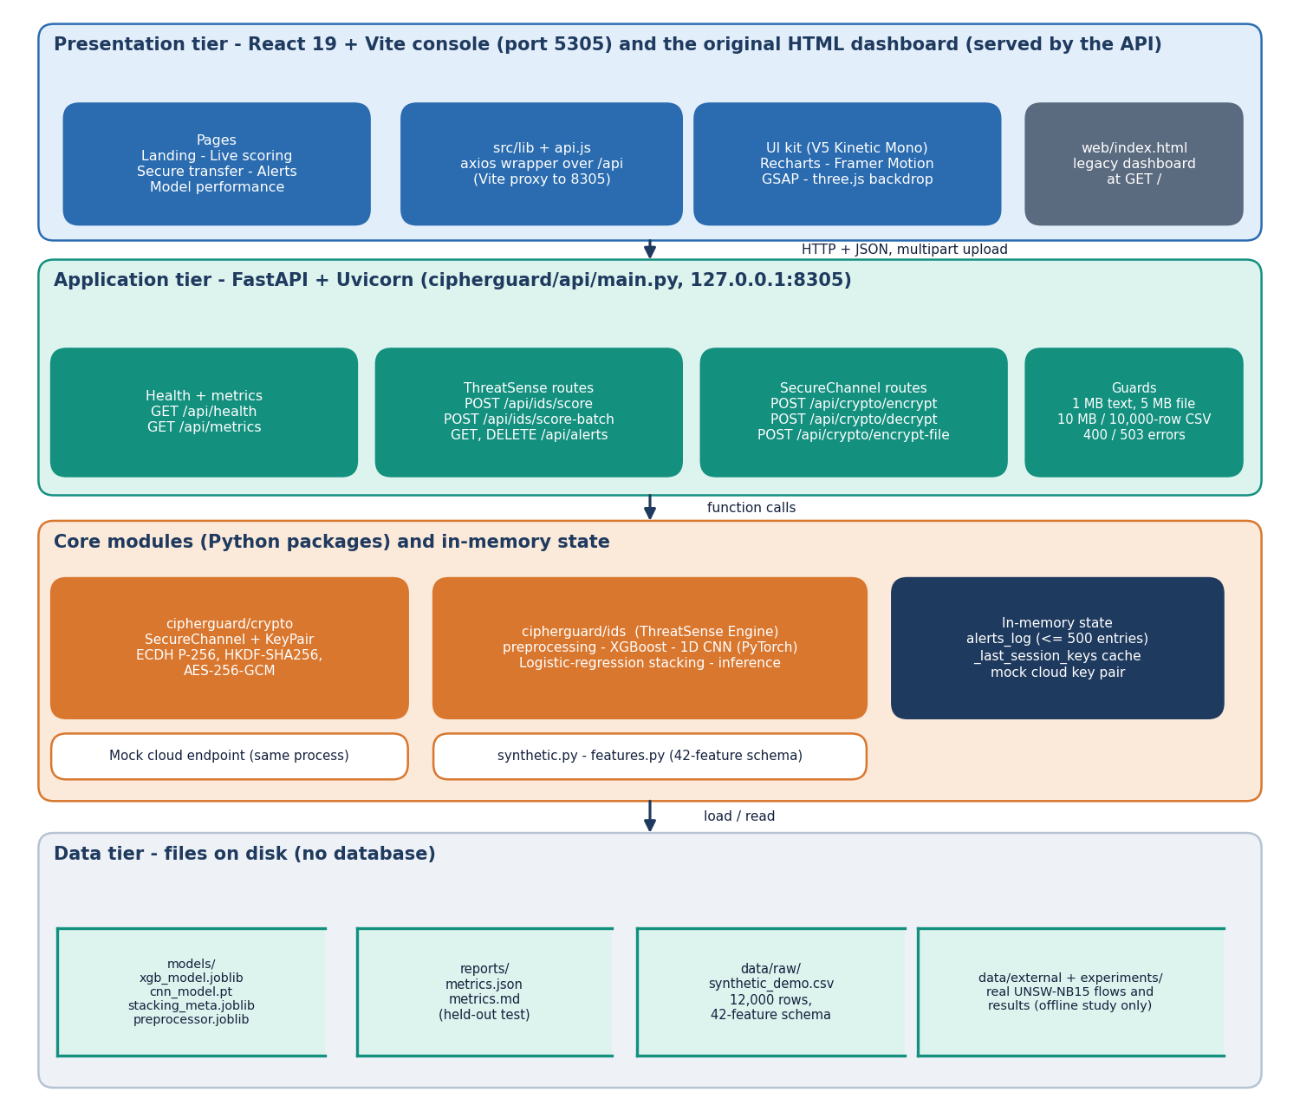
Figure 1: Four-tier architecture of CipherGuard Shield (console, FastAPI application, core packages and in-memory state, file stores).
The presentation tier is a React 19 and Vite console on port 5305, which calls the API through a Vite proxy, together with the original HTML and JavaScript dashboard that the API serves at its root path. The application tier is FastAPI on 127.0.0.1:8305, with route groups for health and metrics, ThreatSense scoring and alerts, and SecureChannel encryption and decryption. Below it sit two Python packages: cipherguard/crypto with SecureChannel and KeyPair, and cipherguard/ids with the preprocessing, training and inference code of the ThreatSense Engine. Three structures live only in process memory: the alert list, the session-key cache and the mock cloud key pair. The data tier consists of files: the model bundle in models/, the metrics report in reports/, the synthetic CSV in data/raw/, and the experiment outputs in experiments/.
The two packages do not import each other. The only place where they meet is main.py, which is a deliberate choice: the console and the tests can exercise each module alone, and the experiments in Chapter 8 time them separately and together.

5.2 High-Level Workflow
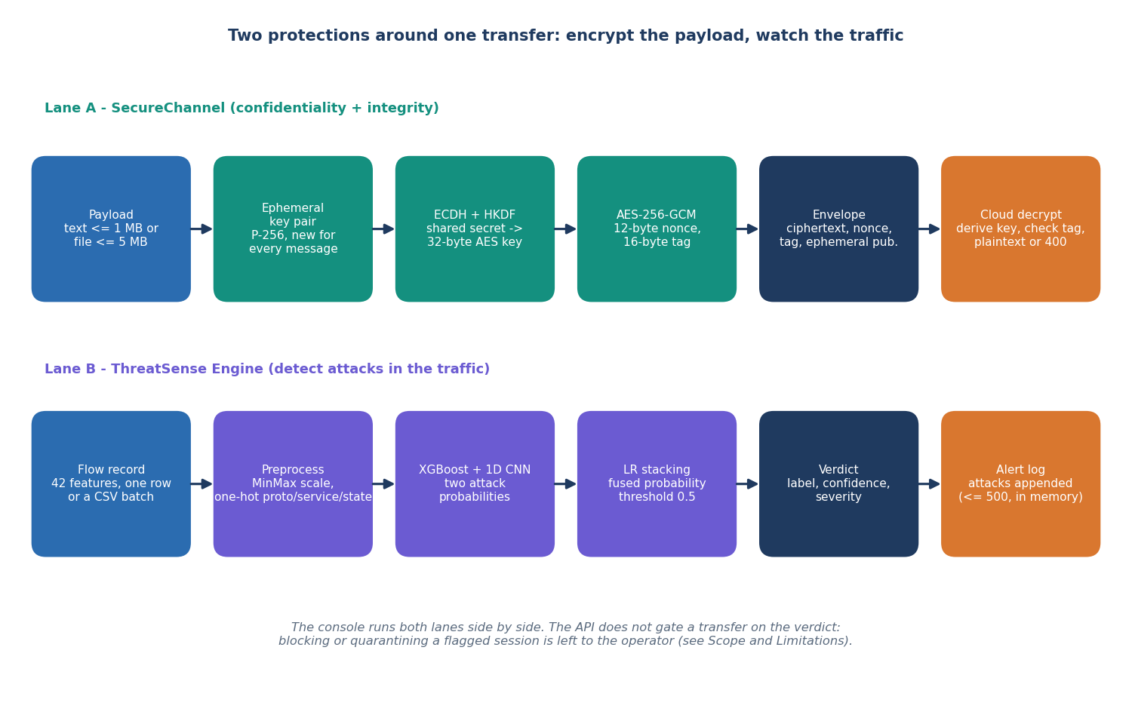
Figure 2: The two protection lanes around one transfer.
Lane A is the confidentiality path. A payload of up to 1 MB of text or 5 MB of file is encrypted with a key that only the sender and the cloud can derive, and the cloud returns the plaintext only if the 16-byte tag verifies. Lane B is the behaviour path. A flow record, or each row of a CSV, is preprocessed, scored by two models and fused into a verdict; attacks are appended to the alert log with a severity.
The two lanes are drawn side by side because that is how the console uses them. A verdict does not hold back or cancel a transfer: the API treats scoring and encryption as independent requests. Coupling a flagged session to a blocked transfer is the first item of future work. What the design does allow is measuring the cost of both lanes for one transfer, which is 5.67 ms for a 100 KB payload in process (Chapter 8).

5.3 Data Flow Diagrams

5.3.1 Level 0
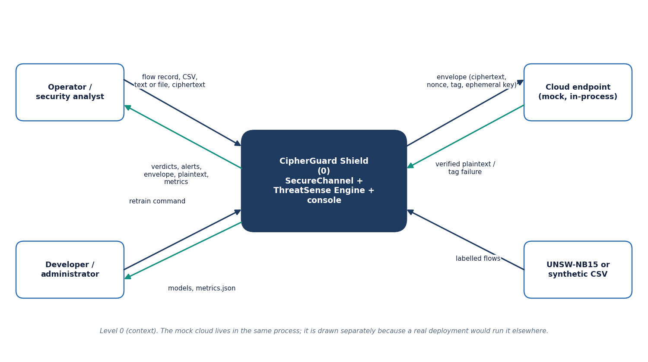  Figure 3: Data flow diagram, level 0 (context). | 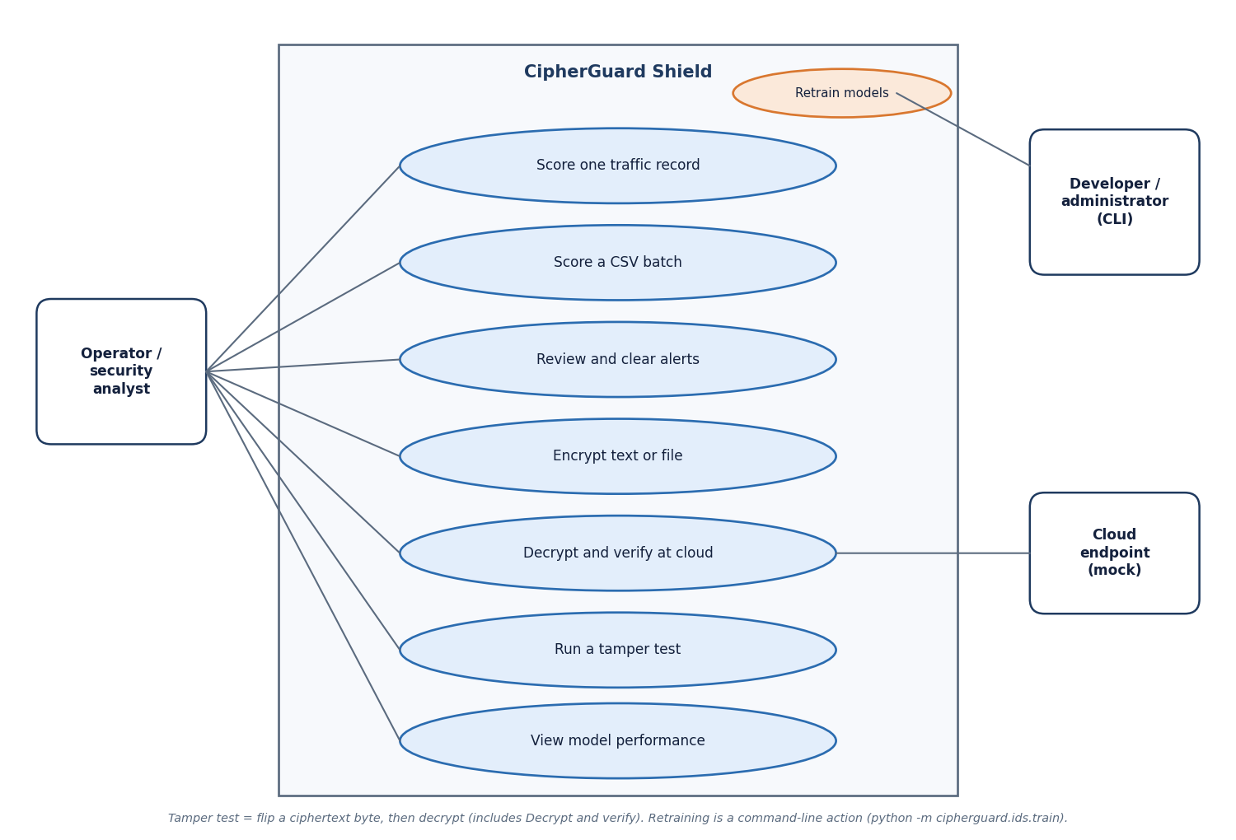  Figure 4: Use-case diagram.

At the context level CipherGuard Shield is one process with four neighbours. The operator provides flow records, CSV files, text, files and ciphertext and receives verdicts, alerts, envelopes, plaintext and metrics. The developer provides a retrain command and receives models and the metrics file. The cloud endpoint receives envelopes and answers with verified plaintext or a tag failure. The labelled-flow source, UNSW-NB15 or the synthetic CSV, is used only when training.

5.3.2 Level 1
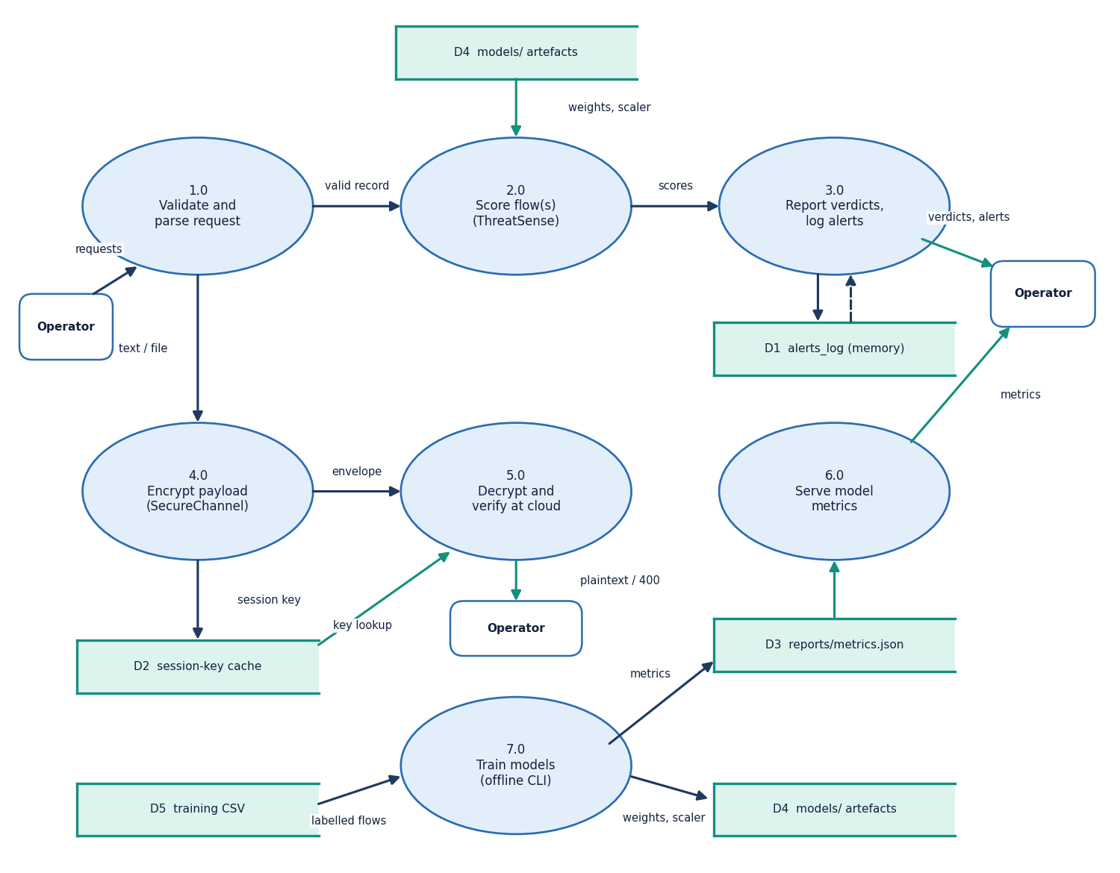
Figure 5: Data flow diagram, level 1.
Level 1 shows seven processes and five stores. Validation (1.0) routes a request either to scoring (2.0) or to encryption (4.0). Scoring reads the stored models (D4) and hands scores to reporting (3.0), which owns the alert log (D1). Encryption writes the session key to the cache (D2); decryption (5.0) reads the cache, falls back to deriving the key with the cloud private key, and answers the operator. The metrics process (6.0) reads metrics.json (D3). Training (7.0) is offline: it reads the training CSV (D5) and writes the models and the metrics file.

5.3.3 Level 2
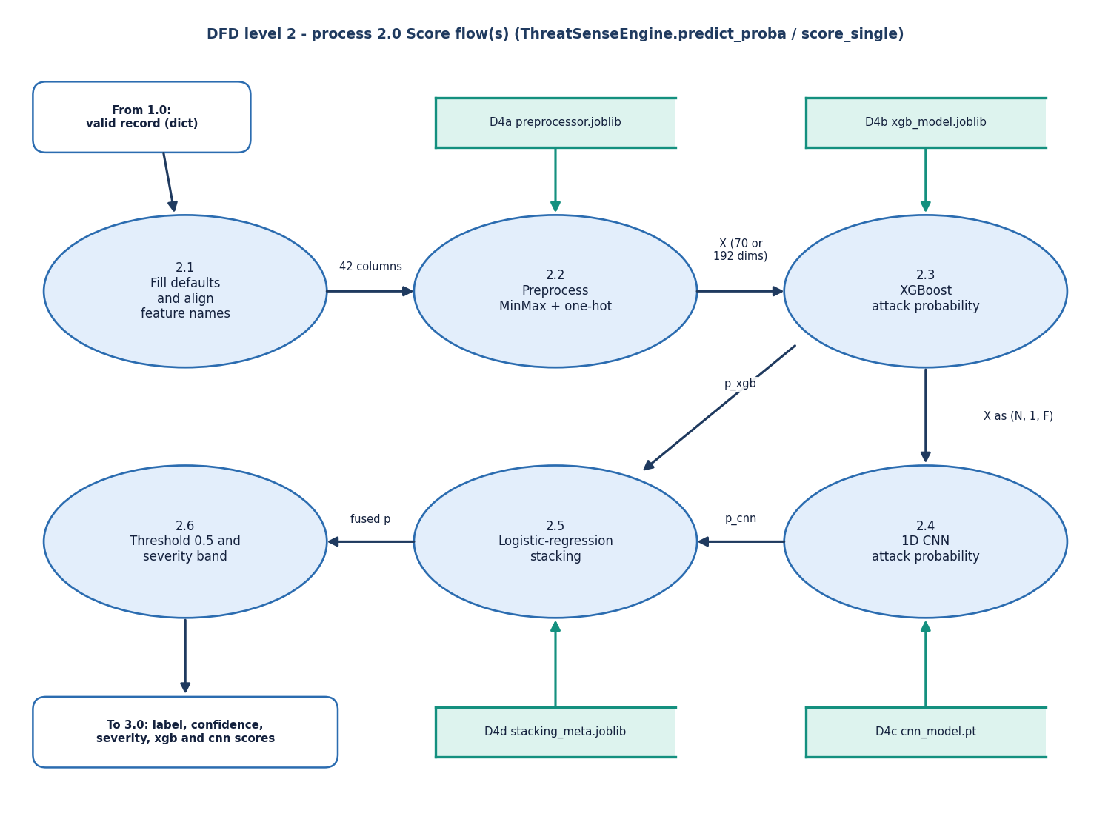
Figure 6: Data flow diagram, level 2, of the scoring process.
The scoring process has six steps. Defaults and name alignment (2.1) make any subset of the 42 features acceptable; the preprocessor (2.2) turns the record into a vector of 70 numbers for the shipped bundle or 192 for the real-data bundle; XGBoost (2.3) and the CNN (2.4) each give an attack probability; the meta-model (2.5) fuses them; and the threshold and severity step (2.6) produces the label returned to the reporting process.

5.4 UML Design

5.4.1 Class Diagram
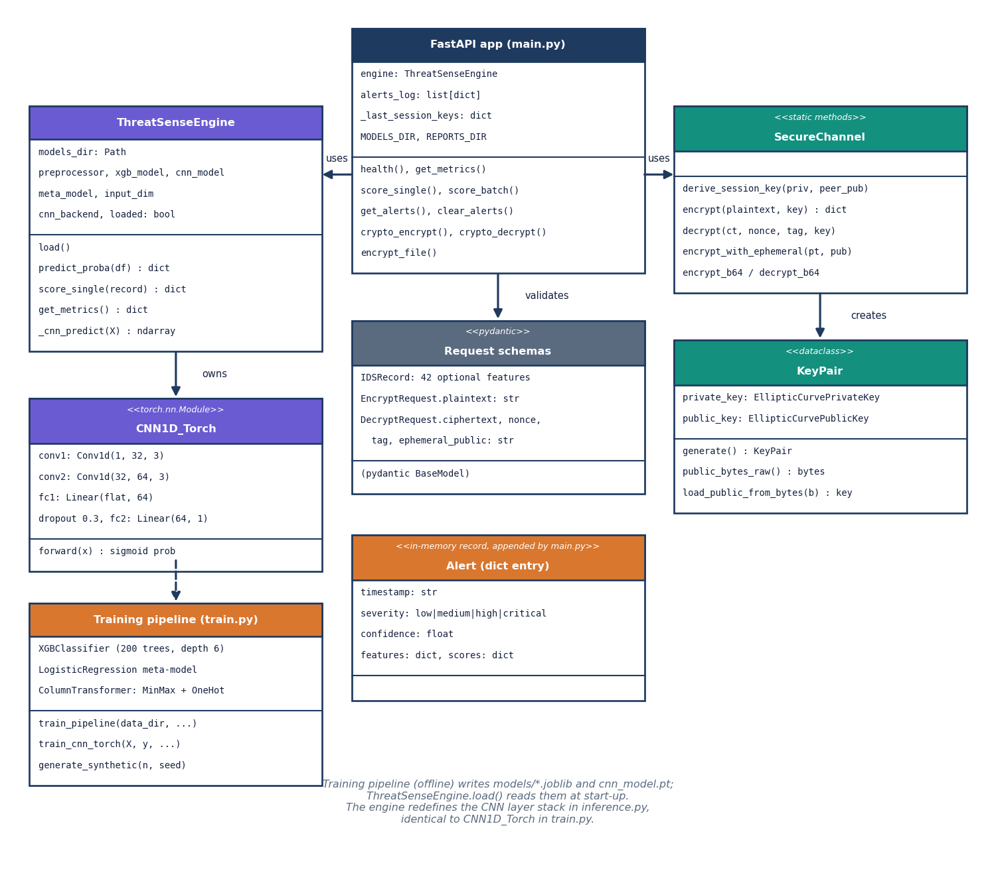
Figure 7: UML class diagram.
The FastAPI application is the only class that knows both modules. It holds a ThreatSenseEngine, the alert list and the session-key cache. ThreatSenseEngine holds the preprocessor, the XGBoost model, the CNN and the meta-model, and its score_single and predict_proba methods are the whole scoring interface. The CNN layer stack is defined twice, in train.py and in inference.py, with identical layers; this duplication keeps inference from importing the training code and its optional TensorFlow probe. SecureChannel is a set of static methods, so a key pair is the only object it creates. The Pydantic schemas validate input, and the alert is a plain dictionary.

5.4.2 Sequence Diagram
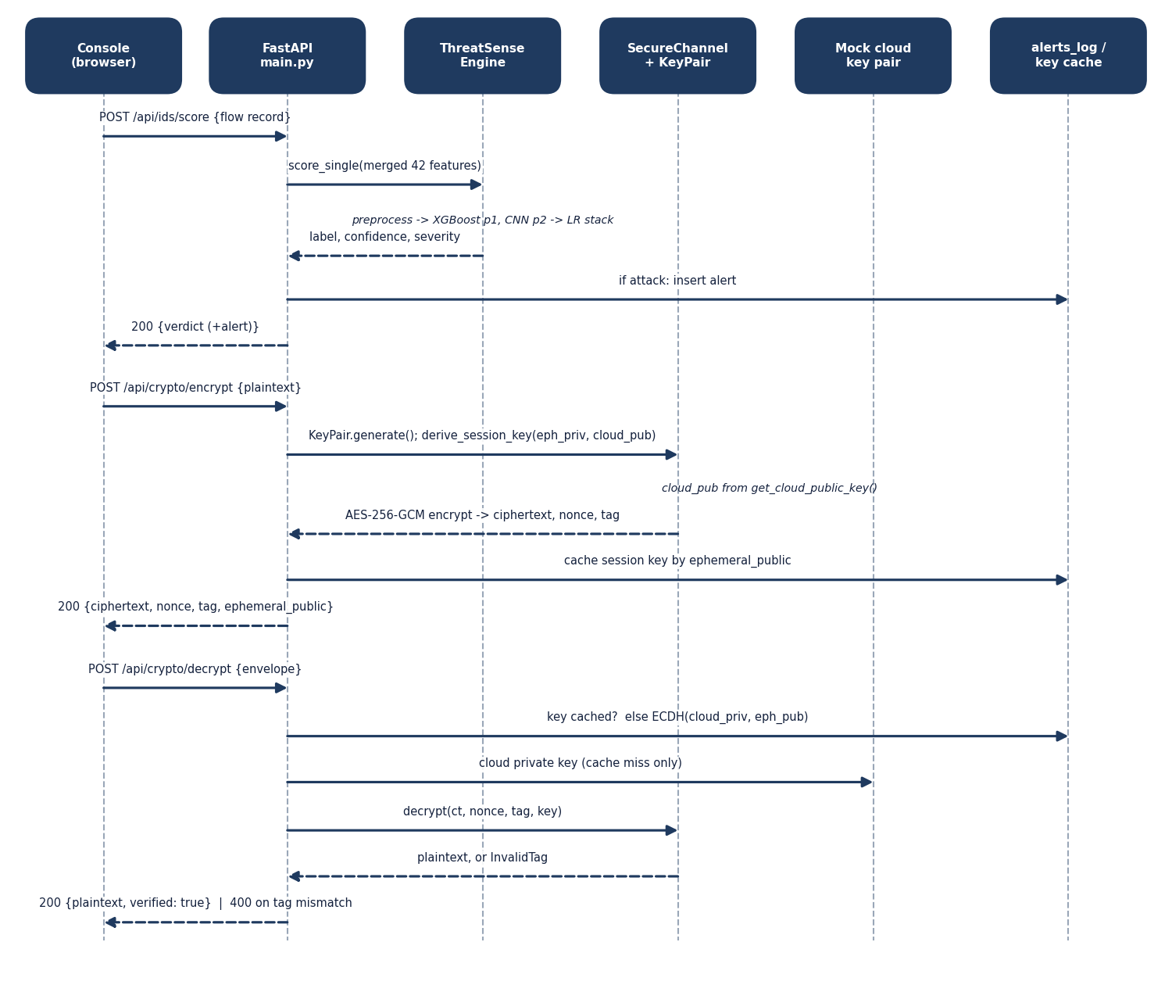
Figure 8: Sequence diagram of scoring, encryption and verified decryption.
The sequence follows three requests. Scoring ends by inserting an alert only for an attack. Encryption derives the key against the cloud public key and caches it under the ephemeral public key, a shortcut that lets the demo decrypt without the cloud's private key. Decryption uses the cache if it can; if the entry is missing, which the test suite forces by clearing the cache, it derives the key with the cloud private key, so the verification does not depend on the shortcut.

5.5 Data Design
CipherGuard Shield has no database. This is a design decision, not an omission: the demonstration needs short-lived alerts and per-process keys, and a database would add a dependency without adding a capability the experiments use. The consequence, stated in the limitations, is that alerts and keys are lost on restart. The entity-relationship diagram therefore shows logical entities and their call-time relations.
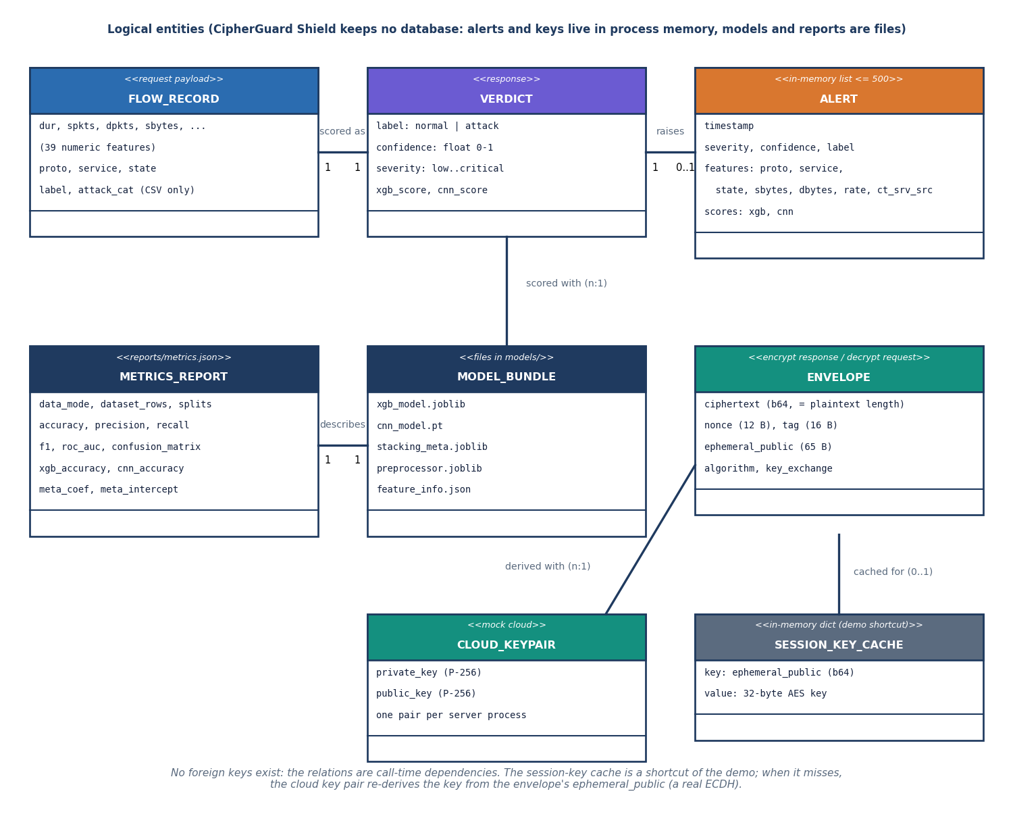
Figure 9: Logical entity-relationship diagram (no database).
Table 15: Data structures and where they live
Structure | Fields | Lives in
Flow record | 42 features: proto, service, state (text) and 39 numeric; optional label, attack_cat in CSV | request body or CSV
Verdict | label, confidence, severity, xgb_score, cnn_score (+ alert for attacks) | response
Alert entry | timestamp, severity, confidence, label, features (proto, service, state, sbytes, dbytes, rate, ct_srv_src), scores (xgb, cnn) | in-memory list, newest first, at most 500
Envelope | ciphertext (base64), nonce (12 B), tag (16 B), ephemeral_public (65 B), algorithm, key_exchange | response and request
Session-key cache | ephemeral public key (base64) to 32-byte AES key | in-memory dict
Cloud key pair | P-256 private and public key, created on first use | in-memory, one per process
Model bundle | xgb_model.joblib, cnn_model.pt, stacking_meta.joblib, preprocessor.joblib, feature_info.json | models/
Metrics report | data mode, split sizes, accuracy, precision, recall, F1, ROC-AUC, confusion matrix, per-model accuracy, meta weights, class balance | reports/metrics.json

The feature schema (cipherguard/ids/features.py) fixes 42 features in a stated order. Three are categorical: proto (six values listed for the synthetic generator), service (thirteen) and state (twelve); the real dataset has more values, which is why its encoded vector has 192 inputs instead of 70. The preprocessor's one-hot encoder is configured to ignore unseen categories, so a value that was not in the training data produces an all-zero block instead of an error.

5.6 Algorithm Design

5.6.1 SecureChannel
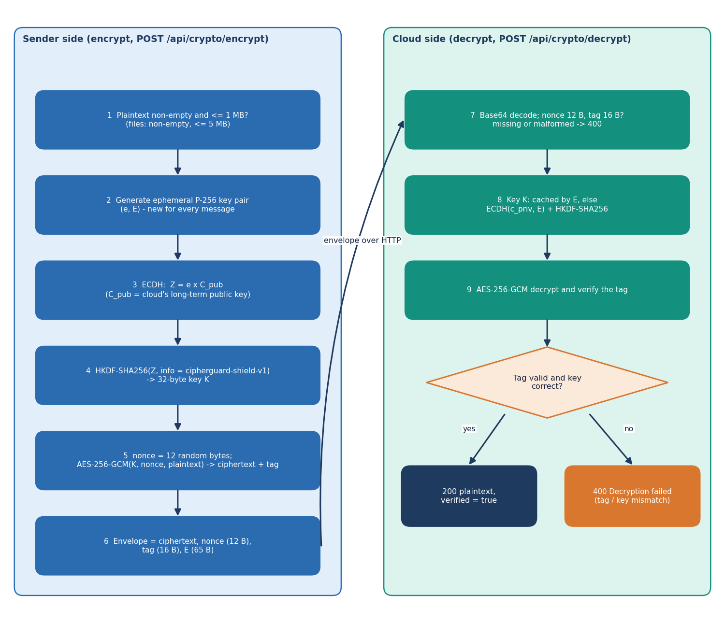
Figure 10: Flowchart of SecureChannel encryption and verified decryption.
The channel follows the standard hybrid pattern: an asymmetric step agrees a key and a symmetric authenticated cipher protects the data. With the cloud's long-term public key Q_c and the sender's fresh private key d_e, the design is:
Z = d_e · Q_c (ECDH on NIST P-256); K = HKDF-SHA256(Z, salt = none, info = "cipherguard-shield-v1", L = 32 bytes) (1)
(C, T) = AES-256-GCM-Enc_K(N, P), N = 96 random bits; P = AES-256-GCM-Dec_K(N, C, T) or reject (2)
The primitives are those specified in NIST SP 800-56A [13], RFC 5869 [14], FIPS 197 [15] and NIST SP 800-38D [12]. The cloud computes the same Z with its private key and the sender's ephemeral public key, so the sender never needs to know a secret that the cloud holds. Because every message also gets a new key, a repeated nonce would not by itself break the scheme, but the implementation still draws a random 96-bit nonce for every message; the benchmark saw 20,000 distinct nonces in 20,000 encryptions. The envelope's fixed overhead is 93 bytes.
The deviation from the batch objective is a design choice recorded here: the key agreement uses elliptic curves instead of RSA. The RSA-OAEP alternative [16] wraps a random AES key with the cloud's RSA public key; its wrapped key is 256 bytes for a 2048-bit modulus against the 65-byte ephemeral point, and the cloud pays an RSA private-key operation per message. The benchmark in Chapter 8 compares the two.

5.6.2 ThreatSense scoring
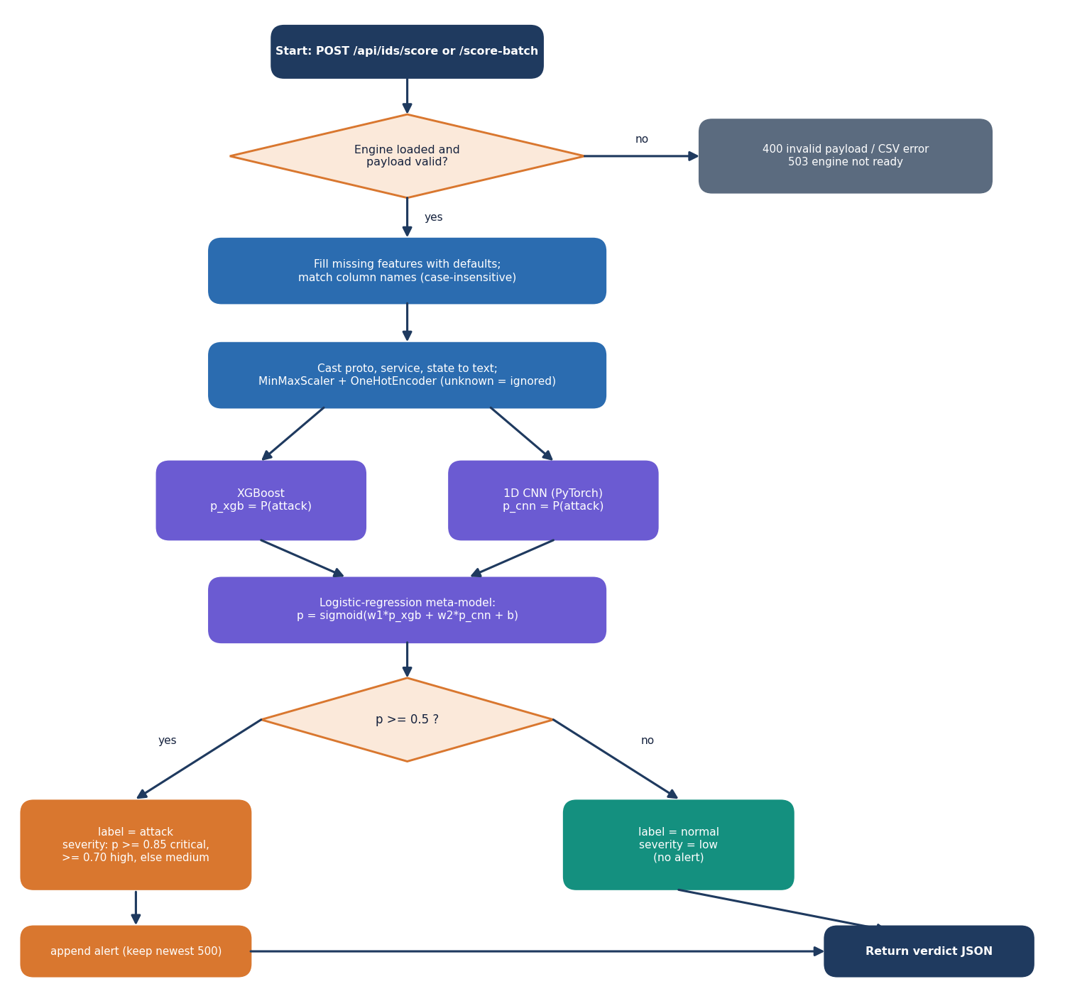
Figure 11: Flowchart of the scoring algorithm.
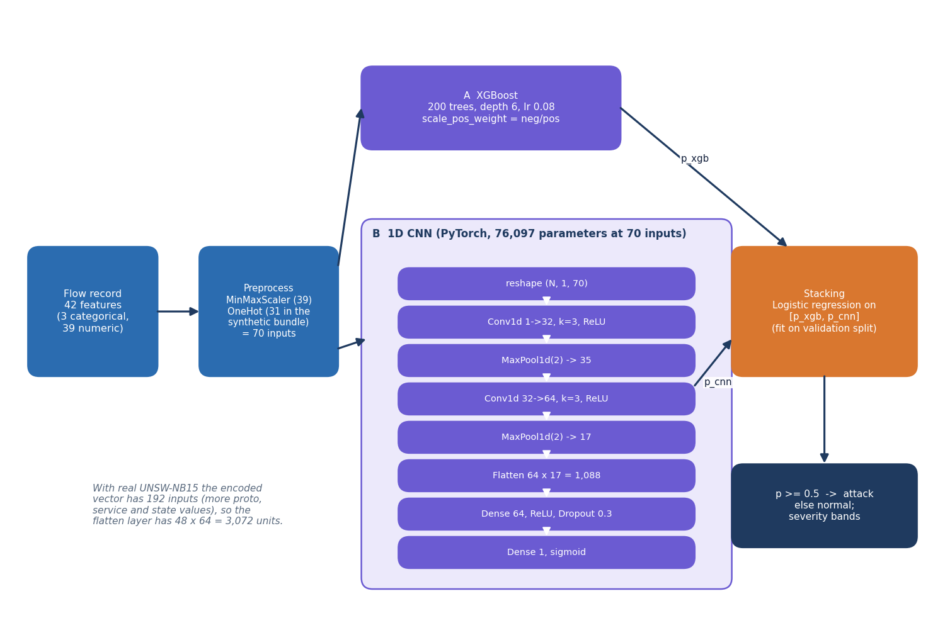
Figure 12: Architecture of the stacked detector.
Preprocessing scales each numeric feature to the range 0 to 1 with min-max normalisation, x' = (x - min) / (max - min), the same first step as the base paper [1], and one-hot encodes the three categorical features. The first model is XGBoost [9] with 200 trees, depth 6, learning rate 0.08, row and column subsampling of 0.85 and scale_pos_weight equal to the ratio of normal to attack rows. The second is a one-dimensional CNN written in PyTorch [18], trained with Adam [19] at 0.001, batch size 256, at most 15 epochs and early stopping with patience 5; it has 76,097 parameters at 70 inputs. Its loss is plain binary cross-entropy: the TensorFlow code path applies balanced class weights, the PyTorch path that actually ran does not.
The two probabilities are fused by stacking [11]: a logistic regression is fitted on the validation split and applied to the test split.
p = σ(w1 · p_xgb + w2 · p_cnn + b); label = attack if p ≥ 0.5, otherwise normal (3)
For the shipped bundle the fitted weights are w1 = 3.77 and w2 = 3.59 with b = -3.57. Severity depends only on p: critical for p ≥ 0.85, high for p ≥ 0.70, medium for any other attack, and low for normal traffic. The base paper fuses its two classifiers with a double-sigmoid median min-max normalisation (DSMMN-SLF); stacking is a simpler analogue, and the documents never call it by that name.

5.7 Module Design
Table 16: Modules, responsibilities and size
Module / file | Responsibility | Lines
cipherguard/crypto/secure_channel.py | KeyPair (P-256 generation, X9.62 encode/decode); SecureChannel: derive_session_key (ECDH + HKDF), encrypt, decrypt (length checks), encrypt_with_ephemeral, base64 helpers; module-level mock cloud key pair | 160
cipherguard/ids/features.py | 42-feature schema, categorical list, label and attack-category column names, allowed category values | 32
cipherguard/ids/preprocessing.py | ColumnTransformer (MinMaxScaler + OneHotEncoder with unknown ignored); tolerant CSV loader; label coercion | 110
cipherguard/ids/synthetic.py | synthetic UNSW-NB15-schema generator with 2.5% label noise | 127
cipherguard/ids/train.py | backend probe, XGBoost, CNN (TensorFlow or PyTorch), stacking, evaluation, artefact and report writing | 462
cipherguard/ids/inference.py | ThreatSenseEngine: load artefacts, prepare features, XGBoost + CNN + meta prediction, severity, metrics read | 186
cipherguard/api/main.py | FastAPI routes, validation, in-memory alert and key caches, static files, model and report directory settings | 382
frontend/src/ (React console) | pages, components, hooks and libraries of the console | 3,210

The modules are small and have one reason to change each. features.py is the single source of the column order that preprocessing.py, train.py, inference.py and main.py all import, so the schema cannot drift between training and serving. main.py is the only module that touches HTTP.

5.8 API Design
Table 17: HTTP interface
Method and path | Request | Response | Errors
GET /api/health | none | status, product, version, engine_loaded | -
GET /api/metrics | none | contents of reports/metrics.json | 404, 503, 500
POST /api/ids/score | JSON object with any subset of the 42 features | label, confidence, severity, xgb_score, cnn_score, alert (attacks) | 400 invalid, 503 / 500 engine
POST /api/ids/score-batch | multipart CSV, at most 10 MB and 10,000 rows | total, attack_count, normal_count, results (first 1,000 rows) | 400 non-CSV / empty / too large, 500, 503
GET /api/alerts?limit= | limit 1 to 500 | alerts (newest first), total | -
DELETE /api/alerts | none | cleared: true | -
POST /api/crypto/encrypt | JSON plaintext, non-empty, at most 1 MB | ciphertext, nonce, tag, ephemeral_public, algorithm, key_exchange, note | 400
POST /api/crypto/decrypt | ciphertext, nonce, tag, ephemeral_public | plaintext, verified | 400 bad base64, missing key, tag or key mismatch
POST /api/crypto/encrypt-file | multipart file, non-empty, at most 5 MB | filename, envelope fields, original_size, encrypted_size | 400
GET /docs, /openapi.json | none | interactive API documentation | -
GET /, /static/* | none | legacy dashboard | 404 for unknown API paths

Validation is strict and returns a meaningful status instead of a stack trace: an empty plaintext, a file of the wrong type, malformed base64 and a mismatched tag all return 400 with a message. A model that is not loaded returns 503. Request bodies are plain JSON; CORS is open to any origin because the server is bound to localhost, a setting that would have to change with any real deployment.
The two directory settings, CIPHERGUARD_MODELS_DIR and CIPHERGUARD_REPORTS_DIR, let the same API serve a different model bundle. They were added during the documentation run so that the bundle trained on real UNSW-NB15 flows could be shown in the console without replacing the shipped files.

5.9 User Interface Design
The console is a React single-page application built on a dark, monospaced design kit with a light theme as an alternative (the choice is remembered in the browser). A sidebar lists the four working screens with keyboard shortcuts, a command palette opened with the slash key jumps to any screen, and an engine badge polls the health route every five seconds. Screenshots of every screen appear in Chapter 8; this section describes their purpose.
• The scoring form exposes three selectors and twelve numeric fields and keeps the remaining 27 features in an advanced section, so that any of the 42 features can be set.
• Presets for a normal flow and an attack flow fill the form and score it, which makes the demonstration repeatable.
• The performance screen states the data mode in a banner, so a reader sees that the shipped numbers come from synthetic data.
• Errors from the API (400, 503, 500) are shown as messages and never as blank screens.

5.10 Key Design Decisions
Table 18: Decisions and their reasons
Decision | Reason | Consequence
ECDH P-256 + HKDF + AES-256-GCM, not RSA + AES | short keys, fresh key per message, one authenticated primitive | differs from objective 1; RSA hybrid benchmarked as baseline
Random 96-bit nonce per message | simple, and safe with a fresh key per message | nonce uniqueness verified over 20,000 messages
Library cryptography only | avoids implementation errors in primitives | security rests on reviewed standards, not on a new scheme
XGBoost + 1D CNN + stacking | strong tabular model, a neural model for diversity, a cheap fusion | stacking did not beat XGBoost alone on real data (Chapter 8)
Schema of 42 UNSW-NB15 features | same features for synthetic and real data | retraining on real data is a file drop
In-memory alerts and keys | no database dependency for a demonstration | state is lost on restart
Mock cloud in the same process | lets the whole channel be tested without infrastructure | no real upload; cloud key not persisted
Scoring independent of transfer | each lane testable alone | no automatic blocking of flagged sessions

5.11 Security and Error-Handling Design
The security design is described against a simple threat model, and the limits of that model are stated. The attacker considered is a party who can read and modify messages between the sender and the cloud endpoint, but who does not hold the cloud's private key. Against that attacker the channel provides confidentiality of the payload and detection of any change to the ciphertext, the nonce, the tag or the key material, because the GCM tag covers them. Replay of an old envelope is not prevented: the service has no message counter or timestamp, so a replayed envelope decrypts again. Traffic analysis is not hidden: message length equals plaintext length.
The row on forward secrecy deserves a precise reading. Each message uses a fresh sender key, so the sender's ephemeral secrets are discarded; but the cloud's long-term key pair is the other half of every ECDH exchange, so a party who later obtains it can recompute the session keys of recorded envelopes. The design therefore gives per-message key independence, not full forward secrecy; achieving the latter would need an interactive handshake with ephemeral keys on both sides, which is future work.
Errors follow one rule: a failure is reported with a status code and a short message, and the server keeps running. The decrypt route returns the same 400 status for a wrong tag and a wrong key, and its message names both causes, so a client cannot tell which one failed.

CHAPTER 6: METHODOLOGY AND SOFTWARE IMPLEMENTATION

6.1 Overall methodology
CipherGuard Shield protects one cloud data path in two independent ways. The first protection is cryptographic: the payload is encrypted before it leaves the sender with a fresh key that only the cloud can reconstruct, and any change to the ciphertext is detected on arrival. The second is statistical: network-flow records that describe the traffic are scored by a machine-learning intrusion detector, and the flows judged to be attacks are logged with a severity. The idea of putting an intrusion detector and an elliptic-curve scheme in one framework comes from the base paper [1]; the project replaces its quantum-inspired network and custom elliptic-curve scheme with components that are standard, available in open-source libraries and testable on a laptop (Section 6.4 gives the reasons). The method has six steps, and the first two belong to the cryptographic lane and the next three to the detection lane:
1. Key agreement. For every message the sender generates a new P-256 key pair and combines its private key with the cloud's long-term public key (ECDH). The shared secret is passed through HKDF-SHA256 to give a 32-byte AES key.
2. Authenticated encryption. The payload is encrypted with AES-256-GCM under a random 12-byte nonce. The result is a ciphertext of the same length as the plaintext and a 16-byte authentication tag. The sender transmits the envelope: ciphertext, nonce, tag and its ephemeral public key.
3. Flow preparation. A flow record with 42 features is completed with defaults for missing fields and transformed by the fitted preprocessor: min-max scaling of the 39 numeric features and one-hot encoding of protocol, service and state.
4. Two classifiers. XGBoost and a one-dimensional convolutional network each output the probability that the flow is an attack.
5. Stacking and decision. A logistic-regression meta-model combines the two probabilities; a probability of at least 0.5 means attack, and the severity band (medium, high, critical) follows from the probability. Attacks are appended to an in-memory alert log.
6. Cloud verification. The cloud re-derives the AES key from its private key and the envelope's ephemeral public key, decrypts, and accepts the message only if the authentication tag verifies.
Two procedures sit outside the request path. The training pipeline (cipherguard/ids/train.py) builds the shipped bundle once from a labelled table and writes the model files and reports/metrics.json. The experiment scripts added during the documentation run (scripts/run_experiments.py, benchmark_crypto.py, measure_pipeline.py) re-use the same preprocessing and model code to evaluate it on real data, to benchmark the cryptography and to time the whole pipeline. Their JSON output is the single source of every figure reported in this document.

6.2 Datasets
Three datasets are involved, and keeping them apart is essential for reading the results. The shipped model was trained on a synthetic table generated by the project; the experiments use real traffic from UNSW-NB15; and one experiment imitates the evaluation protocol of the base paper.

6.2.1 The synthetic demonstration dataset (shipped model)
When data/raw/ holds no UNSW-NB15 file, train_pipeline calls generate_synthetic (cipherguard/ids/synthetic.py) to create 12,000 rows: 6,000 normal and 6,000 attack, with the 42-feature schema of UNSW-NB15. The generator draws every numeric feature from a simple distribution whose parameters differ between the two classes. Attack flows get a longer duration (exponential with mean 1.8 s against 0.8 s), more source packets (Poisson with mean 18 plus a uniform 0 to 7 against Poisson 8), larger byte counts (log-normal with log-mean 7.2 against 6.3), a higher rate (normal with mean 45,000 against 18,000), more connection counters (ct_*) and a different mix of protocols, services and states. A few features are drawn independently of the class (window sizes, TCP base numbers, dttl), and ct_state_ttl is never assigned and is therefore 0 in every row.
After generation 2.5 % of the labels (300 of 12,000 rows) are flipped at random so that accuracy is not a perfect 1.0. The stratified 70/15/15 split gives 8,400 training, 1,800 validation and 1,800 test rows. The shipped metrics (accuracy 97.33%, F1 0.9733) are computed on that test split. Because the classes are separated by construction, the only thing that stops the model from reaching 100 % is the injected label noise, which caps accuracy at about 97.5 % if the clean classes were perfectly separable; the XGBoost model, the CNN and the stack all scored the same 97.33%, which is what a task this easy produces. A second consequence is that the attack_cat column of attack rows is drawn with an unseeded random call, so the file data/raw/synthetic_demo.csv is not reproducible bit for bit.

6.2.2 UNSW-NB15 (real traffic)
UNSW-NB15 [7, 8] was created at the Cyber Range Lab of UNSW Canberra by mixing real normal activity with synthetic contemporary attack behaviour generated by the IXIA PerfectStorm tool; 100 GB of raw traffic was captured with tcpdump, and the Argus and Bro-IDS tools and twelve further algorithms extracted flow features. The data is free for academic research with citation. This project uses the official partition: a training set of 175,341 flows (56,000 normal and 119,341 attack) and a testing set of 82,332 flows (37,000 normal and 45,332 attack, 55.06% attack). The ten traffic categories are Normal, Generic, Exploits, Fuzzers, DoS, Reconnaissance, Analysis, Backdoor, Shellcode and Worms. The 42 features used by the application are exactly the flow features of the official files; the files were obtained as the standard configuration of the Hugging Face repackaging lacg030175/UNSW-NB15 by scripts/fetch_unsw_nb15.py.
The two official files cover different capture periods, so a model trained on the first and tested on the second faces a temporal shift; accuracies obtained this way are lower than those from a random split of the same data, because near-duplicate flows cannot leak from the test set into training. The project reports the temporal protocol as its main real-data result for that reason.

6.2.3 The base paper's protocol
The base paper [1] evaluates on 9,000 flows of UNSW-NB15, balanced to 4,500 per class, split 70/15/15 and repeated ten times with averaged metrics; it does not publish which flows were drawn. The project imitates the protocol in run_paper: for each of ten seeds, 4,500 normal and 4,500 attack flows are sampled from the official training file and split into 6,300 training, 1,350 validation and 1,350 test flows. The sample is comparable in size and balance but not identical, so the comparison in Chapter 8 is indicative only.
Table 19: Datasets and splits used in this project.
Dataset | Rows | Role | Split
Synthetic demo CSV (generated) | 12,000 | Trains the shipped models | 8,400 / 1,800 / 1,800 (70/15/15)
UNSW-NB15 official training set | 175,341 | Trains the real-trained bundle | 149,039 fit / 26,302 validation (85/15)
UNSW-NB15 official testing set | 82,332 | Held-out test, never used for fitting | whole file
Paper-protocol sample | 9,000 | Imitates the base paper | 6,300 / 1,350 / 1,350, 10 repetitions

6.3 Data preparation and feature encoding
All three data paths use the same transformer, build_preprocessor() in cipherguard/ids/preprocessing.py. It is a scikit-learn ColumnTransformer [17] with two branches:
• a MinMaxScaler for the 39 numeric features (durations, packet and byte counts, rates, loads, jitter, TCP window and sequence fields, round-trip times, the ct_* connection counters and the three flag-like fields);
• a OneHotEncoder(handle_unknown="ignore") for the three categorical features proto, service and state, so that a category never seen in training produces an all-zero block instead of an error.
The encoded vector has 70 inputs for the synthetic bundle (39 numeric plus 31 one-hot columns: 6 protocols, 13 services, 12 states) and 192 inputs for the real-trained bundle, because the real files contain many more protocol values (for example unas, ospf, sctp) and service and state values. The scaler and the encoder are fitted on the training portion only; validation and test rows are only transformed, so no information from them reaches the fit.
Class imbalance is handled in two ways. XGBoost receives scale_pos_weight = n_normal / n_attack computed on the training portion (about 0.47 for the real training file, close to 1 for the synthetic one). The README states that the CNN also uses balanced loss weighting; this is true only of the TensorFlow code path, which was not the one that ran. The PyTorch path, which produced every shipped and measured result, trains the CNN with plain, unweighted binary cross-entropy (Section 6.6).

6.4 Algorithm choice and justification
Each component was chosen for a reason that can be checked, and each rejected alternative has a reason too. Table 6.1 summarises the decisions and the paragraphs below discuss the three that matter most.
Table 20: Algorithm choices and the alternatives that were not used.
Role | Chosen | Not chosen | Reason
Payload cipher | AES-256-GCM [12, 15] | AES-CBC + HMAC; ChaCha20-Poly1305 | One primitive gives confidentiality and integrity; hardware-accelerated in the library; tag failure is a single, clear error
Key agreement | ECDH on P-256 [13] | RSA key transport (objective 1); finite-field DH | Small public values (65 B), a fresh key per message at almost no cost, no padding oracle surface
Key derivation | HKDF-SHA256 [14] | Use the raw shared secret | The ECDH output is not uniformly random; HKDF turns it into a uniform 256-bit key and binds a context string
Detector A | XGBoost [9] | Single decision tree; SVM | Strong on tabular data, trains in seconds, gives calibrated-enough probabilities, handles mixed scales
Detector B | 1D CNN [10] | LSTM; quantum-inspired network | Small (76 k parameters at 70 inputs), trains on CPU, offers a different inductive bias from trees
Fusion | Logistic-regression stacking [11] | Plain average; DSMMN score-level fusion | Two learned weights are easy to inspect and to report; the base paper's DSMMN needs parameters it does not publish

6.4.1 ECDH in place of RSA
The first batch objective asked for a hybrid scheme with AES for the payload and RSA for the key exchange. The project keeps the hybrid structure (an asymmetric step to establish a key, a symmetric cipher for the data) but uses elliptic-curve Diffie-Hellman for the asymmetric step. Two properties decided it. First, because the sender creates a fresh key pair for every message, compromise of one session key reveals nothing about other messages, which RSA key transport under a long-term key does not give. Second, the public value in the envelope is 65 bytes instead of the 256 bytes of an RSA-2048 wrapped key. The cost is that the cloud-side step is an ECDH computation (about 53 microseconds including HKDF on the measurement machine). To make the substitution testable, the project benchmarks RSA-2048 and RSA-3072 with OAEP [16] and AES-256-GCM on the same machine (Chapter 7): RSA encryption is cheaper (0.029 ms against 0.122 ms at 1 KB) but RSA decryption at the cloud is dearer (0.449 ms for RSA-2048 and 1.351 ms for RSA-3072 against 0.104 ms).

6.4.2 XGBoost and a CNN, stacked
The detector is deliberately a modest ensemble of two different learners. XGBoost is the strongest standard method on tabular flow features, and it is the model that carries the result on real data. The 1D CNN treats the encoded feature vector as a short sequence; it is included because the base paper's detector is also a convolutional one and because the brief asked for a deep model. The measurements in Chapter 8 show that on the official partition the CNN alone (accuracy 0.841 ± 0.004) is worse than XGBoost (0.910 ± 0.001) and that stacking (0.890 ± 0.002) does not recover the difference. The project reports this rather than adjusting the design: stacking improves slightly on a plain average of the two probabilities and costs almost nothing, but it is not better than XGBoost alone on this data.

6.4.3 What was not reproduced from the base paper
The base paper [1] proposes an eigenvalue-decomposition-augmented quantum-inspired network, a double-sigmoid median score-level fusion (DSMMN-SLF) and an enhanced elliptic-curve encryption (EECC) whose security the authors themselves say has not been proved against the ECDLP. None of these is implemented here. The quantum-inspired network is a research model without a maintained library, the fusion has parameters that are not published, and replacing a standard, reviewed cipher by a new scheme without a security proof would lower, not raise, the protection of real data. The project's contribution is therefore a clean, measured integration of standard parts, and Chapter 8 compares its numbers with the paper's with that difference stated.

6.5 Mathematical formulation
This section states the computations that the code performs, in the order of the pipeline. Symbols are defined where they first appear.

6.5.1 Key agreement, key derivation and authenticated encryption
Let G be the base point of NIST P-256 [13] and C = c·G the cloud's long-term public key, with private scalar c. For each message the sender draws a new scalar e and sends E = e·G. Both parties can compute the same shared point:
Z = x-coordinate of ( e · C ) = x-coordinate of ( c · E ) (4)
HKDF [14] with SHA-256 first extracts a pseudo-random key from Z (no salt, so a string of zero bytes is used) and then expands it with the context string cipherguard-shield-v1 to 32 bytes:
PRK = HMAC-SHA256( salt = 0^32 , Z ) K = HKDF-Expand( PRK , info = "cipherguard-shield-v1" , L = 32 ) (5)
AES-256-GCM [12] encrypts the plaintext M under K and a random 96-bit nonce N, producing a ciphertext T of the same length and a 128-bit tag A that authenticates T (and any associated data, here none):
( T , A ) = AES-256-GCM-Enc( K , N , M ) M = AES-256-GCM-Dec( K , N , T , A ) or reject (6)
GCM computes A from a polynomial (GHASH) over the ciphertext in the field GF(2^128), masked by an AES block that depends on the nonce. Changing any bit of T, N or A, or using a different K, changes the recomputed tag and the decryption fails with an invalid-tag error, which the API turns into HTTP 400. The envelope therefore adds 93 bytes to every message: 12 (nonce) + 16 (tag) + 65 (uncompressed ephemeral point) bytes.

6.5.2 The two classifiers
XGBoost [9] builds an additive model of regression trees. With the logistic loss, the probability of attack is
p_xgb( x ) = sigmoid( sum over t = 1..200 of f_t( x ) ) sigmoid( z ) = 1 / ( 1 + e^(-z) ) (7)
The 1D CNN reads x as a one-channel sequence of length d. With ReLU activations, max pooling of width 2 and convolutions padded so that the length is preserved:
u = ReLU( W1 · flatten( p2 ) + b1 ) , u' = Dropout_0.3( u ) p_cnn( x ) = sigmoid( W2 · u' + b2 ) (8)
The flattened vector has floor(d/4) × 64 elements: 1,088 for d = 70 and 3,072 for d = 192. The number of trainable parameters is 128 + 6,208 + (floor(d/4)·64 + 1)·64 + 65, which is 76,097 for the shipped bundle (file size about 300 KB) and 203,073 for the real-trained bundle. The network is trained by minimising the binary cross-entropy with the Adam optimiser [19]:
L = -( 1 / n ) · sum_i [ y_i · ln p_i + ( 1 - y_i ) · ln( 1 - p_i ) ] (9)

6.5.3 Stacking, decision rule and severity
The meta-model is a logistic regression [11] fitted on the validation split, whose inputs are the two base probabilities:
p( x ) = sigmoid( w_1 · p_xgb( x ) + w_2 · p_cnn( x ) + b ) (10)
The fitted values of the shipped bundle are w_1 = 3.767, w_2 = 3.585 and b = -3.573: both models contribute almost equally. The decision rule and the severity band are
label = attack if p >= 0.5 else normal severity = critical if p >= 0.85 , high if p >= 0.70 , medium otherwise (attacks only); normal flows are low (11)
A threshold of 0.5 is the shipped value. Chapter 8 shows how precision, recall and the false-positive rate move when it changes, because for an operator the cost of a false alarm and the cost of a missed attack are not equal.

6.5.4 Evaluation metrics
With TP, TN, FP and FN the counts of the confusion matrix in which attack is the positive class, the reported metrics are
accuracy = ( TP + TN ) / ( TP + TN + FP + FN ) precision = TP / ( TP + FP ) recall = TP / ( TP + FN ) F1 = 2 · precision · recall / ( precision + recall ) (12)
FPR = FP / ( FP + TN ) FNR = FN / ( FN + TP ) MCC = ( TP·TN - FP·FN ) / sqrt( ( TP+FP )( TP+FN )( TN+FP )( TN+FN ) ) (13)
ROC-AUC is the area under the curve of recall against FPR over all thresholds. When several seeds are run the tables report the mean and the sample standard deviation (n - 1 in the denominator).

6.6 Model architecture and training
Figure 13: Architecture of the ThreatSense Engine: preprocessing, XGBoost, the 1D CNN and the stacking meta-model.

6.6.1 Training configuration
Table 21: Training configuration shared by the shipped bundle and the experiments.
Component | Setting
XGBoost | 200 trees, max depth 6, learning rate 0.08, subsample 0.85, column sample 0.85, scale_pos_weight = n_normal / n_attack, logloss, seed from the run
1D CNN | Conv1d 1-32 (k 3) - MaxPool 2 - Conv1d 32-64 (k 3) - MaxPool 2 - Linear 64 - Dropout 0.3 - Linear 1 - sigmoid; 76,097 parameters at 70 inputs
CNN training | Adam, learning rate 0.001, batch 256, at most 15 epochs, early stopping on validation loss (patience 5, minimum gain 0.0001), best weights restored, plain BCE loss (no class weights)
Meta-model | scikit-learn LogisticRegression with default regularisation, fitted on the validation split's [p_xgb, p_cnn]
Split | Stratified; shipped: 70/15/15 (seed 42); official partition: training file split 85/15 into fit and validation, testing file untouched
Decision | Threshold 0.5 on the stacked probability
Hardware | Intel Core i5-12500 (6 cores / 12 threads), 15.7 GB RAM, Windows 11, CPU only; Python 3.11.9, PyTorch 2.14.1 (CPU), XGBoost 2.0.3, scikit-learn 1.5.0

Training is cheap. On the official partition (149,039 fit rows) XGBoost trains in 4.4 s and the CNN in 246 s on the shared CPU used for the measurements; the meta-model takes milliseconds. The README gives 30 to 60 seconds for building the shipped bundle from the synthetic table, which is what run.bat does on first start when models/ is empty.

6.6.2 Experimental protocol
The experiment script scripts/run_experiments.py imports the shipped code rather than re-implementing it: the preprocessor, the XGBoost settings, train_cnn_torch and the logistic meta-model are the same objects. For the official partition it runs five seeds (42 to 46). A seed controls the stratified 85/15 split of the training file and the initialisation of the CNN and XGBoost; the official testing file (82,332 flows) is scored once per seed and never used for fitting, early stopping or the meta-model. Besides the three project models the script trains four reference models on the same data, so that the ensemble can be judged against simpler alternatives: the plain mean of the two probabilities, a logistic regression, a decision tree (depth 12) and a random forest (100 trees, depth 16). For seed 42 it additionally records the threshold sweep, the detection rate per attack category, the ROC curves, the XGBoost feature importance (gain) and in-process inference times.
For the paper protocol it repeats the whole procedure for ten seeds on the balanced 9,000-flow samples described in Section 6.2.3. For the domain-shift study it scores the 82,332 real test flows with the shipped synthetic-trained bundle, scores fresh synthetic data (seed 7, 6,000 rows) with the same bundle, and scores the synthetic demo CSV with the real-trained models. The seed-42 models are also exported as a bundle that the API can serve (scripts/make_real_bundle.py, Section 6.10).

6.6.3 Two implementation details that affect interpretation
• Unweighted CNN loss. The README describes balanced loss weighting for the CNN. The PyTorch training function uses nn.BCELoss() with no weights; the weighted loss exists only in the TensorFlow function. On the real data this probably contributes to the CNN's high recall (0.99) and high false-positive rate, because the majority class in the training file is attack.
• Stacking on the validation split. The meta-model is fitted on 15 % of the training period. It therefore learns how well the two models agree with the labels in that period; on the later testing period the CNN is less reliable than the weights suggest, which is why the stack is not better than XGBoost alone on the official partition.

6.7 Application architecture
CipherGuard Shield is a single Python process behind a web interface. The browser tier is a React 19 console built with Vite and Tailwind (screens: landing page, live scoring, secure transfer, alerts, model performance) that calls the API through axios and a Vite proxy; the original plain HTML and JavaScript dashboard in web/ is still served by the API at /. The application tier is a FastAPI application (cipherguard/api/main.py, 382 lines) served by Uvicorn on 127.0.0.1:8305. It delegates to two packages: cipherguard/crypto with the SecureChannel and KeyPair classes, and cipherguard/ids with the preprocessing, the training code and the ThreatSenseEngine that loads the model files and scores records.
State is kept in three places and nowhere else. The model files in models/ and the report in reports/ are read at start-up. The alert log is a Python list of at most 500 entries, newest first, lost when the process stops. The cloud's key pair is generated on first use and lives for the lifetime of the process, as does a dictionary that caches session keys by ephemeral public key; this is a shortcut of the demonstration, and when the cache misses (for example for an envelope created before a restart of the cache) the API re-derives the key from the cloud private key and the envelope's ephemeral public key, which is the real protocol. There is no database.

6.8 API design
The API is JSON over HTTP, plus two multipart upload routes. Table 6.3 lists every route; the interactive Swagger page at /docs documents the same contract.
Table 22: API routes of CipherGuard Shield.
Method and path | Request | Success response | Errors
GET /api/health | - | status, product, version, engine_loaded | -
GET /api/metrics | - | contents of reports/metrics.json | 404 not found, 503 engine
POST /api/ids/score | JSON object with any subset of the 42 features | label, confidence, severity, xgb_score, cnn_score, alert (attacks only) | 400 invalid record, 503 / 500 engine
POST /api/ids/score-batch | multipart CSV, at most 10 MB and 10,000 rows | total, attack_count, normal_count, results (first 1,000 rows) | 400 not CSV / empty / too large / unparsable
GET /api/alerts?limit= | limit 1 to 500 (default 100) | alerts (newest first), total | -
DELETE /api/alerts | - | cleared: true | -
POST /api/crypto/encrypt | plaintext (1 byte to 1 MB) | ciphertext, nonce, tag, ephemeral_public (all base64), algorithm, key_exchange | 400 empty or too large
POST /api/crypto/decrypt | ciphertext, nonce, tag, ephemeral_public | plaintext, verified: true | 400 bad base64, missing key, tag or key mismatch
POST /api/crypto/encrypt-file | multipart file, 1 byte to 5 MB | filename, envelope fields, original_size, encrypted_size | 400 missing, empty or too large

The score route accepts any subset of the 42 features. The server fills the rest with defaults defined in the IDSRecord model, overlays the supplied values, and passes the 42-field record to the engine; if the verdict is attack the route builds an alert entry (timestamp, severity, confidence, the protocol, service, state, source and destination bytes, rate and ct_srv_src, and the two model scores), inserts it at the head of the list and returns it with the verdict. The batch route scores a CSV in one vectorised call and adds one alert per attack row.

6.9 Security and error handling

6.9.1 What the design protects
• Confidentiality. Each message is encrypted under its own 256-bit key. Nonces come from the operating system's random source (os.urandom); in 20,000 encryptions the benchmark observed 20,000 distinct nonces and 20,000 distinct ciphertexts for one repeated plaintext.
• Integrity and authenticity of the ciphertext. GCM's tag covers the ciphertext; flipping a single bit of the ciphertext, the tag or the nonce, truncating the ciphertext, or decrypting with another party's key was rejected in every one of 1,000 trials per case.
• Fresh key per message. The sender code creates a new ephemeral key pair for every message and does not store its private part, so the keys of different messages are independent. The demonstration API does keep each derived session key in an in-memory cache (see below), which weakens this property for the lifetime of the process.
• Input limits. Plaintext 1 MB, files 5 MB, CSV 10 MB and 10,000 rows, empty inputs refused, a CSV extension required; malformed base64 and wrong-length fields produce HTTP 400 with a message, never a stack trace.

6.9.2 What it does not protect
• The cloud is a mock. The key pair is created inside the same process and is never written to disk, so there is no key storage, rotation or revocation, and the session-key cache holds every session key in memory for the lifetime of the process.
• No authentication or authorisation. Any client that can reach the port can encrypt, decrypt and clear alerts. CORS is set to *. The server binds to 127.0.0.1 by default, which is the only access control.
• No transport security. The service speaks plain HTTP on the loopback interface; a real deployment needs TLS, and the ECDH step does not authenticate the sender (an active attacker could substitute its own ephemeral key).
• Detection is advisory. The verdict does not block a transfer; the console runs the two lanes side by side and the operator decides.
• The detector can be evaded. No adversarial testing was done, and the model's strongest feature on real data (sttl) is an attribute of the testbed that an attacker can set freely.

6.10 Installation and execution
The product is run in one of three ways; the complete step-by-step guide is Appendix B and HOW_TO_RUN.md.
1. run.bat (Windows). Creates a virtual environment, installs requirements.txt (FastAPI, Uvicorn, cryptography, XGBoost, scikit-learn, PyTorch, pandas), trains the models if models/ is empty, installs the React dependencies with npm install, starts the API on 8305 and the console on 5305 and opens the browser.
2. Manual. pip install -r requirements.txt, then python -m uvicorn cipherguard.api.main:app --host 127.0.0.1 --port 8305, and in frontend/ npm install and npm run dev.
3. Docker. run-docker.bat builds the image from the Dockerfile and maps container port 8000; this path was not exercised in the documentation run.
Loading the shipped models takes about 112 ms on the measurement machine, so the API is ready a second or two after start-up. Ports and host come from .env (BACKEND_PORT, FRONTEND_PORT).
Three additions of the documentation run are part of the execution story. python scripts/fetch_unsw_nb15.py downloads the official training and testing files (about 19 MB) into data/external/ (ignored by git). python scripts/run_experiments.py [official] [paper] [shift] reproduces the experiments (about 25 minutes on the measurement machine). python scripts/make_real_bundle.py turns the seed-42 models into a bundle the API can serve; the bundle is selected with two environment variables:
set CIPHERGUARD_MODELS_DIR=experiments\unsw_nb15\official\models
set CIPHERGUARD_REPORTS_DIR=experiments\unsw_nb15\official\reports
python scripts\serve.py

With these variables unset, the API serves the shipped synthetic-trained bundle. scripts/serve.py imports PyTorch before anything else: on the Windows machine used here, PyTorch's DLLs fail to initialise (error 1114) when NumPy or pandas have already been imported, so the launcher and the test configuration (tests/conftest.py) import it first. The run.bat environment, which pins PyTorch 2.2.0, was not re-run.

CHAPTER 7: SYSTEM TESTING

7.1 Testing strategy
The project had no separate test phase in its first delivery: it shipped with one end-to-end smoke script and a screenshot walk. The documentation run added an automated test suite and a set of measurement scripts, and this chapter reports what they show. The strategy follows the structure of the product. The cryptography is a small, deterministic component with a clear specification, so it is tested exhaustively at unit level and then attacked with systematic tampering. The intrusion detector is a statistical component, so it is tested in two different ways: its software behaviour (loading, shapes, probabilities, unseen categories) by unit tests, and its predictive quality by the multi-seed experiments of Chapter 8. The API ties the two together and is tested through FastAPI's test client and through a smoke script against a running server. Screens are checked by walking every route of the console with real data.
Table 23: Test levels, tools and results.
Level | Tool and scope | Count | Result
Unit | pytest: tests/test_crypto.py, tests/test_ids_engine.py | 16 tests | All passed
API / component | pytest with FastAPI TestClient: tests/test_api.py | 10 tests | All passed
Integration | scripts/smoke_test.py against the running backend (127.0.0.1:8305) | 15 checks | 15 of 15 passed
Functional / screens | Playwright walk of the React console, screenshots 01 to 12 | 12 screens | All rendered with real data
Security | scripts/benchmark_crypto.py tamper and uniqueness tests | 6 cases x 1,000 trials; 20,000 encryptions | As expected in every trial
Performance | scripts/benchmark_crypto.py and measure_pipeline.py | 5 payload sizes; 7 API calls | Reported in Section 7.7
Model validation | scripts/run_experiments.py (5 + 10 seeds) | 15 runs on real data | Reported in Chapter 8

All tests were run on one machine: Intel Core i5-12500 (6 cores, 12 threads), 15.7 GB RAM shared with other running programs, Windows 11, Python 3.11.9, PyTorch 2.14.1 (CPU), XGBoost 2.0.3 and scikit-learn 1.5.0. The pytest suite finished in 2.9 s. Timings in Section 7.7 are medians of repeated runs on this shared machine and should be read as indicative.

7.2 Unit testing
The pytest suite has 26 tests in three files, and all 26 passed. The file tests/conftest.py imports PyTorch before anything else, because on the test machine PyTorch's DLLs fail to initialise if NumPy or pandas are loaded first.

7.2.1 SecureChannel (tests/test_crypto.py, 10 tests)
Table 24: Unit tests of the cryptography.
Test | What it asserts
test_both_sides_derive_the_same_key | ECDH from either side gives the same 32-byte key
test_round_trip | Decrypting an ephemeral-key envelope returns the plaintext; the ciphertext differs from the plaintext
test_sizes_of_nonce_tag_and_point | Nonce 12 bytes, tag 16 bytes, ephemeral public point 65 bytes, ciphertext as long as the plaintext (100 bytes)
test_same_plaintext_gives_different_ciphertext | Two encryptions of the same text differ in ciphertext, nonce and ephemeral key
test_any_flipped_bit_is_rejected (3 cases) | A flipped bit in the ciphertext, in the tag or in the nonce raises InvalidTag
test_wrong_key_is_rejected | A random 32-byte key cannot decrypt a valid envelope
test_bad_parameter_lengths_are_refused | A short key, an 11-byte nonce and a 15-byte tag raise ValueError
test_empty_and_large_payloads | Empty, one-byte and 5 MB payloads all round-trip

7.2.2 ThreatSense Engine (tests/test_ids_engine.py, 6 tests)
Table 25: Unit tests of the detection engine (shipped bundle).
Test | What it asserts
test_engine_loads_all_artifacts | Engine is loaded, uses the torch backend and has 70 input dimensions
test_attack_and_normal_presets | The attack preset is classified attack with severity medium, high or critical; the normal preset is normal with severity low
test_scores_are_probabilities | Confidence, XGBoost score and CNN score all lie in [0, 1]
test_batch_matches_single | A two-row batch gives the labels [attack, normal] and the same probability as the single-record call
test_unseen_category_does_not_crash | A never-seen protocol, service and state still gives a label
test_shipped_metrics_file_is_consistent | The confusion matrix of reports/metrics.json sums to the test size and reproduces the stored accuracy

7.2.3 API (tests/test_api.py, 10 tests)
The ten API tests (tests/test_api.py, via FastAPI's TestClient) check health and metrics; that a normal flow raises no alert while an attack flow does and DELETE clears the list; that an empty record, a non-CSV upload and an empty CSV give 400; the 120-row batch; the encrypt-decrypt round trip, including the path that re-derives the key with the cloud private key when the session-key cache is empty; rejection of a tampered ciphertext; 400 for empty plaintext, invalid base64 and a missing ephemeral key; and the file round trip with an empty file and a file of 5 MB + 1 byte refused.

7.3 Integration testing
scripts/smoke_test.py drives a running backend over HTTP exactly as the console does. It was run against the shipped bundle on port 8305 and all 15 of 15 checks passed (log in docs/metrics/smoke_run.txt). The checks cross the module boundaries: the API with the engine (checks 2 to 8), the API with the SecureChannel (10 to 15) and the alert log with the scorer (8 and 9). The script has a --frontend option that repeats the checks through the Vite proxy; that option was not run in the final pass because the React server was started separately for the screenshots.
The fifteen checks are: health; engine loaded; metrics; attack preset scored attack; normal preset scored normal; the 120-row sample batch (60 attacks, 60 normal); non-CSV upload rejected; alerts present; alerts cleared; encrypt with 12-byte nonce and 16-byte tag; decrypt round trip; tampered ciphertext rejected; empty plaintext rejected; file encryption size; file decrypt round trip.

7.4 Functional testing
Functional testing walked every route of the React console with real data, using Playwright with 1440 x 900 pixel windows (scripts/capture_screens.py for screens 01 to 09 and scripts/capture_real_screens.py for 10 to 12). The walk clicked the real buttons (Simulate attack, Use sample, Encrypt and transmit, Decrypt and verify, Tamper ciphertext), waited for the server's answers and saved a screenshot. It also collected browser console errors, page errors and failed requests; the only failed request is the intentional HTTP 400 of the tamper test. Screens 03 to 12 show states that can only occur if the corresponding API call succeeded, so the screenshots double as evidence of the functional test.
Table 26: Functional checks by screen.
Screen | Function | Observed result
01, 02 | Landing page, dark and light themes | Page loads, live counters animate, terminal calls the API
03 | Live scoring: attack preset | Verdict ATTACK, severity HIGH, ensemble probability 0.84 (XGBoost 0.45, CNN 1.00)
04, 05 | Batch scoring and session charts | 120-row sample scored; per-row table, attack-versus-normal chart
06 | Secure transfer, verified | Encrypt shows ciphertext, nonce, tag and ephemeral key; decrypt shows verified plaintext
07 | Secure transfer, tampered | After altering the ciphertext the decrypt is rejected (tag failure)
08 | Alerts | Alerts from the batch are listed with severity, confidence and scores
09 | Model performance, shipped bundle | 97.33 % on synthetic data, banner "synthetic demo data", confusion matrix
10 | Real flows, shipped model | 120 real UNSW-NB15 flows: the shipped model agrees with the labels on 78 of 120 (65.0 %)
11 | Model performance, real-trained bundle | 88.79 % on the 82,332 official test flows, confusion matrix, 192 input dimensions
12 | Real flows, real-trained bundle | Same 120 flows: agreement 101 of 120 (84.2 %)

7.5 Security testing
The security tests are attacks on the envelope that a network adversary or a faulty client could mount. Each was repeated 1,000 times with fresh messages and random positions (tamper_tests in scripts/benchmark_crypto.py), so that a position-dependent weakness would have shown up. The untouched message is the control: it must be accepted.
Table 27: Tamper tests on the SecureChannel (1,000 trials each).
Case | Expected | Observed | Result
Untouched message accepted | accepted | 1,000 of 1,000 | Pass
Ciphertext bit flipped | rejected | 1,000 of 1,000 | Pass
Tag bit flipped | rejected | 1,000 of 1,000 | Pass
Nonce bit flipped | rejected | 1,000 of 1,000 | Pass
Ciphertext truncated by one byte | rejected | 1,000 of 1,000 | Pass
Decrypted with another party's key | rejected | 1,000 of 1,000 | Pass

A second test checks for nonce reuse, which is the one way to break GCM badly: 20,000 encryptions of one identical plaintext produced 20,000 distinct nonces and 20,000 distinct ciphertexts. Input validation was tested through the API: empty plaintext, empty file, a file of 5 MB + 1 byte, invalid base64, a missing ephemeral key, a non-CSV upload and an empty CSV all produced HTTP 400 and none produced a server error.
What the security testing does not establish matters as much. It does not show that the cryptography library is free of defects (it relies on the cryptography package), that the key derivation is used correctly beyond the tests above, or that the service is safe to expose: the API has no authentication, CORS is open (*), the transport is plain HTTP on the loopback interface, the cloud key pair and all session keys live in process memory, and no fuzzing, penetration test or dependency audit was run. The adversary model of the tests is the network attacker who modifies a message in transit; an adversary who can call the API, or read the process memory, is out of scope.

7.6 Validation and edge cases
Validation asks whether the system behaves sensibly at the edges of its input space. The table separates what was actually exercised from what the code promises but no test checks.
Table 28: Edge cases and how they were checked.
Case | Behaviour | Checked by
Category never seen in training (protocol, service, state) | Scored without error; the one-hot block is all zeros | test_unseen_category_does_not_crash
Record with only a few features | Missing features take the documented defaults | Smoke and API tests (partial records)
Empty JSON object | 400 | test_score_rejects_empty_payload
Non-CSV or empty CSV upload | 400 | test_batch_scoring_and_validation; smoke check 7
Empty plaintext, empty file | 400 | test_crypto_input_validation; test_file_encryption_...; smoke check 13
File of 5 MB + 1 byte | 400 | test_file_encryption_round_trip_and_limits
Payload of 5 MB, 1 byte, 0 bytes (library level) | Round-trip succeeds | test_empty_and_large_payloads
Invalid base64, missing ephemeral key | 400 | test_crypto_input_validation
Session-key cache empty | Real ECDH with the cloud private key | test_decrypt_uses_cloud_private_key_when_cache_is_empty
Real flows instead of synthetic | Scores, but quality depends on the training data (Chapter 8) | Experiments; screens 10 to 12
CSV with 10,001 rows, CSV above 10 MB, plaintext above 1 MB | Specified as 400 | Not tested (limits are in the code only)
Concurrent requests, very long sessions | Not specified | Not tested

Model validation, the other kind of validation, is done by repetition rather than by single runs. The official-partition experiment was run with five seeds and the base-paper protocol with ten, so that every reported metric has a standard deviation; for example the stacked model's accuracy on the official test set is 0.890 ± 0.002 and its ROC-AUC 0.9843 ± 0.0003. The test set is never used for fitting, early stopping or the meta-model. A deliberate weakness of the validation is that the threshold analysis of Chapter 8 was computed on the test set; it describes the trade-off and is not a tuned result.

7.7 Performance testing

7.7.1 Cryptography
Each operation was timed with a high-resolution clock on payloads of 1 KB to 5 MB, 300 repetitions for payloads up to 100 KB and 40 or 15 for the larger ones; the table gives medians. SecureChannel includes everything the API does for one message: ephemeral key generation, ECDH, HKDF, AES-GCM and the base64 encoding that the API needs. The comparison columns are AES-256-GCM alone (no key agreement, no base64) and a classical RSA-OAEP key wrap plus AES-GCM, which the project did not adopt but measured as the baseline for objective 1.
Table 29: Median encryption and decryption time in milliseconds by payload size.
Payload | SecureChannel enc | SecureChannel dec | AES-GCM only enc / dec | RSA-2048 + AES enc / dec | RSA-3072 + AES enc / dec
1 KB | 0.122 | 0.104 | 0.008 / 0.008 | 0.029 / 0.449 | 0.044 / 1.351
10 KB | 0.145 | 0.116 | 0.009 / 0.009 | 0.032 / 0.443 | 0.046 / 1.458
100 KB | 0.510 | 0.302 | 0.026 / 0.026 | 0.050 / 0.471 | 0.065 / 1.442
1 MB | 4.263 | 2.990 | 0.787 / 0.797 | 0.811 / 1.230 | 0.970 / 2.236
5 MB | 21.4 | 14.2 | 3.895 / 3.327 | 3.774 / 3.695 | 3.806 / 4.699

Three observations follow. First, for payloads up to 100 KB every SecureChannel operation takes well under one millisecond (0.510 ms to encrypt 100 KB). Second, at 1 MB and above SecureChannel is several times slower than raw AES-GCM (21.4 ms against 3.895 ms for 5 MB) because it also base64-encodes the data, a cost of the demonstration API format and not of the cipher; its throughput is about 234 MB/s against 1,284 MB/s for AES-GCM alone. Third, the asymmetric step is cheap: ECDH key generation takes 24 microseconds and ECDH with HKDF 53 microseconds, while one RSA-2048 key generation took 68 ms and RSA-3072 104 ms (single samples, one-time cost). RSA-OAEP encryption is cheaper than SecureChannel at small sizes, but RSA decryption costs 4.3 times (2048 bits) and 13.1 times (3072 bits) more at the cloud for a 1 KB message. The fixed wire overhead of SecureChannel is 93 bytes per message (9.1 % of a 1 KB message, under 0.1 % above 100 KB).
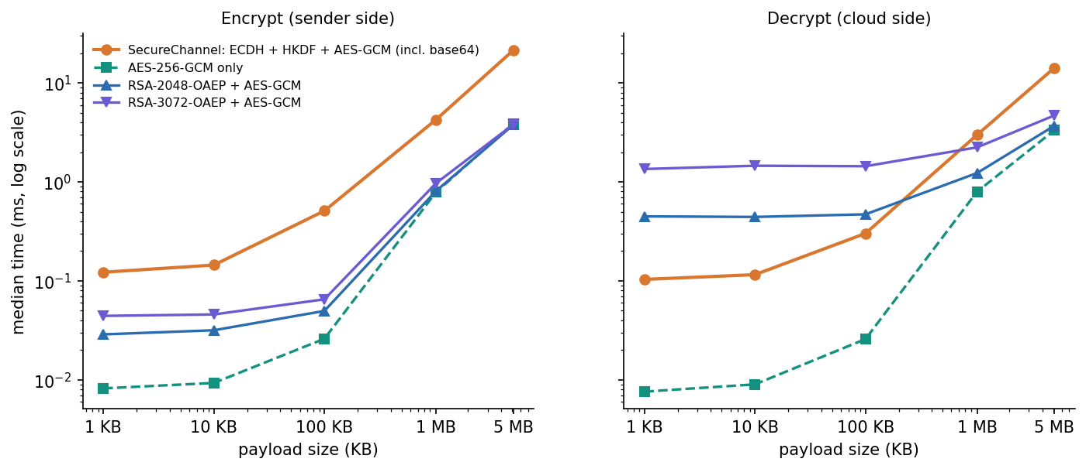
Figure 14: Median encryption and decryption time against payload size for SecureChannel, AES-GCM alone and two RSA hybrids (log scale).

7.7.2 Detection and the combined pipeline
The in-process cost of one protected 100 KB transfer was timed over 200 repetitions: scoring one flow takes 3.92 ms, encrypting 100 KB 0.54 ms and decrypting it 0.38 ms. Measured end to end the three steps take 5.67 ms (95th percentile 7.35 ms). The intrusion detector accounts for 81 % of that time, encryption for 11 % and decryption for 8 %: it is the detection, not the encryption, that dominates the combined overhead. Batch scoring is far cheaper per flow: 120 rows take 5.7 ms and 1,000 rows 16.6 ms. Loading the models takes 112 ms. For the real-trained bundle (192 inputs) one flow takes 3.25 ms, 100 flows 7.7 ms and 1,000 flows 43.4 ms.
Table 30: API latency over HTTP on 127.0.0.1 (milliseconds).
Call | Median | 95th percentile | Repetitions
GET /api/health | 0.78 | 1.15 | 100
POST /api/ids/score (one flow) | 5.47 | 6.01 | 100
POST /api/crypto/encrypt (1 KB text) | 1.20 | 1.38 | 100
POST /api/crypto/decrypt (1 KB text) | 0.91 | 1.09 | 100
POST /api/ids/score-batch (120 rows) | 19.02 | 19.68 | 30
POST /api/crypto/encrypt-file (1 MB) | 17.23 | 38.54 | 20
Score + encrypt + decrypt, three calls (1 KB) | 8.11 | 8.86 | 60

The three-call sequence of scoring a flow, encrypting 1 KB and decrypting it takes about 8 ms through HTTP, which is the figure that answers the gap named in the literature survey: the two protections can run together on one data path for a few milliseconds per message on a CPU-only laptop. What the measurements do not cover is throughput under concurrent load, network latency to a real cloud provider, and the memory footprint.

7.8 User acceptance testing
No formal user acceptance test was held: there was no test group, questionnaire or acceptance criteria agreed with a stakeholder, and this chapter does not claim one. What was done instead is a scripted walkthrough by the project team of the complete user journey on real data: start the application, score an attack and a normal record, upload a CSV, read the alerts, encrypt a message, decrypt it, tamper with it, and open the performance page. Every step produced the expected screen (Section 7.4). The walkthrough also exposed usability points that a formal acceptance test would be expected to find: the model-performance page of the shipped bundle shows 97.33 % beside a banner that says the data are synthetic, and a reader who skips the banner will over-trust the figure; and the text under the sample button describes the sample as real flows although it is synthetic.

7.9 Defects and observations from testing
Findings of the test and measurement runs: (1) the shipped model scores 0.660 accuracy and ROC-AUC 0.657 on real UNSW-NB15 flows (screen 10: 65 % agreement), so a real-trained bundle was produced and a switch to serve it was added; (2) PyTorch fails to load (DLL error 1114) when NumPy or pandas are imported first on the test machine, so the launcher and tests import it first (the original run.bat environment was not re-run); (3) the README claims balanced loss weighting for the CNN but the PyTorch path trains with unweighted BCE; (4) the UI text calls the bundled sample "real flows" although it is synthetic; (5) attack_cat of the synthetic data is drawn with an unseeded random call; (6) on real data the stack does not beat XGBoost alone (0.890 ± 0.002 against 0.910 ± 0.001), which Chapter 8 reports as a finding; (7) alerts and the cloud key pair live in memory and are lost on restart. All were documented rather than hidden.

7.10 Limits of the testing done
The results above support the claims of this report, but they have limits that the reader should know:
• One machine, one operating system, one run per timing. All timings come from a shared Intel i5-12500 machine running Windows 11; no other operating system, browser other than Chromium or Chrome, or Python version was tested.
• Default settings only. Docker, the TensorFlow code path and run.bat in a fresh environment were not exercised in the documentation run.
• No load, soak or concurrency testing, no memory or energy measurement, and no measurement against a real cloud provider or over a real network.
• No adversarial testing of the detector. The IDS was never attacked with crafted flows, and its dependence on the sttl feature suggests that it would be easy to evade.
• No independent review of the cryptography. The tamper tests show that the library behaves as specified in the cases tried; they are not a security audit.
• Threshold analysis on the test set. The threshold sweep of Chapter 8 uses the held-out data and is descriptive, not a tuned operating point.
• Real-data results come from one dataset. UNSW-NB15 is a testbed capture with known artefacts; the results say nothing about other networks, and the official test period is the only temporal shift examined.
• Small automated suite. Twenty-six tests and fifteen smoke checks cover the main routes and the cryptography; they do not cover the front-end components, and the React console was tested only by the screenshot walk.

CHAPTER 8: RESULTS AND OUTPUT SCREENS
This chapter reports what was measured and what the running application shows. Section 8.1 describes the set-up and the data, Section 8.2 presents the output screens, Sections 8.3 to 8.5 give the detection results on real and on synthetic data, Sections 8.6 and 8.7 the cryptographic and combined-overhead measurements, Section 8.8 the comparison with the base paper, Sections 8.9 and 8.10 sample output and the analysis of successes and failures, and Sections 8.11 and 8.12 the limits of the evaluation and the objectives against the outcomes. Where a result is weak it is reported as weak.

8.1 Experimental set-up
All measurements were made on one machine: an Intel Core i5-12500 (6 cores, 12 threads), 15.7 GB of memory, no GPU, Windows 11, shared with other programs, so absolute timings are indicative. Every figure and table was produced from stored JSON by the scripts in scripts/ and scripts/docs_build/; nothing was typed in by hand.
Table 31: Data used in the evaluation
Item | Content | Source and status
Shipped (synthetic) dataset | 12,000 rows, split 8,400 / 1,800 / 1,800 | Generated by cipherguard/ids/synthetic.py with the UNSW-NB15 feature schema; 2.5% label noise; not real traffic
UNSW-NB15 official training set | 175,341 flows (56,000 normal, 119,341 attack) | Real flows [7]; fetched by scripts/fetch_unsw_nb15.py; used for fitting (85%) and validation (15%)
UNSW-NB15 official testing set | 82,332 flows (55.1% attack) | Real flows from a later capture period; never used for fitting
Base-paper-style subset | 9,000 flows, 4,500 per class, split 6,300 / 1,350 / 1,350 | Sampled from the official training set, 10 repetitions with different seeds

Models used the shipped hyper-parameters and the threshold 0.5 unless stated; no significance test was run, and five seeds (official partition) and ten repetitions (paper protocol) give the spread.

8.2 Output screens
The captures below are real screens of the running console (Chrome, 1440 by 900 pixels, dark theme), made by scripts/capture_screens.py and scripts/capture_real_screens.py with the backend and the React console running and data in every view. The remaining screens (landing page in both themes, batch scoring, session charts, the tampered-ciphertext rejection and the alerts table) are in Appendix C.
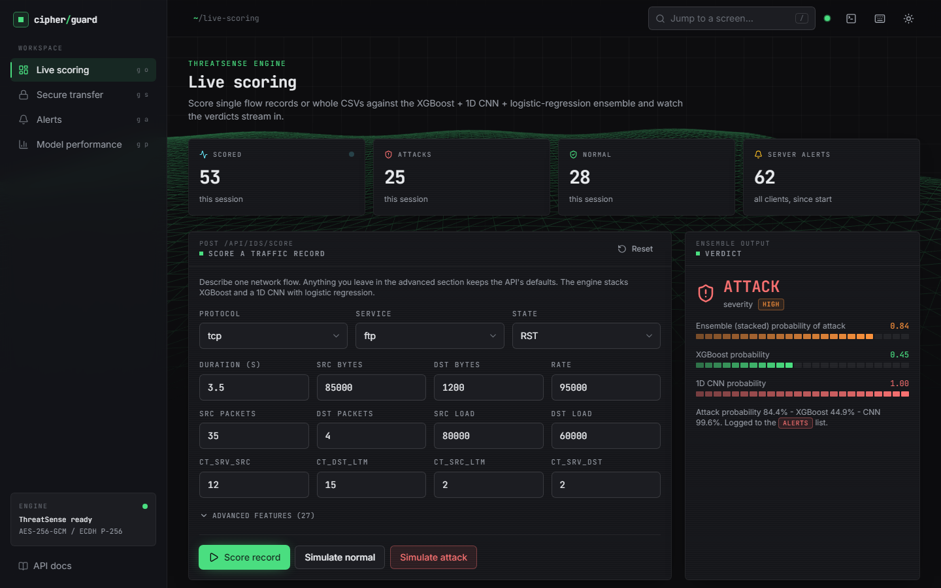
Figure 15: Output screen: live scoring. The attack preset was scored: verdict ATTACK, severity HIGH, stacked probability 0.84 (XGBoost 0.45, CNN 1.00). Counters show 53 flows scored in this session.
The live-scoring screen shows the single-record form (three selects and twelve main numeric fields; 27 more features are kept at API defaults under Advanced features), the ensemble verdict and a bar for each model. It is the clearest view of why the stacked model matters to an operator: the two base models disagree (0.45 against 1.00) and the meta-model settles on 0.84, which is still above the 0.5 threshold and in the HIGH band (0.70 to 0.85).
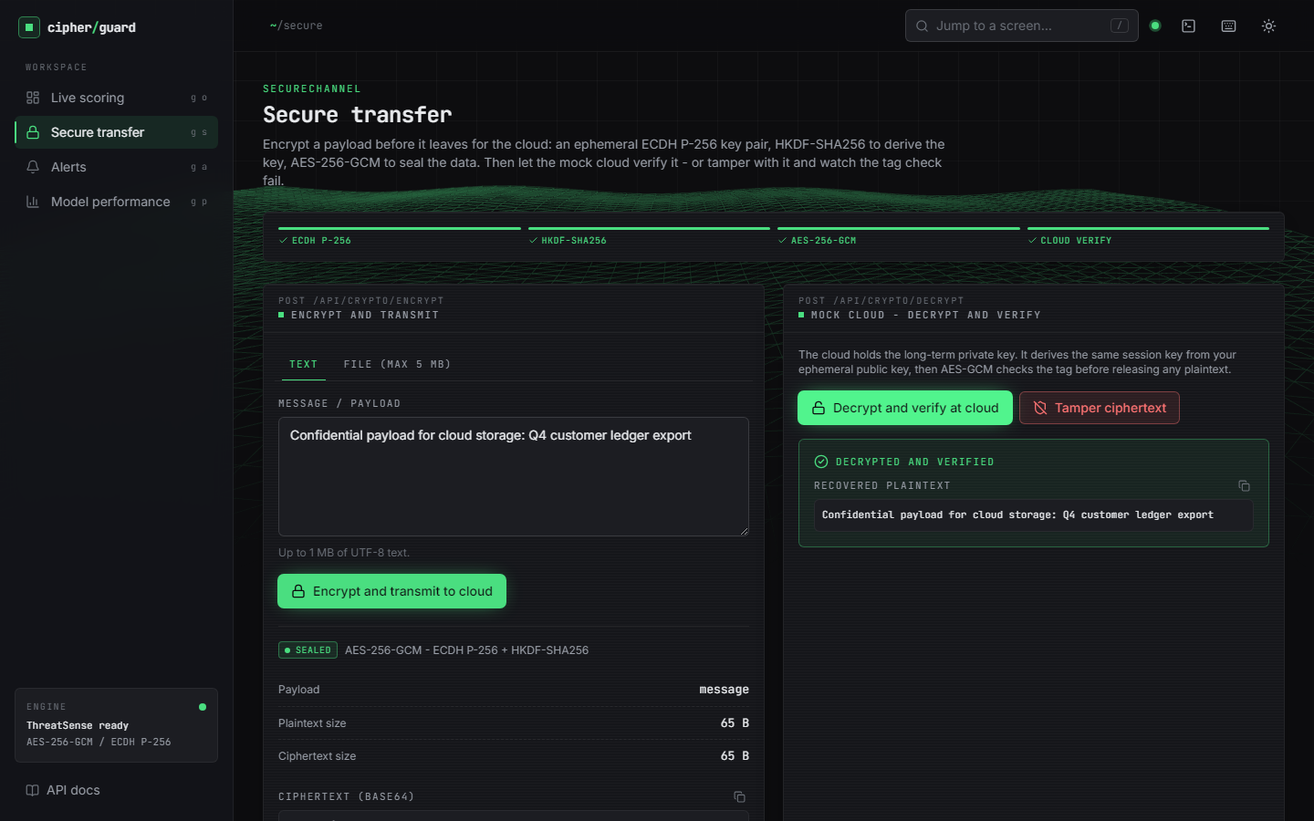
Figure 16: Output screen: secure transfer. A text payload was encrypted (ciphertext, 12-byte nonce, 16-byte tag, 65-byte ephemeral public key shown) and then decrypted and verified at the mock cloud.
The secure-transfer screen exposes the real values returned by POST /api/crypto/encrypt and /api/crypto/decrypt; nothing is simulated in the browser. The Decrypted and verified banner appears only when the API returns verified: true.
  Figure 17: Output screen: model performance of the shipped bundle - 97.33% accuracy on 1,800 synthetic test rows. The banner at the top states the data mode. |   Figure 18: Output screen: model performance of the real-trained bundle served with CIPHERGUARD_MODELS_DIR - 88.79% accuracy on the 82,332-flow official test set, 192 input dimensions.

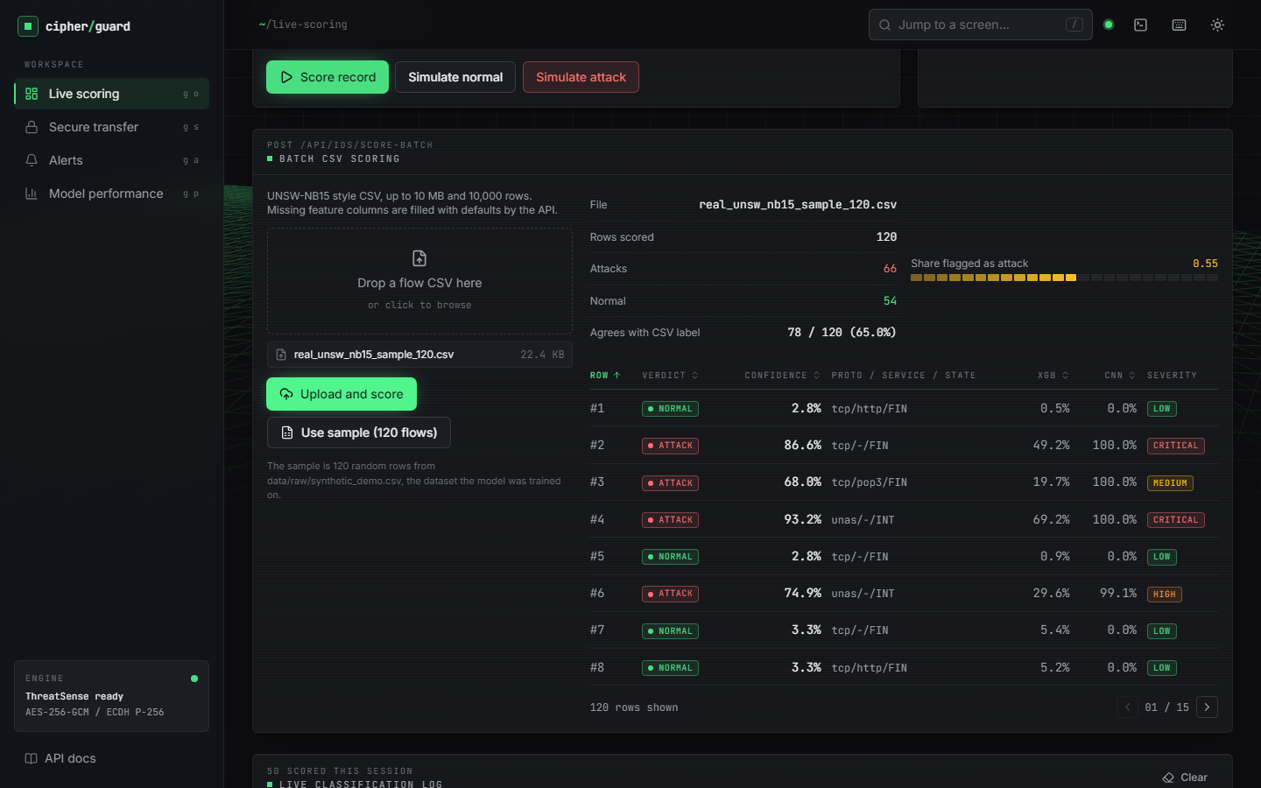  Figure 19: Output screen: 120 real UNSW-NB15 flows scored by the shipped (synthetic-trained) bundle - 66 flagged as attack and 78 of 120 verdicts (65.0%) agree with the labels in the file. | 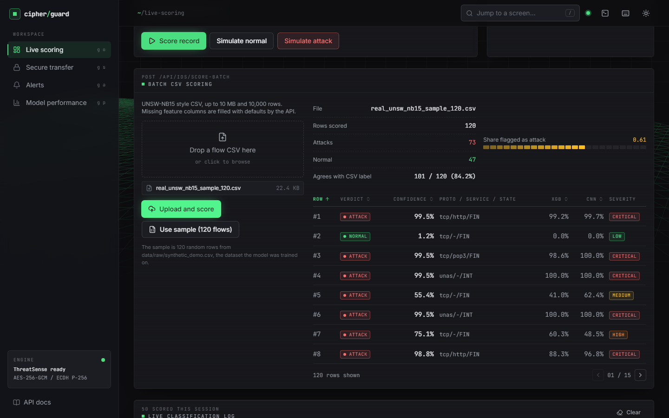  Figure 20: Output screen: the same 120 real flows scored by the real-trained bundle - 73 flagged as attack and 101 of 120 verdicts (84.2%) agree with the labels.

Screens 10 and 12 make the main finding of this chapter visible in the product itself: the same screen, the same 120 flows and the same code give 65.0% agreement with a synthetic-trained model and 84.2% with a model trained on real flows. The 120-flow sample is small, so only the direction (not the exact percentages) should be taken from it; the exact figures come from the full test set in the next sections.

8.3 Detection performance on real UNSW-NB15 traffic
This section reports the shipped model design trained on the real official training set and tested on the real official testing set (82,332 flows, 55.1% attack). The test period is later than the training period, so this is the realistic deployment question - train on the past, detect in the future - and it is harder than a random split [8].
Table 32: Detection metrics on the official testing set, mean ± standard deviation over five seeds (threshold 0.5)
Model | Accuracy | Precision | Recall | F1 | ROC-AUC | FPR
Stacked ensemble (shipped design) | 0.890 ± 0.002 | 0.844 ± 0.002 | 0.981 ± 0.001 | 0.907 ± 0.001 | 0.984 ± 0.000 | 0.222 ± 0.004
XGBoost alone | 0.910 ± 0.001 | 0.883 ± 0.001 | 0.964 ± 0.001 | 0.922 ± 0.001 | 0.985 ± 0.000 | 0.156 ± 0.001
1D CNN alone | 0.841 ± 0.004 | 0.780 ± 0.005 | 0.991 ± 0.001 | 0.873 ± 0.003 | 0.976 ± 0.002 | 0.342 ± 0.010
Mean of XGBoost and CNN | 0.888 ± 0.004 | 0.843 ± 0.007 | 0.979 ± 0.002 | 0.906 ± 0.003 | 0.983 ± 0.001 | 0.223 ± 0.011
Random forest (100 trees) | 0.859 ± 0.001 | 0.800 ± 0.001 | 0.991 ± 0.001 | 0.885 ± 0.001 | 0.982 ± 0.000 | 0.303 ± 0.003
Decision tree (depth 12) | 0.853 ± 0.009 | 0.803 ± 0.011 | 0.973 ± 0.004 | 0.880 ± 0.006 | 0.958 ± 0.006 | 0.293 ± 0.021
Logistic regression | 0.806 ± 0.000 | 0.749 ± 0.000 | 0.973 ± 0.000 | 0.846 ± 0.000 | 0.955 ± 0.000 | 0.399 ± 0.001

The headline reading is not the one the design intended. The stacked ensemble reaches 0.890 ± 0.002 accuracy and an F1 of 0.907 ± 0.001, but XGBoost alone is better on accuracy (0.910 ± 0.001), precision and false-positive rate (0.156 ± 0.001 against 0.222 ± 0.004). The 1D CNN has the highest recall (0.991 ± 0.001) but raises false alarms on 34.2% of normal flows, and the logistic-regression meta-model, fitted on a validation split from the training period, inherits much of that. Stacking beats the plain mean of the two models only marginally (0.890 ± 0.002 against 0.888 ± 0.004) and beats a decision tree, a logistic regression and a random forest, but not XGBoost. The standard deviations are small (at most 0.009), so these orderings are stable across seeds (Figure below).
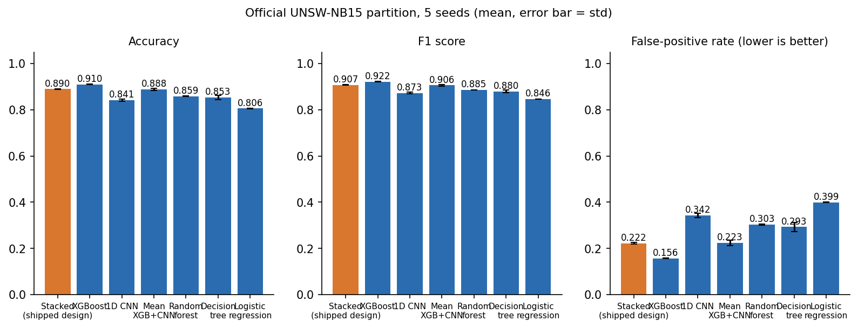
Figure 21: Accuracy, F1 and false-positive rate of the seven models on the official test set; error bars are one standard deviation over five seeds.

8.3.1 Confusion matrices
For seed 42 the stacked model's confusion matrix is [[28,646 true negatives, 8,354 false positives], [877 false negatives, 44,455 true positives]]: accuracy 0.8879, precision 0.8418, recall 0.9807, F1 0.9059, ROC-AUC 0.9839, false-positive rate 0.2258, false-negative rate 0.0193 and a Matthews correlation of 0.783. The error is lopsided: the system misses few attacks but raises many false alarms.
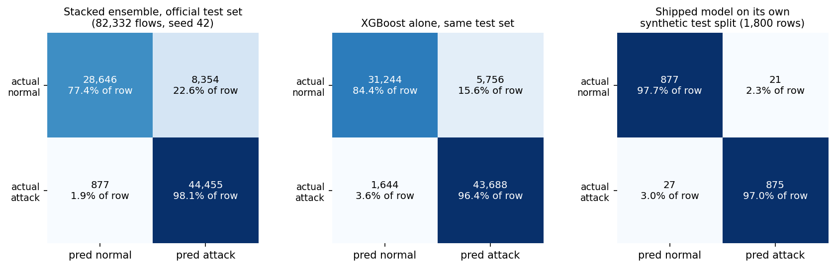
Figure 22: Confusion matrices: the stacked model and XGBoost on the official test set (seed 42), and the shipped model on its own synthetic test split.

8.3.2 ROC curves
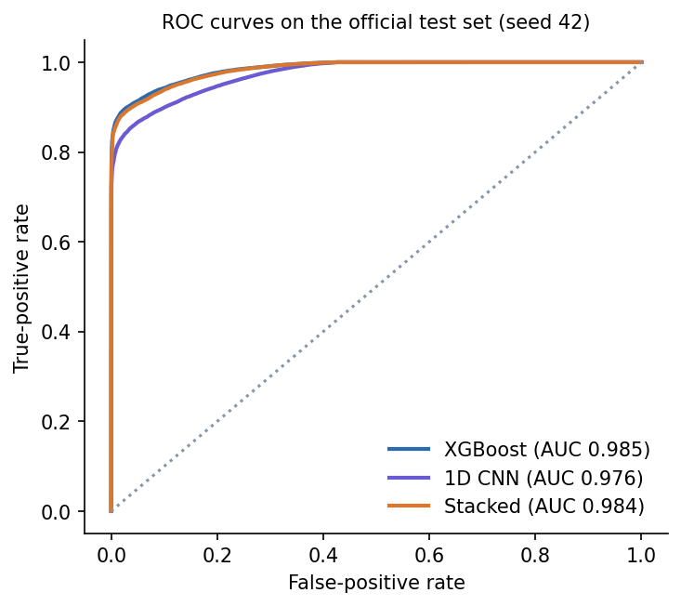  Figure 23: ROC curves of the two base models and the stacked model on the official test set (seed 42). | 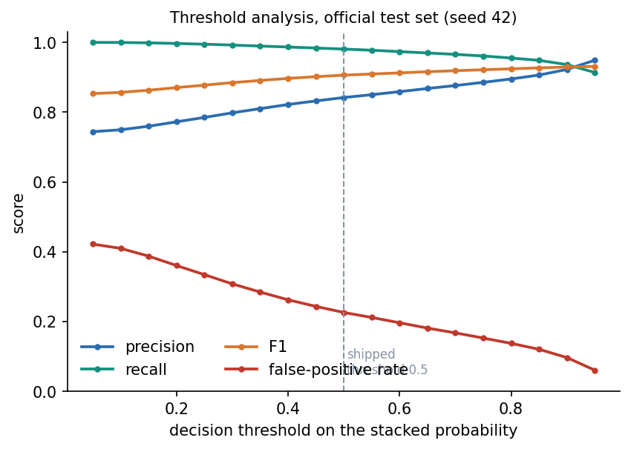  Figure 24: Precision, recall, F1 and false-positive rate of the stacked model against the decision threshold (official test set, seed 42).

The three curves are close: ranking quality is high for all of them (AUC 0.976 to 0.985), and the differences in accuracy at threshold 0.5 are mostly calibration differences, not ranking differences. That is why the threshold analysis below matters.

8.3.3 Threshold analysis
Table 33: Stacked model on the official test set (seed 42) at different thresholds
Threshold | Accuracy | Precision | Recall | F1 | FPR
0.10 | 0.8157 | 0.7494 | 0.9995 | 0.8566 | 0.4095
0.50 | 0.8879 | 0.8418 | 0.9807 | 0.9059 | 0.2258
0.70 | 0.9058 | 0.8761 | 0.9655 | 0.9186 | 0.1673
0.90 | 0.9214 | 0.9224 | 0.9360 | 0.9292 | 0.0965

Raising the threshold from the shipped 0.5 to 0.9 lifts accuracy from 0.8879 to 0.9214 and cuts the false-positive rate from 0.2258 to 0.0965, at the price of recall falling from 0.9807 to 0.9360. The best F1 on this sweep is 0.9308 at threshold 0.95. The sweep was run on the test set, so it shows the trade-off the operator can choose; it is not a tuned result, and a deployment would pick the threshold on a validation set.

8.3.4 Results by traffic category
Table 34: Stacked model by category on the official test set (seed 42, threshold 0.5)
Category | Flows | Handled correctly | Share
Normal (passed) | 37,000 | 28,646 | 77.4%
Fuzzers | 6,062 | 5,257 | 86.7%
Analysis | 677 | 665 | 98.2%
Shellcode | 378 | 375 | 99.2%
Exploits | 11,132 | 11,083 | 99.6%
Reconnaissance | 3,496 | 3,492 | 99.9%
DoS | 4,089 | 4,086 | 99.9%
Generic | 18,871 | 18,870 | 100.0%
Backdoor | 583 | 583 | 100.0%
Worms | 44 | 44 | 100.0%

Eight of the nine attack categories are detected at 98% or better; the ninth is Fuzzers (86.7% detected, 805 of 6,062 missed). The weak class is normal traffic: only 77.4% of the 37,000 normal flows pass, so 22.6% raise a false alarm. Rare classes (Worms, 44 flows; Shellcode, 378) are detected, but their small counts make the percentages uncertain.
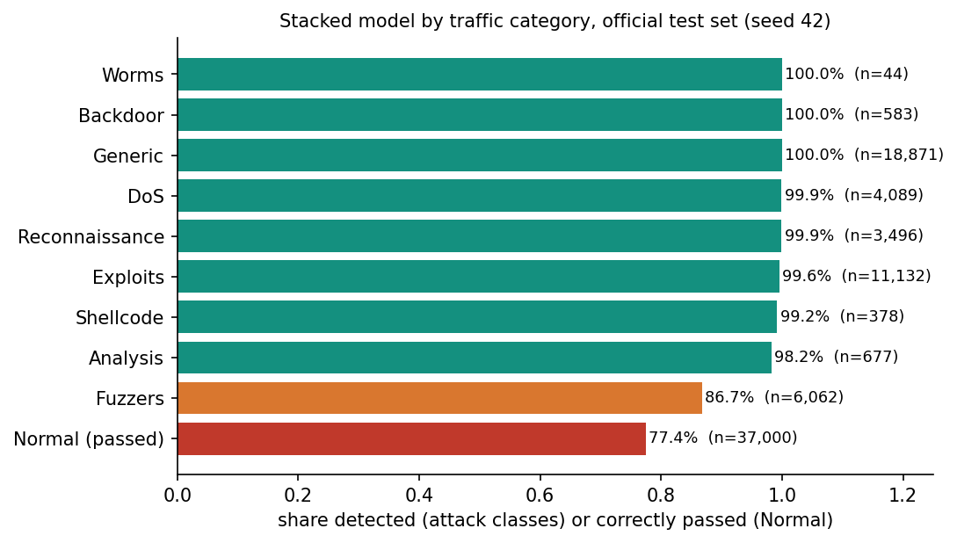
Figure 25: Share of each category handled correctly by the stacked model (attack classes: detected; Normal: correctly passed).

8.3.5 What the model relies on
The five most important XGBoost features by gain are sttl, swin, ct_srv_dst, ct_state_ttl, ct_dst_sport_ltm. sttl (the source time-to-live) has a gain of 2,725, about 16 times that of the second feature. A time-to-live that separates attack from normal flows so cleanly is a property of how the UNSW-NB15 testbed generated its traffic rather than of attacks in general, so part of the accuracy above would not carry over to another network.

8.4 Detection performance under the base paper's protocol
To make a comparison with the base paper [1] possible, the experiment was repeated in the paper's style: 9,000 flows, balanced at 4,500 per class, a stratified 70/15/15 split (here 6,300 / 1,350 / 1,350) and 10 repetitions with different seeds. The sample was drawn from the official training set; the paper does not say which 9,000 flows it used.
Table 35: Detection metrics under the base-paper-style protocol, mean ± standard deviation over ten repetitions
Model | Accuracy | Precision | Recall | F1 | ROC-AUC | FPR
Stacked ensemble (shipped design) | 0.938 ± 0.007 | 0.934 ± 0.012 | 0.944 ± 0.009 | 0.939 ± 0.007 | 0.988 ± 0.002 | 0.067 ± 0.013
XGBoost alone | 0.939 ± 0.007 | 0.938 ± 0.012 | 0.939 ± 0.007 | 0.939 ± 0.007 | 0.989 ± 0.002 | 0.062 ± 0.013
1D CNN alone | 0.904 ± 0.010 | 0.865 ± 0.033 | 0.960 ± 0.036 | 0.909 ± 0.008 | 0.977 ± 0.003 | 0.153 ± 0.045
Random forest (100 trees) | 0.939 ± 0.008 | 0.938 ± 0.011 | 0.941 ± 0.008 | 0.939 ± 0.008 | 0.989 ± 0.002 | 0.063 ± 0.011

On a random balanced subset the picture is different from the temporal split: the stacked model scores 0.938 ± 0.007, XGBoost 0.939 ± 0.007 and the random forest 0.939 ± 0.008, all within one standard deviation of each other, while the CNN alone is clearly lower (0.904 ± 0.010). Stacking therefore brings no measurable gain over XGBoost here either. False-positive rates (0.067 ± 0.013 for the stack) are far lower than on the official partition, because the test flows come from the same period as the training flows.

8.5 The shipped model on synthetic data: why 97.33% is not evidence
The bundle that the application loads by default, and whose numbers the Model performance screen shows, was trained on 12,000 synthetic rows. On its own 1,800-row test split it reaches accuracy 0.9733, precision 0.9766, recall 0.9701, F1 0.9733 and ROC-AUC 0.9704; XGBoost alone (0.9733) and the CNN alone (0.9733) score exactly the same. Three different models agreeing to four decimals is a sign that the task, as generated, is almost perfectly separable: the generator draws attack and normal flows from different distributions, and the only unavoidable error is the 2.5% label noise (300 of 12,000 rows), which caps accuracy at 0.975 if the clean classes were separable. On a fresh synthetic sample (seed 7, 6,000 rows) the same model scores 0.9750, right at that cap.
Table 36: The same models on different data
Models trained on | Tested on | Rows | Accuracy | F1 | ROC-AUC
Synthetic data (shipped) | Its own synthetic test split | 1,800 | 0.9733 | 0.9733 | 0.9704
Synthetic data (shipped) | Fresh synthetic data (seed 7) | 6,000 | 0.9750 | 0.9750 | 0.9749
Synthetic data (shipped) | Real official test set | 82,332 | 0.6603 | 0.6917 | 0.6567
Real official training set | Real official test set (5-seed mean) | 82,332 | 0.8897 | 0.9073 | 0.9843
Real official training set | Synthetic demo CSV | 12,000 | 0.3733 | 0.3557 | 0.3394

Scored on the 82,332 real test flows, the shipped model reaches an accuracy of 0.660 and a ROC-AUC of 0.657, with a Matthews correlation of 0.313: barely better than guessing; it flags 55.1% of the flows as attacks although the true share is 55.1%, and its XGBoost part alone is at 0.589. In the other direction, a model trained on real flows scores 0.373 on the synthetic CSV, below chance, because the generator's distributions differ from, and in places invert, the patterns of real traffic. The 97.33% on the Model performance screen is therefore a property of the generator, not a statement about intrusion detection, and the console says so in its data-mode banner.
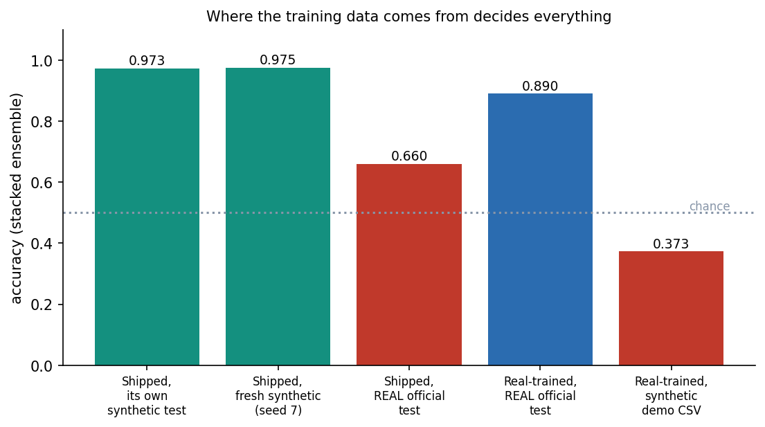
Figure 26: Accuracy of the stacked ensemble for each combination of training data and test data.

8.6 Cryptographic performance and integrity
scripts/benchmark_crypto.py times the product's SecureChannel and two baselines on the same machine: raw AES-256-GCM (no key exchange) and a classical hybrid in which a fresh AES-256-GCM key is wrapped with RSA-OAEP (SHA-256) for a 2048-bit and a 3072-bit key [16]. SecureChannel timings include an ephemeral P-256 key pair, ECDH, HKDF-SHA256 and the base64 conversion that the HTTP API needs; the RSA and AES-only timings do not include base64.
Table 37: Median time in milliseconds (encrypt / decrypt) by payload size
Payload | SecureChannel (ECDH + HKDF + AES-GCM) | AES-256-GCM only | RSA-2048-OAEP + AES-GCM | RSA-3072-OAEP + AES-GCM
1 KB | 0.122 / 0.104 | 0.008 / 0.008 | 0.029 / 0.449 | 0.044 / 1.351
100 KB | 0.510 / 0.302 | 0.026 / 0.026 | 0.050 / 0.471 | 0.065 / 1.442
5 MB | 21.387 / 14.213 | 3.895 / 3.327 | 3.774 / 3.695 | 3.806 / 4.699

For payloads up to 100 KB, SecureChannel encrypts in 0.12 to 0.51 ms and decrypts in 0.10 to 0.30 ms. At 1 KB, RSA-2048 wraps a key faster (0.029 ms against 0.122 ms) because encryption with the small public exponent is cheap, but the cloud-side unwrap is dearer (0.449 ms for RSA-2048 and 1.351 ms for RSA-3072 against 0.104 ms), which matters because the cloud serves many senders. For large payloads the bulk cipher dominates and the base64 step makes SecureChannel the slowest option (5 MB: 21.4 ms to encrypt, about 234 MB/s, against 3.9 ms for raw AES-GCM). Key set-up is small: an ephemeral P-256 key pair takes 24 microseconds and ECDH plus HKDF 53 microseconds, whereas a one-time RSA-2048 key pair took 68 ms and an RSA-3072 pair 104 ms (single samples).
Figure 27: Median encryption and decryption time against payload size for SecureChannel, raw AES-256-GCM and two RSA-OAEP hybrids (log-log axes).
Table 38: Integrity and uniqueness tests (scripts/benchmark_crypto.py)
Case | Trials | Behaved as expected | All
Untouched message accepted | 1,000 | 1,000 | yes
Ciphertext bit flipped | 1,000 | 1,000 | yes
Tag bit flipped | 1,000 | 1,000 | yes
Nonce bit flipped | 1,000 | 1,000 | yes
Ciphertext truncated by one byte | 1,000 | 1,000 | yes
Decrypted with another party's key | 1,000 | 1,000 | yes

Every tamper case was rejected in all 1,000 trials (flipping a bit in the ciphertext, tag or nonce, truncating the ciphertext by one byte, or decrypting with another party's key), and an untouched message was accepted every time. 20,000 encryptions of one plaintext produced 20,000 distinct nonces and 20,000 distinct ciphertexts, so identical messages are unlinkable. The wire overhead is fixed at 93 bytes (12-byte nonce, 16-byte tag and 65-byte ephemeral public key), i.e. 9.1% of a 1 KB message, 0.09% of 100 KB and 0.0089% of 1 MB, before the 33% that base64 adds in the JSON API.

8.7 The combined overhead of encryption and detection
The literature survey named a gap: cryptography and intrusion detection are treated as separate concerns, and the combined overhead of running both on one transmission path is not measured. scripts/measure_pipeline.py measures it in two ways: in process against the shipped models (200 repetitions) and through the HTTP API on 127.0.0.1 (30 to 100 repetitions).
Table 39: In-process timings (milliseconds)
Operation | Median | 95th percentile
IDS scoring of one flow (in process) | 3.92 | 4.33
Encrypt 100 KB (in process) | 0.54 | 0.67
Decrypt 100 KB (in process) | 0.38 | 0.51
Protected transfer: score + encrypt + decrypt (in process) | 5.67 | 7.35
Batch scoring, 120 rows (in process) | 5.7 | 6.1
Batch scoring, 1,000 rows (in process) | 16.6 | 17.7

One protected transfer of a 100 KB payload costs 5.67 ms end to end. Scoring the flow takes 81% of the combined cost, encryption 11% and decryption 8% (shares of the three component medians). The security layer that adds most latency is therefore the detector, not the cipher; the cipher is cheap enough to be left on for every message. The one-time engine load took 112 ms.
Table 40: HTTP API latency on 127.0.0.1 (milliseconds)
Request | Median | 95th percentile
POST /api/ids/score | 5.47 | 6.01
POST /api/crypto/encrypt (1 KB text) | 1.20 | 1.38
POST /api/crypto/decrypt (1 KB text) | 0.91 | 1.09
POST /api/crypto/encrypt-file (1 MB) | 17.23 | 38.54
score + encrypt + decrypt, three HTTP calls (1 KB) | 8.11 | 8.86

Through the API, the three calls of a protected 1 KB transfer take 8.1 ms in total. The measurements were made against 127.0.0.1 because on this machine a request to localhost adds about two seconds of name-resolution fallback. Real network round trips to a cloud provider, TLS and concurrent users are not included; they are not part of what was measured.

8.8 Comparison with the base paper
The base paper [1] fuses a quantum-inspired network and LeNet with a double-sigmoid score-level fusion (DSMMN-SLF) for detection and encrypts data with an enhanced elliptic-curve scheme (EECC). It evaluates on 9,000 balanced UNSW-NB15 samples with a 70/15/15 split and 10 runs. This project uses neither the quantum-inspired network nor EECC; it uses XGBoost, a 1D CNN and logistic-regression stacking for detection, and standard ECDH + AES-GCM for encryption.
Table 41: Reported and measured detection results
Model / setting | Accuracy | Precision | FPR | Status
Proposed model (FLPF-EVD-QNN + LeNet, DSMMN fusion) | 0.9487 (Table 2 mean); 0.9564 (ablation, TD 80%) | 0.97 at TD 90% | 0.03 | Base paper, as reported
Best re-implemented baseline in the paper (SqueezeNet) | 0.9354 | not stated | not stated | Base paper, as reported
Weakest baseline in the paper (Bi-LSTM) | 0.8993 | not stated | not stated | Base paper, as reported
This project: stacked ensemble (paper-style protocol) | 0.9383 ± 0.0071 | 0.9338 ± 0.0121 | 0.067 ± 0.013 | Measured, 10 runs
This project: XGBoost alone (paper-style protocol) | 0.9386 ± 0.0070 | 0.9380 ± 0.0119 | 0.062 ± 0.013 | Measured, 10 runs
This project: stacked ensemble (official partition) | 0.8897 ± 0.0016 | 0.8442 ± 0.0021 | 0.222 ± 0.004 | Measured, 5 seeds, temporal split
This project: shipped model as delivered | 0.9733 | 0.9766 | 0.023 | Synthetic data - not comparable

Under a comparable protocol the stacked ensemble reaches 0.9383 ± 0.0071: about one point below the paper's proposed model (0.9487), 3.6 points below its quoted precision of 0.97, and slightly above the strongest baseline the paper re-implemented (0.9354). The comparison is indicative only: the paper does not publish which 9,000 flows it sampled, the hyper-parameters of its baselines, or its test fraction; our flows come from the official training file; and the paper's own numbers vary by table (0.9564 in the ablation, 0.9487 in the statistical table). On the harder official partition the stacked ensemble falls to 0.890, a figure the paper does not report. Encryption cannot be compared at all: the paper reports 0.39 s to encrypt and 0.26 s to decrypt for its EECC without stating the data size or hardware, whereas SecureChannel takes about 0.1 ms for 1 KB on a desktop CPU; the two numbers answer different questions. The paper's attack analysis (key-breaking time, correlation) is not reproduced here; the only security evidence in this project is the tamper and uniqueness tests of Section 8.6 and the standard security properties of the primitives.

8.9 Sample inputs and outputs
The following requests and responses were produced by the running API with the shipped bundle (docs/metrics/sample_io.json); long base64 strings are shortened with an ellipsis.

8.9.1 Scoring one flow
200 OK
{
"label": "attack",
"confidence": 0.844,
"severity": "high",
"xgb_score": 0.4486,
"cnn_score": 0.9963
}

The flow (large upload on FTP, reset state) is flagged as an attack with severity high: the stacked probability is 0.84, from XGBoost 0.45 and the CNN 1.00. An alert object with the timestamp and key features is also returned and appended to the alert log.
The ordinary web flow is passed as normal with severity low, but note how far the models disagree: XGBoost gives 0.034 while the CNN gives 0.91; the meta-model settles on 0.46, just under the 0.5 threshold. A borderline verdict like this is the kind that produces false alarms when the data change.

8.9.2 Encrypting and decrypting
POST /api/crypto/encrypt
{
"plaintext": "Quarterly payroll export - confidential"
}
200 OK
{
"ciphertext": "2mSrflJYn6ItVT1wMqGEQoqGxydD...",
"nonce": "/bE1BSizpoUG59kq",
"tag": "Dcl1xvdC57l+8SrIR1tT5g==",
"ephemeral_public": "BFxP6HV3qRUuxqORG4YMYp9hZ5sY...",
"algorithm": "AES-256-GCM",
"key_exchange": "ECDH P-256 + HKDF-SHA256"
}

POST /api/crypto/decrypt (the four fields above, in full)
200 OK
{
"plaintext": "Quarterly payroll export - confidential",
"verified": true
}

-- after flipping one bit of the ciphertext --
400 Bad Request
{
"detail": "Decryption failed (tag verification or key mismatch): "
}

The envelope holds a 39-byte ciphertext (the plaintext has 39 characters), a 12-byte nonce, a 16-byte tag and a 65-byte uncompressed ephemeral public key. Decrypting returns the plaintext with verified: true; changing a single bit of the ciphertext makes the API answer 400, and no plaintext is released. An empty plaintext is refused with 400 ("Plaintext cannot be empty").

8.10 Success and failure analysis

8.10.1 What worked
• Authenticated encryption behaved exactly as specified. All six tamper and wrong-key cases were rejected 1,000 times out of 1,000 and nonces never repeated in 20,000 encryptions; 26 of 26 automated tests and 15 of 15 smoke checks passed.
• The detector ranks real traffic well. ROC-AUC is 0.984 ± 0.000 on the temporally shifted official test set, recall is 98.1%, and every one of the nine attack categories is detected at 86% or better.
• The combined layer is cheap. A protected transfer of 100 KB costs 5.7 ms in process.
• The console tells the truth about its data. The data-mode banner and the real-flow screens (10 to 12) show the difference between synthetic and real training data to anyone using the product.

8.10.2 What did not work
• False alarms. At the shipped threshold the stacked model flags 22.6% of normal flows (8,354 of 37,000 in the seed-42 run). With about half of real traffic being attacks in this dataset that is tolerable for a benchmark; in a network where attacks are rare it would bury operators in alerts. Raising the threshold to 0.9 reduces the false-positive rate to 9.6% at the price of 6.4% missed attacks.
• Fuzzers. 13.3% of Fuzzers flows (805 of 6,062) are missed; they resemble normal traffic in the 42 features.
• Stacking did not help. The meta-model is fitted on a validation split from the training period; on the later test period it is no better than XGBoost alone, and the CNN adds false alarms. The extra model costs 246 s of CNN training on the CPU (XGBoost: 4 s) for no measured gain.
• Domain shift. The shipped model trained on synthetic data scores 0.660 on real flows. Any retraining on another network would face the same risk in milder form, because UNSW-NB15 is a laboratory capture.
• Reliance on `sttl`. One feature carries most of the importance. A deployment in which the time-to-live distribution differs would lose accuracy without any attack changing.

8.11 Limitations of the evaluation
• The detection results use one public dataset captured in one laboratory; no result was checked on another network or on traffic captured by the project team.
• The base-paper comparison cannot be exact (unpublished subset and hyper-parameters) and says nothing about EECC or the quantum-inspired network, which were not implemented.
• Timing was measured on one shared desktop-class machine, in process and on the loopback interface; no network, TLS, concurrency, memory or energy measurement was made.
• The IDS was not tested against adversarial or evasive traffic, and the console was tested in Chrome only. The Docker image and the TensorFlow code path were not exercised.

8.12 Objectives versus outcomes
Table 42: The six batch objectives and what the measurements show
# | Objective | Outcome
1 | Hybrid AES + RSA encryption | Partly met by substitution. A hybrid asymmetric-plus-symmetric scheme is implemented with ECDH P-256 + HKDF-SHA256 + AES-256-GCM; RSA-OAEP + AES-GCM was implemented only as a benchmark baseline (Section 8.6).
2 | Secure key generation, distribution and storage | Generation and distribution met (a fresh ephemeral key per message, HKDF-derived 256-bit key, public key carried in the envelope). Storage not met: the cloud key pair exists only in process memory.
3 | Encrypt before upload, decrypt after download | Met against a mock cloud: text and file encryption, decrypt-and-verify, tamper rejection. No real cloud provider or upload.
4 | Classifier on a benchmark intrusion dataset | Met in the experiments: real UNSW-NB15, stacked 0.890 ± 0.002, XGBoost 0.910 ± 0.001 on the official partition. The shipped default model is trained on synthetic data.
5 | Flag and log suspicious sessions during transfer | Partly met: flows are scored and attacks are logged with severity in a 500-entry in-memory list; detection is not tied to a specific transfer and nothing is blocked automatically.
6 | Evaluate enc/dec time, throughput overhead and detection accuracy | Met: latency by size and algorithm, throughput, a combined per-transfer overhead of 5.7 ms, and detection metrics with seeds, thresholds and categories.

Taken together the results support a measured, partly positive conclusion: the encryption layer meets its specification and is cheap; the detection layer works on real traffic with a high ranking quality but a false-alarm rate that needs a higher threshold; the added complexity of stacking is not justified by the data; and the number the product shows by default describes its synthetic generator, not the world.

CHAPTER 9: CONCLUSION

9.1 Summary of the work
This project built CipherGuard Shield, a platform that puts two protections around one cloud data path: SecureChannel, which encrypts a payload with a fresh ECDH P-256 key, HKDF-SHA256 and AES-256-GCM and verifies it at the cloud, and the ThreatSense Engine, which classifies network flows with XGBoost, a 1D CNN and logistic-regression stacking and logs attacks with a severity. A REST API, a React console and the original dashboard expose both. The work was then measured: on real UNSW-NB15 flows, in cryptographic benchmarks and in a combined pipeline test, and verified with 26 automated tests and 15 smoke checks.

9.2 Objectives achieved
Section 8.12 sets the six objectives of the batch against the outcomes. Objectives 3 (encrypt before upload, decrypt after download) and 6 (evaluate times, overhead and accuracy) are met; objective 4 (classifier on a benchmark dataset) is met in the experiments on real UNSW-NB15, while the shipped default model is synthetic; objectives 1 (hybrid scheme, met by substitution of ECDH for RSA) and 5 (flag and log suspicious sessions) are met in part; objective 2 is met for key generation and distribution but not for key storage.

9.3 Key findings
1. Authenticated encryption is cheap and behaved exactly as specified. 1,000 of 1,000 trials of each of six tamper cases were correct; a protected 100 KB transfer costs 5.7 ms, of which 81% is detection.
2. The synthetic default says nothing about real traffic. 0.9733 on synthetic data against 0.660 (ROC-AUC 0.657) on the 82,332 real test flows.
3. On real data the detector ranks well but alarms too often. Stacked accuracy 0.890 ± 0.002, ROC-AUC 0.984 ± 0.000, false-positive rate 0.222 ± 0.004; a threshold of 0.9 gives accuracy 0.921 and a false-positive rate of 0.096.
4. Stacking gave no gain over XGBoost. XGBoost alone: 0.910 ± 0.001 on the official partition and 0.939 ± 0.007 against 0.938 ± 0.007 under the base paper's protocol.
5. Against the base paper the stacked model is about one point lower under a comparable protocol (0.938 ± 0.007 against 0.9487); the comparison is indicative only because the datasets differ in their subsets.

9.4 Practical applications
• A teaching and prototyping platform for encrypting data before upload and watching network flows in one place.
• A reference implementation of ephemeral-key hybrid encryption with tamper tests and a measured RSA baseline.
• A starting point for a flow-based alerting service once live flow export, authentication and persistent storage are added (Chapter 10).
• A template for reporting an intrusion-detection result honestly: real data, official split, seeds, thresholds, categories and a synthetic-versus-real audit.

9.5 Known limitations
The default model is synthetic; the official test set is harder than a random split and produces 22.6% false alarms on normal traffic at threshold 0.5; Fuzzers are missed 13.3% of the time; the cloud is a mock with in-memory keys; there is no authentication, TLS or persistent store; live traffic and adversarial inputs were not tested; and the base paper's EECC and quantum-inspired network were not reproduced. Chapter 8 and the Scope and Limitations document give the full list.

9.6 Lessons learned
• Report the data a number was measured on in the same sentence as the number; a synthetic 97% and a real 89% are different claims.
• Run the simple baseline first. XGBoost alone matched or beat a three-model stack, a result that would have stayed hidden without a baseline table.
• Prefer standard, maintained primitives and measure them against the alternative that was asked for (RSA) rather than adopting a non-standard scheme.

CHAPTER 10: FUTURE SCOPE

10.1 Improvements to the existing system
• Make the real-trained bundle the default and ship the data-fetch script, so the console shows real-data metrics from the first start; keep the synthetic generator only as a test fixture.
• Choose the decision threshold on a validation set and expose it in the console; a threshold of 0.9 already cuts the false-positive rate on the official partition from 0.226 to 0.096.
• Train the CNN with class weights (the TensorFlow branch already does) and compare with XGBoost alone; drop the CNN if it still adds nothing.
• Fit the stacking meta-model on data from a period later than the training data, or replace it by simple averaging with a calibrated XGBoost.
• Replace the session-key cache by a strict ECDH-only decrypt path and remove the demo shortcut.

10.2 Additional features
• Flow export instead of CSV rows: read flows from a tap or a flow exporter (for example Zeek or NetFlow) and score them continuously.
• Gate transfers on verdicts: hold, quarantine or require approval for a transfer whose session is flagged, and tie alerts to sessions.
• Persistent alert store (a database), search, acknowledgement and export.
• Authentication, authorisation and TLS for the API and the console, with audit logging.
• Key management: a KMS or HSM for the cloud key, key rotation and certificates for the cloud's public key.
• Multi-class detection (attack category, not only attack or normal) and explanations of verdicts.

10.3 Scalability and deployment
• Containerise and test the existing Docker files, run the API behind a reverse proxy and several workers; scoring 1,000 rows takes about 17 ms in process, so one core can serve thousands of flows a second, while the CNN's 4-minute training and XGBoost's 4 seconds make regular retraining jobs practical.
• Move the cloud endpoint into a separate service with its own key custody and a real object store, then measure real network latency and concurrency.
• Add drift monitoring: track the distribution of the 42 features and the alert rate, and retrain when they move.

10.4 Further research
• Evaluate on more recent and more varied data sets and on traffic captured in a real network; test whether the sttl dependence disappears.
• Test adversarial robustness: evasive flows, poisoned training data, and the effect of attackers who know the model.
• Reproduce the base paper's EECC and quantum-inspired network, and compare them with the standard primitives and models used here on the same data.
• Study federated or privacy-preserving training so that several clouds can share a detector without sharing flows.
• Provide a significance analysis and confidence intervals for the comparison between stacked and single models.

REFERENCES
[1] V. Kalyanasundaram, S. Raja and S. Kanthimathi, "Intrusion detection model using fused quantum NN-LeNet with improved elliptic curve cryptography based data security," IEEE Access, vol. 14, pp. 63767-63779, 2026, doi: 10.1109/ACCESS.2026.3686106.
[2] H. Boye, "Strengthening cloud security through advanced encryption and anomaly detection techniques for secure data storage and transmission," FMDB Trans. Sustain. Comput. Lett., vol. 2, no. 3, pp. 153-163, 2024, doi: 10.69888/FTSCL.2024.000241.
[3] J. Singh and G. S. Bhathal, "An automated data deletion: a secure method for multi-cloud security with intrusion detection system," Int. J. Sci. Res. (IJSR), vol. 13, no. 8, pp. 213-217, Aug. 2024, doi: 10.21275/SR24730194843.
[4] M. B. Shinde and P. P. Ghadekar, "Federated learning-based attack detection and secure data transmission in cloud using improved Blowfish encryption," Eng. Appl. Artif. Intell., vol. 182, Art. no. 115975, 2026, doi: 10.1016/j.engappai.2026.115975.
[5] N. Pamarthi and N. Rao N, "A cloud-based data privacy framework using hybrid encryption algorithms for secure data transmission," Genet. Mol. Res., 2026, doi: 10.4238/mq5a9v31.
[6] M. M. Alhusseini, A. Rouhi and M.-R. Feizi-Derakhshi, "AI-powered hybrid intrusion detection framework for cloud security using novel metaheuristic optimization," arXiv:2601.01134, Jan. 2026.
[7] N. Moustafa and J. Slay, "UNSW-NB15: a comprehensive data set for network intrusion detection systems (UNSW-NB15 network data set)," in Proc. Mil. Commun. Inf. Syst. Conf. (MilCIS), Canberra, Australia, 2015, pp. 1-6, doi: 10.1109/MilCIS.2015.7348942.
[8] N. Moustafa and J. Slay, "The evaluation of network anomaly detection systems: statistical analysis of the UNSW-NB15 data set and the comparison with the KDD99 data set," Inf. Secur. J.: Global Perspective, vol. 25, no. 1-3, pp. 18-31, 2016, doi: 10.1080/19393555.2015.1125974.
[9] T. Chen and C. Guestrin, "XGBoost: a scalable tree boosting system," in Proc. 22nd ACM SIGKDD Int. Conf. Knowl. Discovery Data Mining, San Francisco, CA, USA, 2016, pp. 785-794, doi: 10.1145/2939672.2939785.
[10] Y. LeCun, L. Bottou, Y. Bengio and P. Haffner, "Gradient-based learning applied to document recognition," Proc. IEEE, vol. 86, no. 11, pp. 2278-2324, Nov. 1998, doi: 10.1109/5.726791.
[11] D. H. Wolpert, "Stacked generalization," Neural Netw., vol. 5, no. 2, pp. 241-259, 1992, doi: 10.1016/S0893-6080(05)80023-1.
[12] M. Dworkin, "Recommendation for block cipher modes of operation: Galois/Counter Mode (GCM) and GMAC," NIST Special Publication 800-38D, Nov. 2007, doi: 10.6028/NIST.SP.800-38D.
[13] E. Barker, L. Chen, A. Roginsky, A. Vassilev and R. Davis, "Recommendation for pair-wise key-establishment schemes using discrete logarithm cryptography," NIST Special Publication 800-56A, Rev. 3, Apr. 2018, doi: 10.6028/NIST.SP.800-56Ar3.
[14] H. Krawczyk and P. Eronen, "HMAC-based extract-and-expand key derivation function (HKDF)," IETF RFC 5869, May 2010, doi: 10.17487/RFC5869.
[15] National Institute of Standards and Technology, "Advanced Encryption Standard (AES)," Federal Information Processing Standards Publication 197, Nov. 2001 (updated May 2023), doi: 10.6028/NIST.FIPS.197-upd1.
[16] K. Moriarty, B. Kaliski, J. Jonsson and A. Rusch, "PKCS #1: RSA cryptography specifications version 2.2," IETF RFC 8017, Nov. 2016, doi: 10.17487/RFC8017.
[17] F. Pedregosa et al., "Scikit-learn: machine learning in Python," J. Mach. Learn. Res., vol. 12, pp. 2825-2830, 2011.
[18] A. Paszke et al., "PyTorch: an imperative style, high-performance deep learning library," in Adv. Neural Inf. Process. Syst. (NeurIPS), vol. 32, 2019, arXiv:1912.01703.
[19] D. P. Kingma and J. Ba, "Adam: a method for stochastic optimization," in Proc. 3rd Int. Conf. Learn. Represent. (ICLR), 2015, arXiv:1412.6980.
[20] H. Kadry, A. Farouk, E. A. Zanaty and O. Reyad, "Intrusion detection model using optimized quantum neural network and elliptical curve cryptography for data security," Alexandria Eng. J., vol. 71, pp. 491-500, May 2023, doi: 10.1016/j.aej.2023.03.072.
[21] M. Nadeem, A. Arshad, S. Riaz, S. S. Band and A. Mosavi, "Intercept the cloud network from brute force and DDoS attacks via intrusion detection and prevention system," IEEE Access, vol. 9, pp. 152300-152309, 2021, doi: 10.1109/ACCESS.2021.3126535.
[22] M. Bakro, R. R. Kumar, A. A. Alabrah, Z. Ashraf, M. N. Ahmed, M. Shameem and A. Abdelsalam, "An improved design for a cloud intrusion detection system using hybrid features selection approach with ML classifier," IEEE Access, vol. 11, pp. 64228-64247, 2023, doi: 10.1109/ACCESS.2023.3289405.
[23] E. B. Mbaya, E. Adetiba, J. A. Badejo, J. S. Wejin, O. Oshin and O. Isife, "SecFedIDM-V1: a secure federated intrusion detection model with blockchain and deep bidirectional long short-term memory," IEEE Access, vol. 11, pp. 116011-116025, 2023, doi: 10.1109/ACCESS.2023.3325992.
[24] S. Rahman, S. Pal, S. Mittal, T. Chawla and C. Karmakar, "SYN-GAN: a robust intrusion detection system using GAN-based synthetic data for IoT security," Internet Things, vol. 26, Art. no. 101212, Jul. 2024, doi: 10.1016/j.iot.2024.101212.
[25] F. Alrayes, M. Zakariah, S. Amin, Z. Khan and J. Alqurni, "Network security enhanced with deep neural network-based intrusion detection system," Comput. Mater. Continua, vol. 80, no. 1, pp. 1457-1490, 2024, doi: 10.32604/cmc.2024.051996.
[26] S. Lin, C. Feng, T. Jiang and H. Jing, "Evaluation of network security grade protection combined with deep learning for intrusion detection," IEEE Access, vol. 11, pp. 130990-131000, 2023, doi: 10.1109/ACCESS.2023.3333013.
[27] M. M. Alani, A. I. Awad and E. Barka, "A hybrid ensemble learning-based intrusion detection system for the Internet of Things," in Proc. IEEE Int. Conf. Cyber Secur. Resilience (CSR), 2024, pp. 1-8, doi: 10.1109/CSR61664.2024.10679427.
[28] E.-U.-H. Qazi, T. Zia, M. H. Faheem, K. Shahzad, M. Imran and Z. Ahmed, "Zero-touch network security (ZTNS): a network intrusion detection system based on deep learning," IEEE Access, vol. 12, pp. 141625-141638, 2024, doi: 10.1109/ACCESS.2024.3466470.
[29] M. Hdaib, S. Rajasegarar and L. Pan, "Quantum deep learning-based anomaly detection for enhanced network security," Quantum Mach. Intell., vol. 6, no. 1, Art. no. 26, 2024, doi: 10.1007/s42484-024-00163-2.
[30] D. Vengala, D. Kavitha and A. P. S. Kumar, "Three factor authentication system with modified ECC based secured data transfer: untrusted cloud environment," Complex Intell. Syst., vol. 9, no. 3, pp. 2915-2928, 2023, doi: 10.1007/s40747-021-00305-0.
[31] S. M. Kasongo and Y. Sun, "Performance analysis of intrusion detection systems using a feature selection method on the UNSW-NB15 dataset," J. Big Data, vol. 7, Art. no. 105, 2020, doi: 10.1186/s40537-020-00379-6.
[32] R. Vinayakumar et al., "Deep learning approach for intelligent intrusion detection system," IEEE Access, vol. 7, pp. 41525-41550, 2019, doi: 10.1109/ACCESS.2019.2895334.
[33] Z. Ahmad et al., "Network intrusion detection system: a systematic study of machine learning and deep learning approaches," Trans. Emerg. Telecommun. Technol., vol. 32, no. 1, Art. no. e4150, 2021, doi: 10.1002/ett.4150.
[34] M. Ring et al., "A survey of network-based intrusion detection data sets," Comput. Secur., vol. 86, pp. 147-167, Sep. 2019, doi: 10.1016/j.cose.2019.06.005.
[35] Z. Zoghi and G. Serpen, "UNSW-NB15 computer security dataset: analysis through visualization," arXiv:2101.05067, 2021.
[36] P. Goldschmidt and D. Chuda, "Network intrusion datasets: a survey, limitations, and recommendations," arXiv:2502.06688, 2025.
[37] V. Mahalle and A. Shahade, "Enhancing the data security in cloud by implementing hybrid (RSA & AES) encryption algorithm," in Proc. Int. Conf. Power, Autom. Commun. (INPAC), 2014, pp. 146-149, doi: 10.1109/INPAC.2014.6981152.
[38] B. Ranganatha Rao and B. Sujatha, "A hybrid elliptic curve cryptography (HECC) technique for fast encryption of data for public cloud security," Meas.: Sens., vol. 29, Art. no. 100870, Oct. 2023, doi: 10.1016/j.measen.2023.100870.
[39] L. Sudha and C. Arunachalaperumal, "Optimized hybrid advanced encryption standard and elliptic curve cryptography-based secure data storage in cloud environment," Iran. J. Sci. Technol., Trans. Electr. Eng., vol. 49, no. 3, pp. 1045-1070, 2025, doi: 10.1007/s40998-025-00816-3.
[40] "Securing data transmission and storage in cloud computing using hybrid AES-256 and RSA encryption and key management technique," Int. J. Sci. Eng. Appl., Mar. 2025, doi: 10.7753/IJSEA1403.1013 (authors not listed in the Crossref or OpenAlex records).

APPENDIX A: IMPORTANT CODE
The key functions are copied from 8.ProjectCode in the state in which the results were measured (excerpts of whole statements; the full files are in the repository).

A.1 Key derivation and authenticated encryption (`secure_channel.py`)
def _derive_aes_key(shared_secret: bytes, info: bytes = b"cipherguard-shield-v1") -> bytes:
"""HKDF-SHA256: derive 32-byte AES-256 key."""
hkdf = HKDF(
algorithm=hashes.SHA256(),
length=32,
salt=None,
info=info,
)
return hkdf.derive(shared_secret)

@staticmethod
def derive_session_key(
private_key: ec.EllipticCurvePrivateKey,
peer_public_key: ec.EllipticCurvePublicKey,
info: bytes = b"cipherguard-shield-v1"
) -> bytes:
shared = private_key.exchange(ec.ECDH(), peer_public_key)
return _derive_aes_key(shared, info=info)

def encrypt(plaintext: bytes, session_key: bytes) -> dict:
...
if len(session_key) != 32:
raise ValueError("session_key must be 32 bytes for AES-256")
nonce = os.urandom(12) # 96-bit nonce per NIST
aesgcm = AESGCM(session_key)
ct_with_tag = aesgcm.encrypt(nonce, plaintext, None)
# AESGCM appends 16-byte tag
ciphertext = ct_with_tag[:-16]
tag = ct_with_tag[-16:]

def decrypt(ciphertext: bytes, nonce: bytes, tag: bytes, session_key: bytes) -> bytes:
...
aesgcm = AESGCM(session_key)
ct_with_tag = ciphertext + tag
return aesgcm.decrypt(nonce, ct_with_tag, None)

A.2 The 1D CNN, XGBoost and the stacking meta-model (`train.py`)
class CNN1D_Torch(nn.Module):
def __init__(self, input_dim: int):
super().__init__()
self.conv1 = nn.Conv1d(1, 32, 3, padding=1)
self.pool1 = nn.MaxPool1d(2)
self.conv2 = nn.Conv1d(32, 64, 3, padding=1)
self.pool2 = nn.MaxPool1d(2)
# Compute flattened size after conv+pool
# input length = input_dim, after pool1: floor(dim/2), after pool2: floor(dim/4)
flat = (input_dim // 4) * 64
if input_dim % 4 != 0:
# more precise: use conv arithmetic
flat = (input_dim // 2 // 2) * 64
self.fc1 = nn.Linear(flat, 64)
self.dropout = nn.Dropout(0.3)
self.fc2 = nn.Linear(64, 1)
self.flat = flat
def forward(self, x):
# x: (batch, 1, seq_len)
x = torch.relu(self.conv1(x))
x = self.pool1(x)
x = torch.relu(self.conv2(x))
x = self.pool2(x)
x = x.view(x.size(0), -1)
x = torch.relu(self.fc1(x))
x = self.dropout(x)
x = torch.sigmoid(self.fc2(x))
return x

print("[ThreatSense] Training XGBoost...")
xgb_model = xgb.XGBClassifier(
n_estimators=200,
max_depth=6,
learning_rate=0.08,
subsample=0.85,
colsample_bytree=0.85,
scale_pos_weight=scale_pos_weight,
eval_metric="logloss",
random_state=random_state,
n_jobs=-1,
)
xgb_model.fit(X_train, y_train, verbose=False)
xgb_val_proba = xgb_model.predict_proba(X_val)[:, 1]
print(" XGBoost done.")
...
# ---- Fusion: Logistic Regression stacking (ensemble stacking) ----
print("[ThreatSense] Training stacking meta-model (Logistic Regression)...")
stack_X_val = np.column_stack([xgb_val_proba, cnn_val_proba])
meta = LogisticRegression()
meta.fit(stack_X_val, y_val)
print(f" Meta weights: coef={meta.coef_.tolist()} intercept={meta.intercept_.tolist()}")

# Evaluate
xgb_test_proba = xgb_model.predict_proba(X_test)[:, 1]
# cnn_test_proba already computed
stack_X_test = np.column_stack([xgb_test_proba, cnn_test_proba])
stack_test_proba = meta.predict_proba(stack_X_test)[:, 1]
y_pred = (stack_test_proba >= 0.5).astype(int)

A.3 Scoring and severity (`inference.py`)
def predict_proba(self, df: pd.DataFrame) -> dict:
self.ensure_loaded()
X = self._prepare_X(df)
xgb_proba = self.xgb_model.predict_proba(X)[:, 1]
cnn_proba = self._cnn_predict(X)
stack_X = np.column_stack([xgb_proba, cnn_proba])
ensemble_proba = self.meta_model.predict_proba(stack_X)[:, 1]
preds = (ensemble_proba >= 0.5).astype(int)
return {
"ensemble_proba": ensemble_proba.tolist(),
"ensemble_pred": preds.tolist(),
"xgb_proba": xgb_proba.tolist(),
"cnn_proba": cnn_proba.tolist(),
"labels": ["attack" if p == 1 else "normal" for p in preds],
}

prob = res["ensemble_proba"][idx]
label = res["labels"][idx]
severity = "low"
if label == "attack":
if prob >= 0.85:
severity = "critical"
elif prob >= 0.70:
severity = "high"
else:
severity = "medium"
return {
"label": label,
"confidence": float(prob),

A.4 The encrypt and decrypt routes (`main.py`)
@app.post("/api/crypto/encrypt")
def crypto_encrypt(req: EncryptRequest):
if not req.plaintext:
raise HTTPException(status_code=400, detail="Plaintext cannot be empty")
if len(req.plaintext.encode()) > 1024 * 1024:
raise HTTPException(status_code=400, detail="Payload too large (max 1 MB)")
# Use ephemeral ECDH to cloud public key
cloud_pub = get_cloud_public_key()
# Generate ephemeral and encrypt
from cipherguard.crypto.secure_channel import KeyPair, SecureChannel
ephemeral = KeyPair.generate()
session_key = SecureChannel.derive_session_key(ephemeral.private_key, cloud_pub)
enc = SecureChannel.encrypt(req.plaintext.encode(), session_key)
# Store session key keyed by ephemeral_public for decrypt demo (in real world cloud would derive via its private key)
eph_pub_b64 = base64.b64encode(ephemeral.public_bytes_raw()).decode()
# Also store under simple id
_last_session_keys[eph_pub_b64] = session_key
...
@app.post("/api/crypto/decrypt")
def crypto_decrypt(req: DecryptRequest):
...
# Derive session key: prefer stored ephemeral key, otherwise try ECDH with cloud private
session_key = None
if req.ephemeral_public and req.ephemeral_public in _last_session_keys:
session_key = _last_session_keys[req.ephemeral_public]
elif req.ephemeral_public:
# Derive via cloud private key + ephemeral public (real ECDH)
try:
eph_pub_bytes = base64.b64decode(req.ephemeral_public)
eph_pub = KeyPair.load_public_from_bytes(eph_pub_bytes)
cloud_priv = get_cloud_keypair().private_key
session_key = SecureChannel.derive_session_key(cloud_priv, eph_pub)
except Exception as e:
raise HTTPException(status_code=400, detail=f"Invalid ephemeral_public: {e}")
else:
raise HTTPException(status_code=400, detail="ephemeral_public required for decryption (ECDH)")

try:
pt = SecureChannel.decrypt(ct, nonce, tag, session_key)
return {"plaintext": pt.decode(errors="replace"), "verified": True}
except Exception as e:
# AESGCM tag mismatch etc.
raise HTTPException(status_code=400, detail=f"Decryption failed (tag verification or key mismatch): {e}")

APPENDIX B: INSTALLATION AND USER GUIDE

B.1 Requirements and start
• Windows 10 or 11, about 4 GB of free memory, Python 3.10 to 3.12 (measurements used Python 3.11.9), Node.js 18 or newer, and a current browser; internet access for the first installation only.
• Double-click run.bat in 8.ProjectCode: it creates .venv, installs requirements.txt, trains the models only if models/ is empty, installs the frontend packages and starts the API (http://127.0.0.1:8305) and the React console (http://127.0.0.1:5305). Keep the window open while using the application.
pip install -r requirements.txt
python scripts/serve.py 8305 # API; imports torch first (WinError 1114 otherwise)
cd frontend && npm install && npm run dev # console on the port in .env

B.2 Real-trained bundle, tests and experiments
To serve the models trained on the real UNSW-NB15 training set, set CIPHERGUARD_MODELS_DIR=experiments/unsw_nb15/official/models and CIPHERGUARD_REPORTS_DIR=experiments/unsw_nb15/official/reports before starting scripts/serve.py; uploading data/samples/real_unsw_nb15_sample_120.csv on the Live scoring screen then shows how many verdicts agree with its labels.
python -m pytest tests -v # 26 tests: crypto, engine, API
python scripts/smoke_test.py # 15 checks against the running API
python scripts/run_experiments.py # official partition, paper protocol, domain shift
python scripts/benchmark_crypto.py # crypto benchmark and tamper tests
python scripts/measure_pipeline.py --api # combined overhead, in process and over HTTP

• Port in use: netstat -ano | findstr :8305, stop the process or change .env. HTTP 503: model files missing; run python -m cipherguard.ids.train. Decryption failed (400): expected after the Tamper button.

APPENDIX C: ADDITIONAL SCREENS
These screens complete the set of real captures of the running application (1440 x 900, Chromium). The screens used in Chapter 8 are not repeated here. Screens 01 to 09 were taken with the shipped, synthetic-trained bundle.
The four screens below complete the set of real captures of the running application (1440 x 900, shipped synthetic-trained bundle); the screens used in Chapter 8 are not repeated.
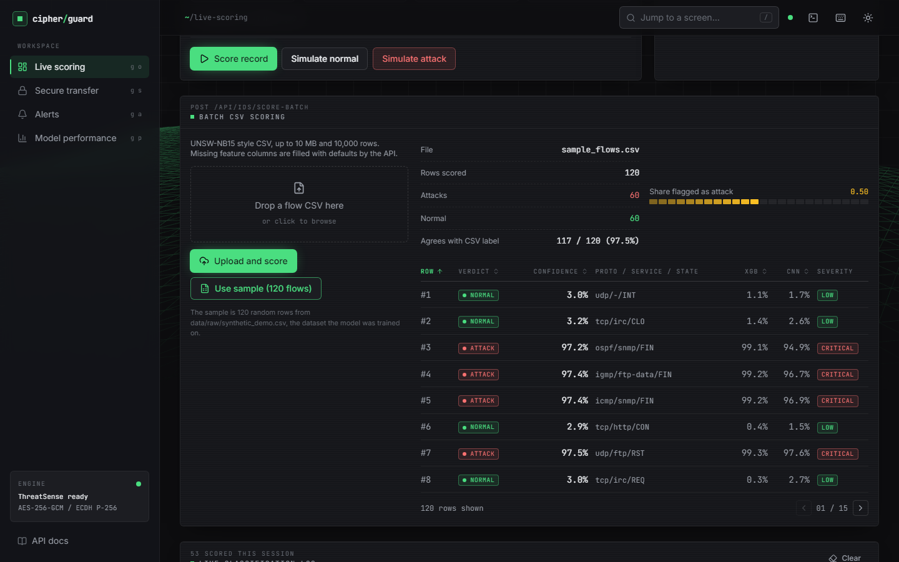  Figure 28: Batch CSV scoring of the bundled 120-row synthetic sample. | 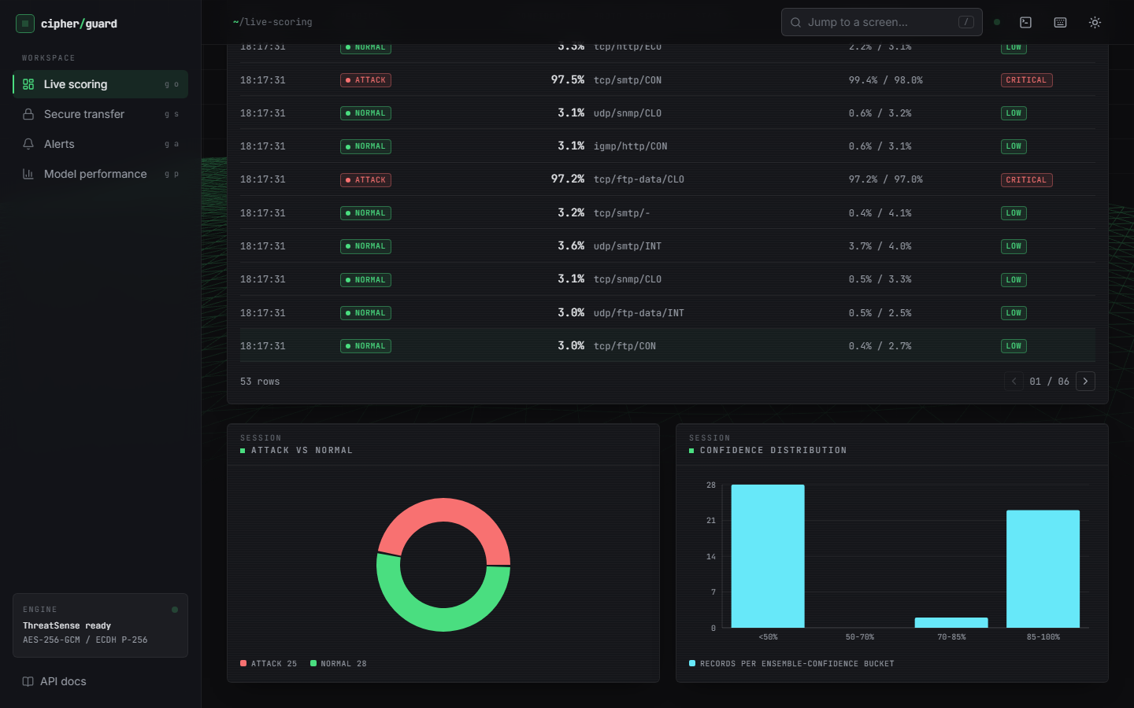  Figure 29: Session charts: attack versus normal and the confidence distribution.

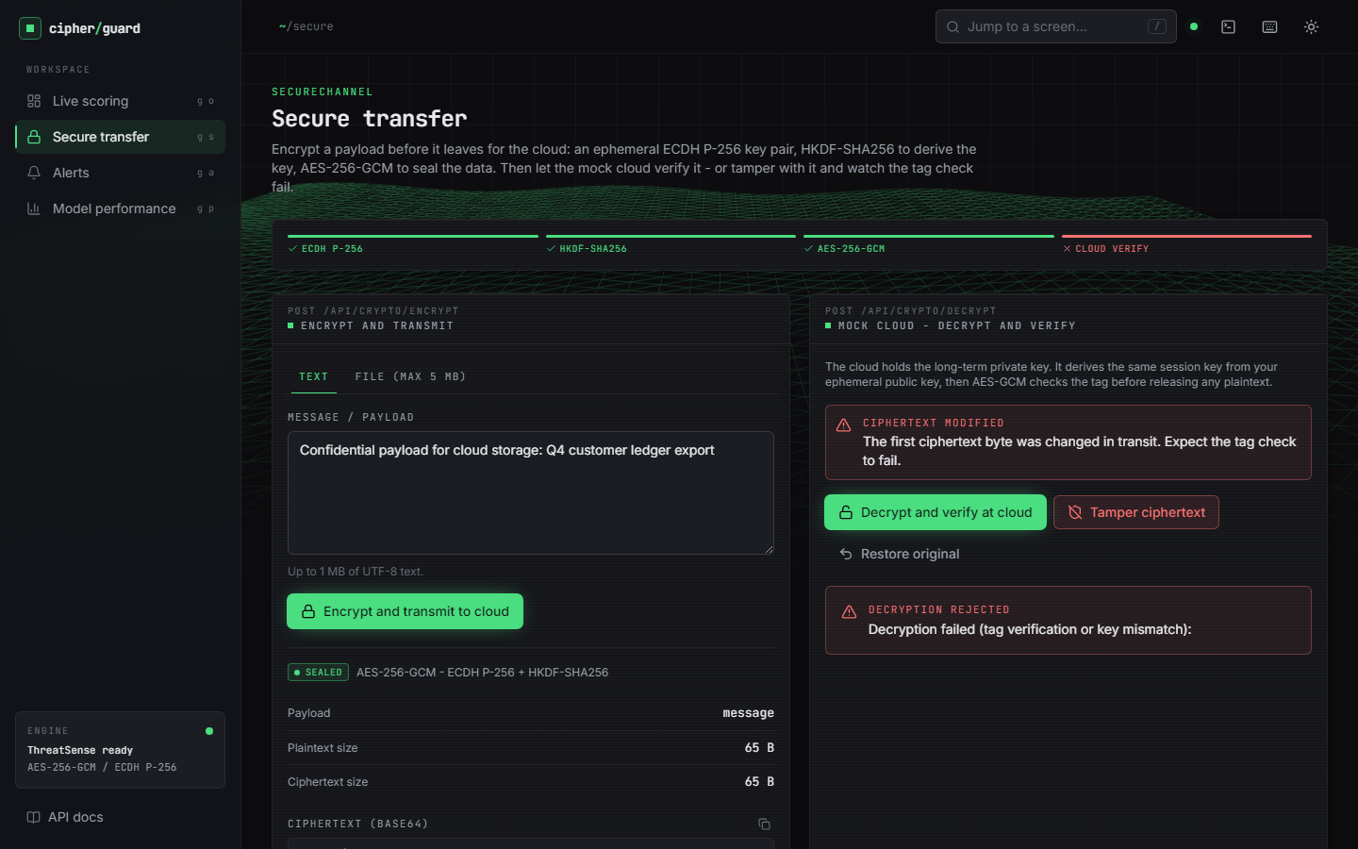  Figure 30: Secure transfer: a flipped ciphertext byte is rejected. | 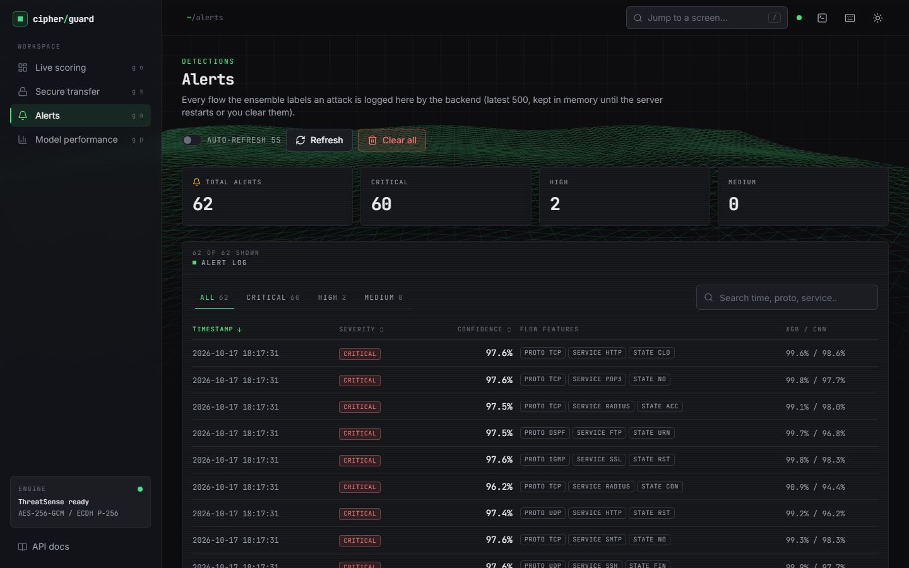  Figure 31: Alerts screen populated by the batch.

